Lesson 13 Practice Problems
- Graph the equations ${\left(x−2\right)}^{2}+{\left(y+3\right)}^{2}=36$ and $x=2$. Where do they intersect?
- 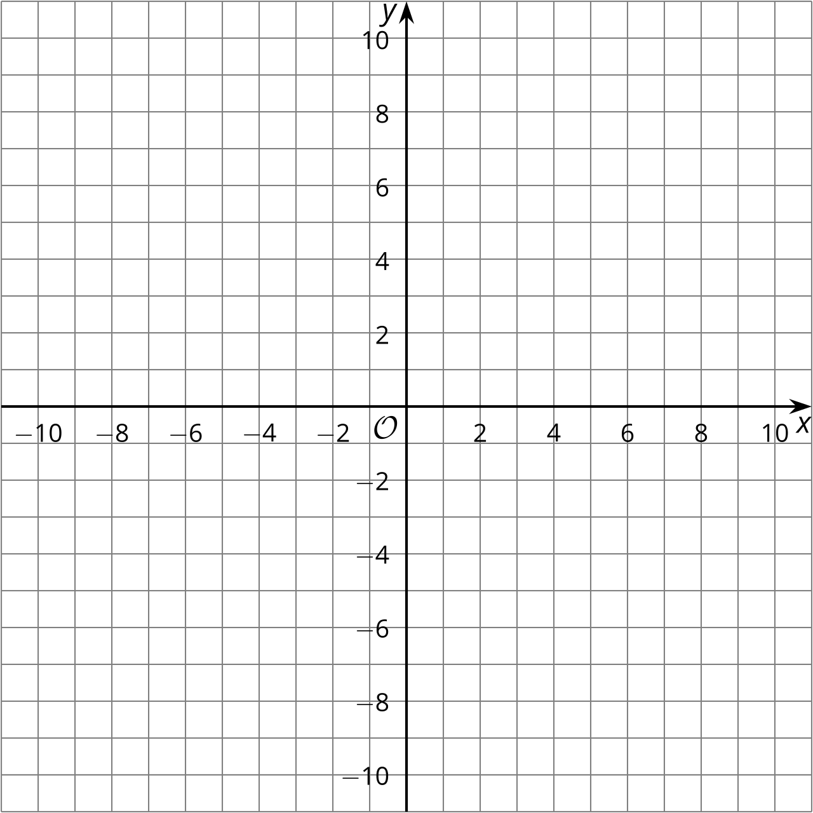
- Select all equations for which the point $\left(2,\text{-}3\right)$ is on the graph of the equation.
  - $y−3=x−2$
  - $4x+y=5$
  - $y=5x−13$
  - $x^{2}+y^{2}=13$
  - ${\left(x−2\right)}^{2}+{\left(y−\left(\text{-}3\right)\right)}^{2}=25$
  - $y={\left(x−2\right)}^{2}+3$
  - $y=x^{2}−7$
- The image shows a graph of the parabola with focus $\left(3,4\right)$ and directrix $y=2$, and the line given by $y=4$. Find and verify the points where the parabola and the line intersect.
- 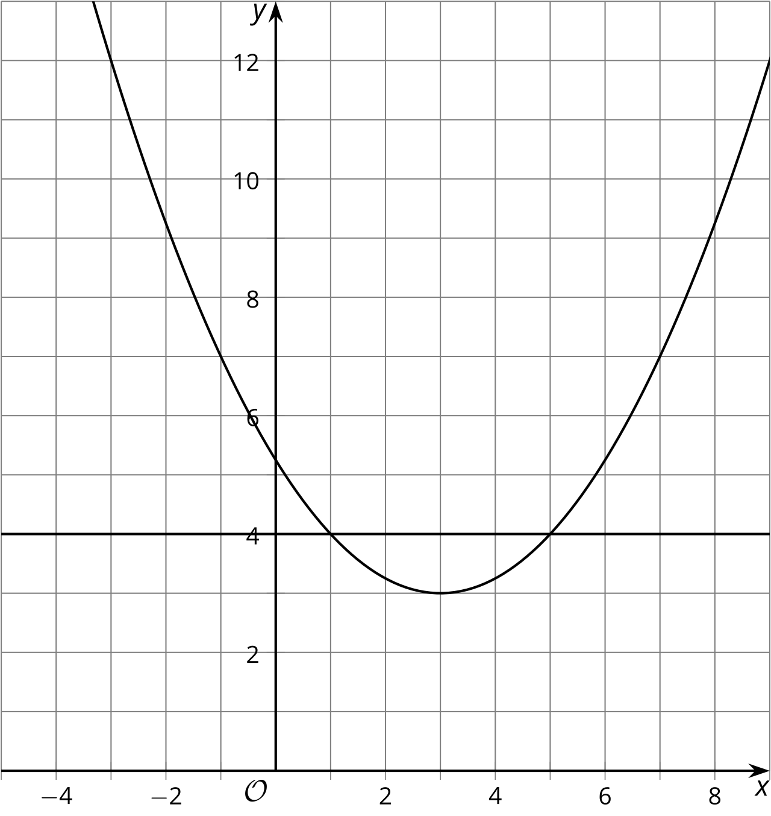
- Here is a line $ℓ$. Write equations for and graph 4 different lines perpendicular to $ℓ$ .
- 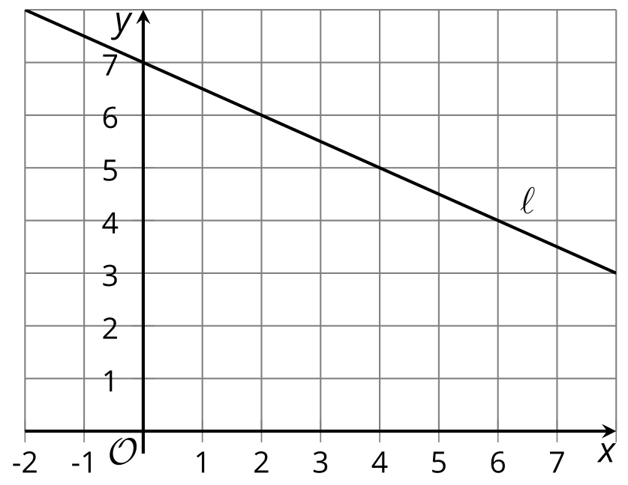
- (From Unit 6, Lesson 12.)
- Write an equation whose graph is a line perpendicular to the graph of $y=4$ and which passes through the point $\left(2,5\right)$.
- (From Unit 6, Lesson 12.)
- Select all lines that are perpendicular to $y−4=\text{-}\frac{2}{3}\left(x+1\right)$.
  - $y=\frac{3}{2}x+8$
  - $3x−2y=2$
  - $3x+2y=10$
  - $y−2=\text{-}\frac{2}{3}\left(x−1\right)$
  - $y=\frac{3}{2}x$
- (From Unit 6, Lesson 11.)
- Select the line parallel to $3x−2y=10$.
  - $y−1=\frac{3}{2}\left(x+6\right)$
  - $6x+4y=\text{-}20$
  - $y=\text{-}\frac{3}{2}x+2$
  - $y−4=\frac{2}{3}\left(x+1\right)$
- (From Unit 6, Lesson 10.)
- Explain how you could tell whether $x^{2}+bx+c$ is a perfect square trinomial.
- (From Unit 6, Lesson 5.)
© CC BY 2019 by Illustrative Mathematics®

