Lesson 13: Polynomial Division (Part 2)
- Let’s learn a different way to divide polynomials.

13.1: Notice and Wonder: Different Divisions
What do you notice? What do you wonder?
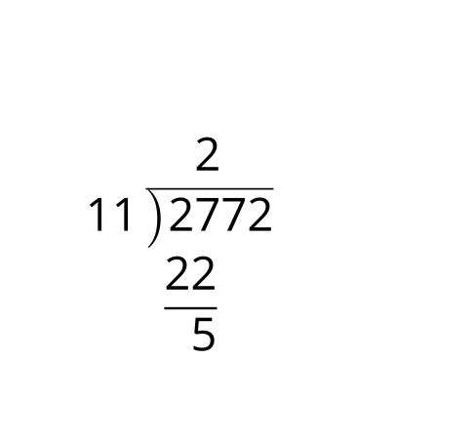
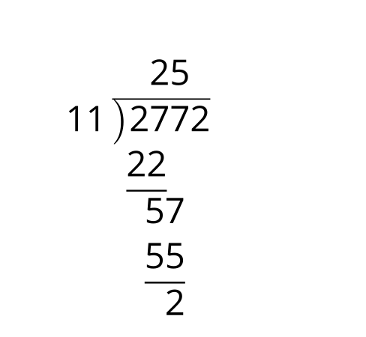
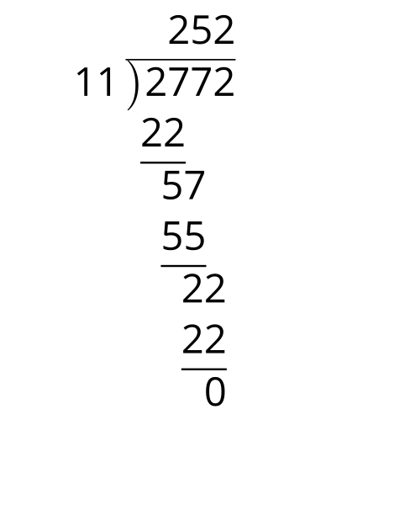
2x2+7x+22x+12x3+7x2+7x+2-2x3−2x2_+7x+225x2+7x+22

13.2: Polynomial Long Division
- Diego used the long division shown here to figure out that $6x^{2}−7x−5=\left(2x+1\right)\left(3x−5\right)$. Show what it would look like if he had used a diagram.
- 3x−52x+16x2−7x−5-6x2−3x_−55-10x−510x+5_0
- $2x$ | - $6x^{2}$
- 1
- Pause here for a whole-class discussion.
- $\left(x−2\right)$ is a factor of $2x^{3}−7x^{2}+x+10$, which means there is some other factor $A$ where $2x^{3}−7x^{2}+x+10=\left(x−2\right)\left(A\right)$. Finish the division started here to find the value of $A$.
- 2x2+x+100x−22x3−7x2+x+10-2x3+4x2_+x+100
- Jada used the diagram shown here to figure out that $2x^{3}+13x^{2}+16x+5=\left(2x+1\right)\left(x^{2}+6x+5\right)$. Show what it would look like if she had used long division.
 | - $x^{2}$ | - $6x$ | - 5
- $2x$ | - $2x^{3}$ | - $12x^{2}$ | - $10x$
- 1 | - $x^{2}$ | - $6x$ | - 5
- $\begin{matrix}2x+12x^{3}+13x^{2}+16x+5\end{matrix}$

Are you ready for more?
- What is $\left(x^{4}−1\right)÷\left(x−1\right)$?
- Use your response to predict what $\left(x^{7}−1\right)÷\left(x−1\right)$ is, and then use division to check your prediction.

13.3: More Long Division
Here are some polynomial functions with known factors. Rewrite each polynomial as a product of linear factors using long division.
- $A\left(x\right)=x^{3}−7x^{2}−16x+112$, $\left(x−7\right)$
x255555555555x−7x3−7x2−16x+112-x3+7x2_.55555555555
- $C\left(x\right)=x^{3}−3x^{2}−13x+15$, $\left(x+3\right)$

13.4: Missing Numbers
Here are pairs of equivalent expressions, one in standard form and the other in factored form. Find the missing numbers.
- $x^{2}+9x+14$ and x+2x+30
- $x^{2}−9x+20$ and x−30x−30
- $2x^{2}+2x−24$ and 2x+30x−3
- 30x3+11x2−17x+6 and $\left(\text{-}x+3\right)\left(2x−1\right)\left(x−2\right)$
- $6x^{3}+2x^{2}−16x+8$ and x−12x+430x−2
- $2x^{3}+7x^{2}−7x−12$ and 2x−3x+30x+30
- x3+6x2+30x−10 and x+2x−1x+30

Lesson 13 Summary
In earlier grades, we learned how to add, subtract, and multiply numbers. We also learned that one way to divide numbers, like 1573 divided by 11, is by using long division.
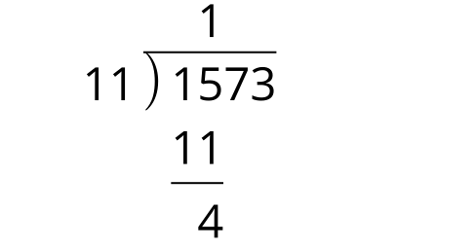
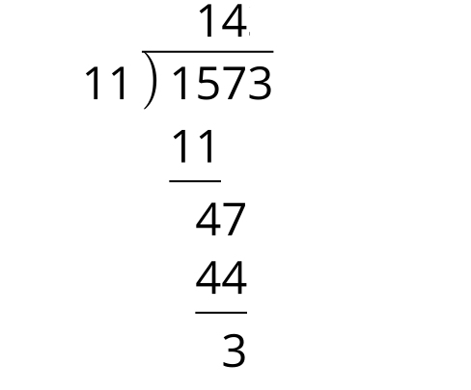
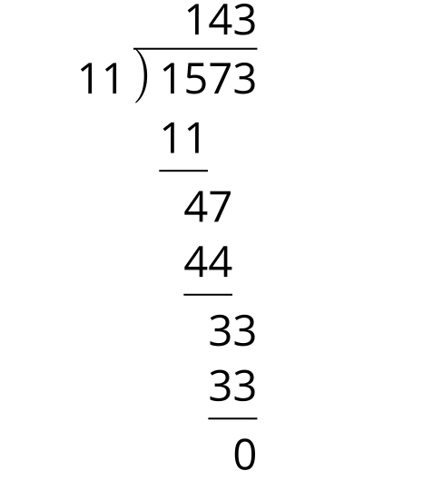
Here the division has been completed in stages, focusing on the highest power of 10 (1,000) in the dividend 1,573, and working down. This long division shows that $1573=\left(11\right)\left(143\right)$.
Similar to integers, we can add, subtract, and multiply polynomials. It turns out that we can also use long division on polynomials. Instead of focusing on powers of 10, in polynomial long division we focus on powers of $x$. Just as we started with the highest power or 10, we start with the highest power of $x$, the leading term, and work down to the constant term. For example, here is $x^{3}+5x^{2}+7x+3$ divided by $x+1$ completed in three stages. Notice how terms of the same degree are in the same columns.
x2+7x+33x+1x3+5x2+7x+3-x3−x2_+7x+3334x2+7x+33
x2+4x+33x+1x3+5x2+7x+3-x3−x2_+7x+3334x2+7x+33-4x2−4x_+33
x2+4x+3x+1x3+5x2+7x+3-x3−x2_+7x+3334x2+7x+33-4x2−4x_+333x+3
At each stage, the focus is only on the term with the largest exponent that’s left. At the conclusion, we can see that $x^{3}+5x^{2}+7x+3=\left(x+1\right)\left(x^{2}+4x+3\right)$.
© CC BY 2019 by Illustrative Mathematics®

