Unit 2 Lesson 9 Cumulative Practice Problems
- These two triangles are similar. What are $a$ and $b$? Note: the two figures are not drawn to scale.
- 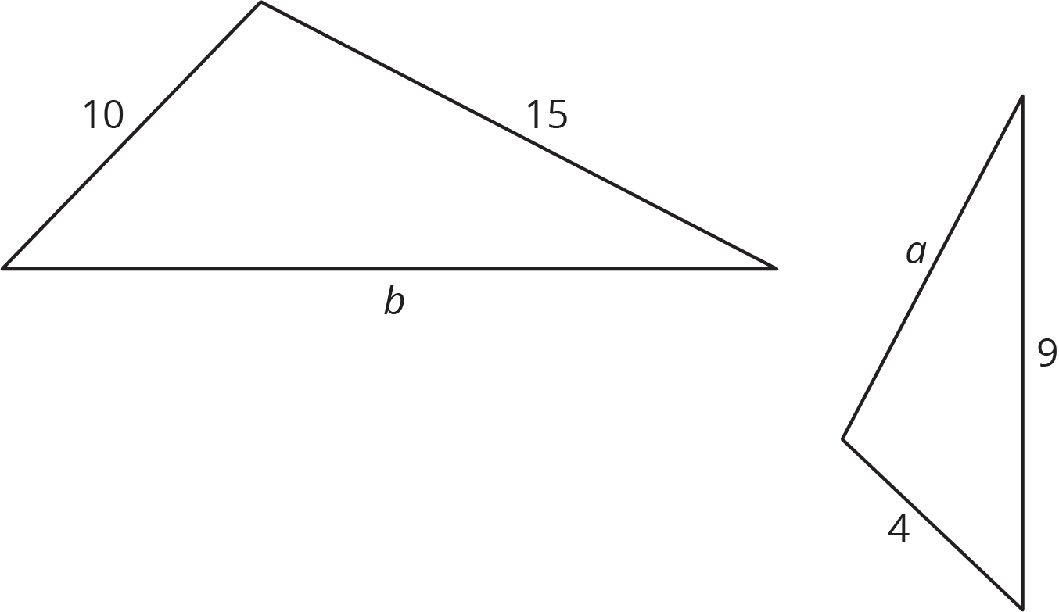
- Here is triangle $ABC$. Triangle $XYZ$ is similar to $ABC$ with scale factor $\frac{1}{4}$.
- 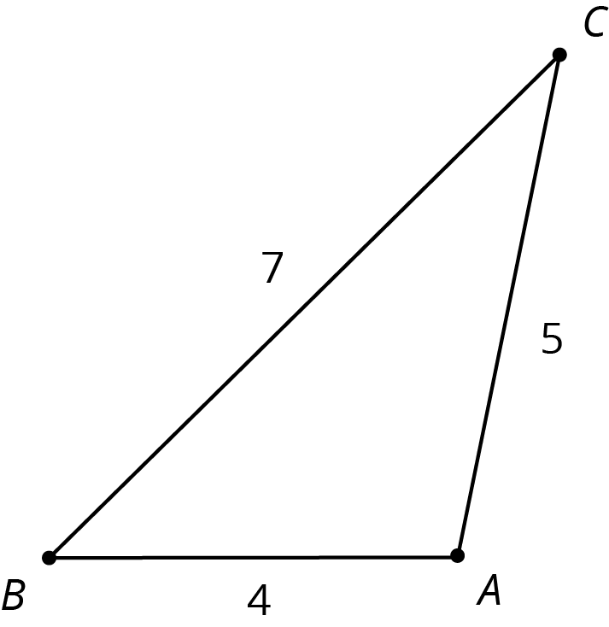
  - Draw what triangle $XYZ$ might look like.
  - How do the angle measures of triangle $XYZ$ compare to triangle $ABC$? Explain how you know.
  - What are the side lengths of triangle $XYZ$?
  - For triangle $XYZ$, calculate (long side) $÷$ (medium side), and compare to triangle $ABC$.
- The two triangles shown are similar. Find the value of $\frac{d}{c}$.
- 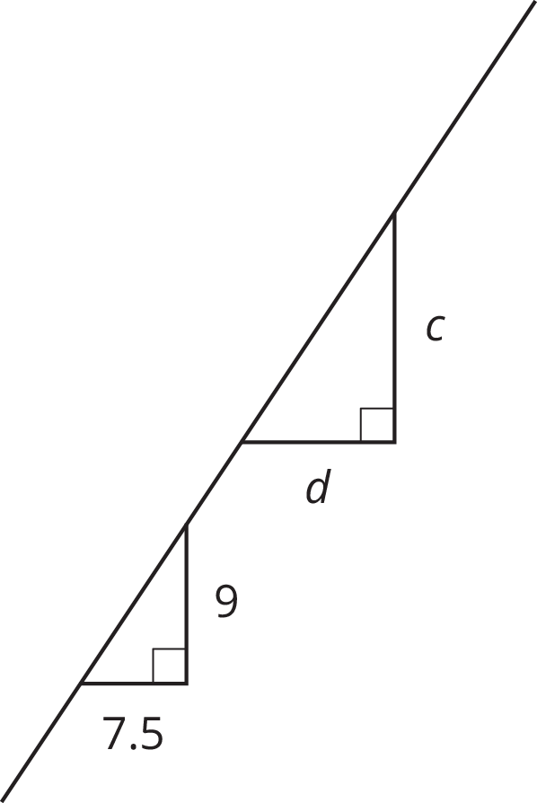
- The diagram shows two nested triangles that share a vertex. Find a center and a scale factor for a dilation that would move the larger triangle to the smaller triangle.
- 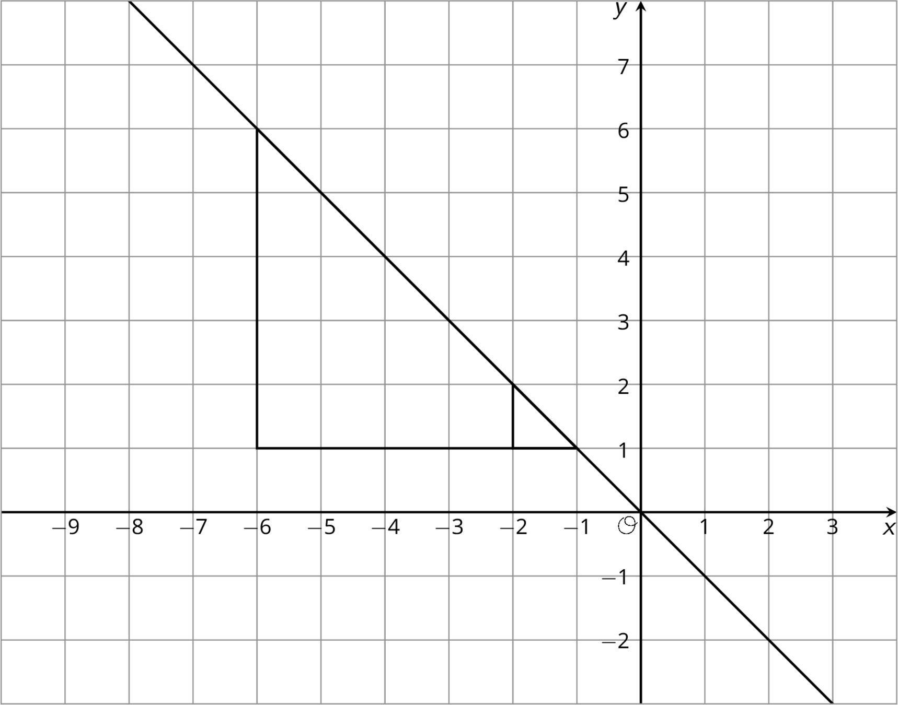
- (From Unit 2, Lesson 5.)
© CC BY Open Up Resources. Adaptations CC BY IM.

