Unit 3 Lesson 9: From Feet to Inches

WU Estimation Exploration: Small Fry, Big Fish (Warm up)

Student Task Statement
How long is this Cobia fish in inches?
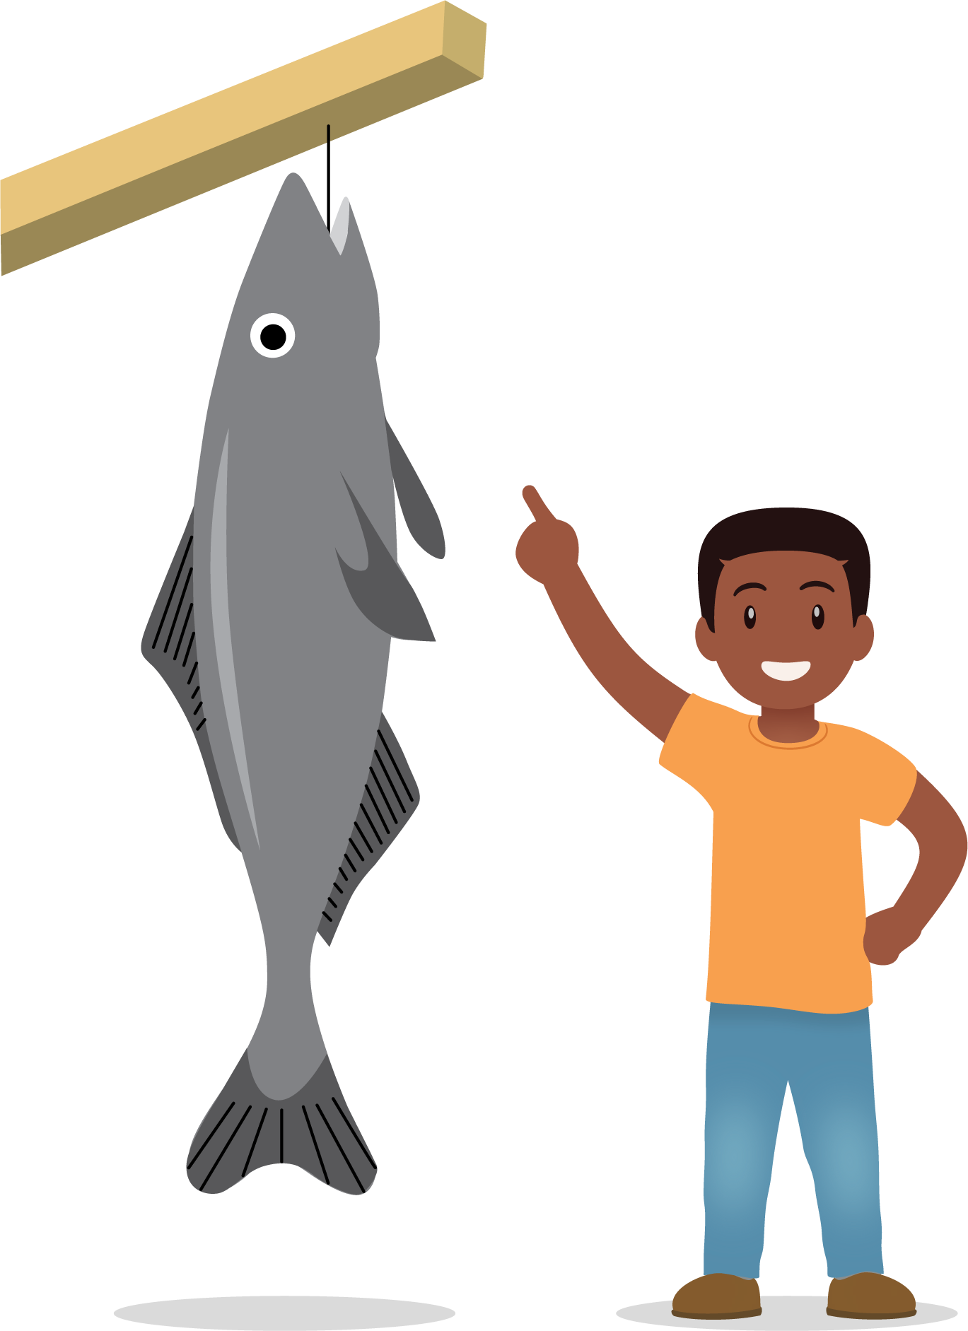
- Record an estimate that is:
- too low | - about right | - too high
- Record an estimate that is:
- too low | - about right | - too high

1 Measure the Length of Fish

Student Task Statement
- Work with your group to measure the tape strips around the classroom in feet. Then measure the length in inches.
- Tape A
- largemouth bass
- 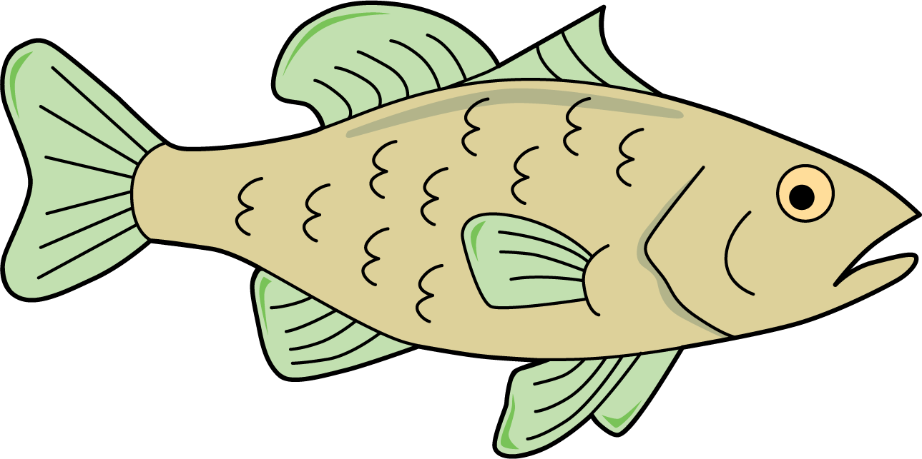
- Length in feet: __________
- Length in inches: __________
- Tape B
- spiny dogfish shark
- 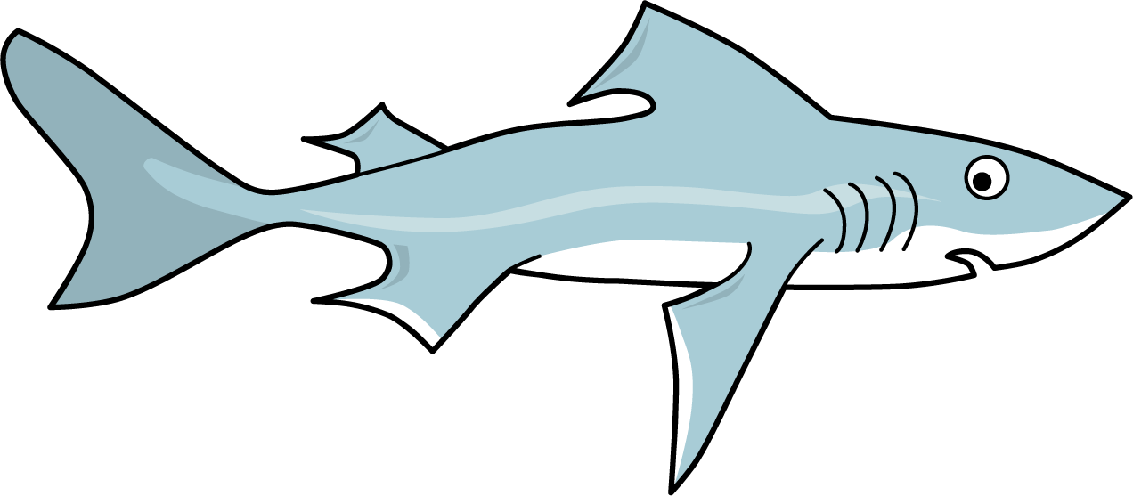
- Length in feet: __________
- Length in inches: __________
- Tape C
- catfish
- 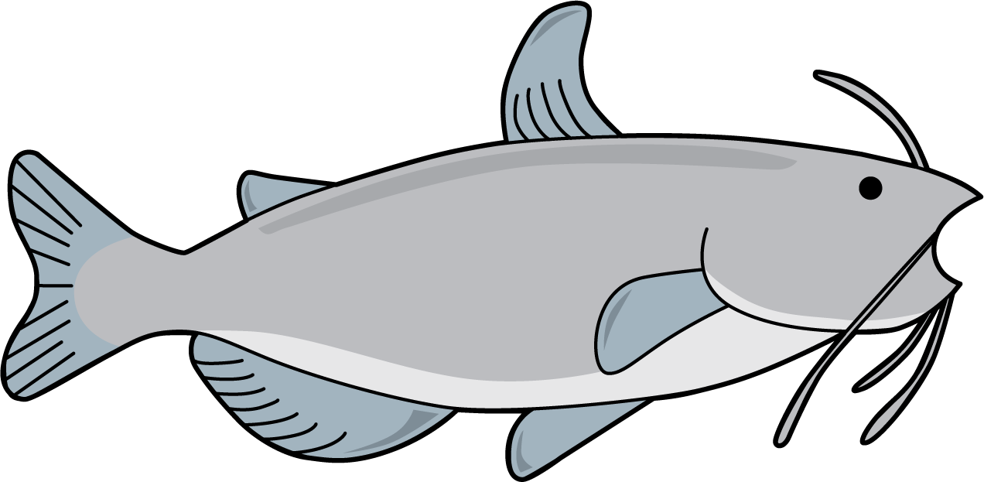
- Length in feet: __________
- Length in inches: __________
- Tape D
- koi
- 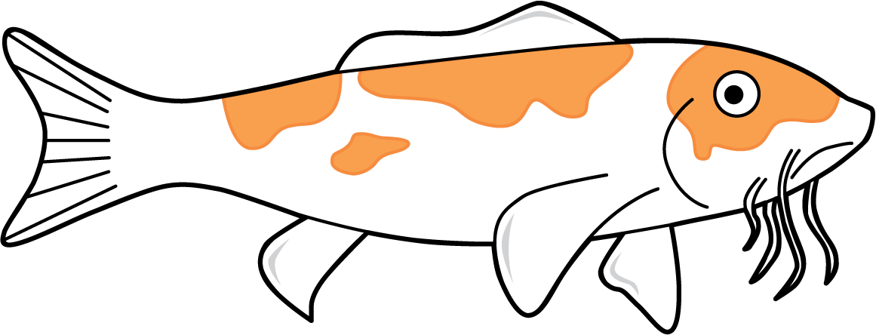
- Length in feet: __________
- Length in inches: __________
- What did you notice about the number of feet compared to the number of inches when you measured the tape strips?

2 Inches or Feet?

Student Task Statement
- Estimate the length of objects around the room. Say if you will measure in inches or feet.
- object to measure | - my estimate | - circle inches or feet
- inches
- feet
- inches
- feet
- inches
- feet
- inches
- feet
- Choose the best tool to measure each object. Complete the table to record your actual measurements.
object to measure | measurement tool | actual length (include unit)
© CC BY 2021 Illustrative Mathematics®

