Lesson 4: Decompose Even and Odd Numbers
- Let’s represent even and odd numbers.

Warm-up: Number Talk: Equal Addends
Find the value of each expression mentally.
- $6+6$
- $7+7$
- $7+8$
- $8+9$

4.1: Share in Different Ways
- Kiran baked 12 cookies. He wants to put them in two gift bags. Show a few different ways he can share the cookies.
  - Can both bags have the same amount of cookies?
  - $12=\underset{_}{}+\underset{_}{}$
  - Can both bags have an even number of cookies?
  - $12=\underset{_}{}+\underset{_}{}$
  - Can both bags have an odd number of cookies?
  - $12=\underset{_}{}+\underset{_}{}$
  - Can one bag have an even number of cookies and the other have an odd number of cookies?
  - $12=\underset{_}{}+\underset{_}{}$
- Lin baked 14 cookies. She wants to put them in two gift bags. Show a few different ways she can share the cookies.
  - Can both bags have the same amount of cookies?
  - $14=\underset{_}{}+\underset{_}{}$
  - Can both bags have an even number of cookies?
  - $14=\underset{_}{}+\underset{_}{}$
  - Can both bags have an odd number of cookies?
  - $14=\underset{_}{}+\underset{_}{}$
  - Can one bag have an even number of cookies and the other have an odd number of cookies?
  - $14=\underset{_}{}+\underset{_}{}$
- Noah baked 15 cookies. He wants to put them in two gift bags. Show a few different ways he can share the cookies.
  - Can both bags have the same amount of cookies?
  - $15=\underset{_}{}+\underset{_}{}$
  - Can both bags have an even number of cookies?
  - $15=\underset{_}{}+\underset{_}{}$
  - Can both bags have an odd number of cookies?
  - $15=\underset{_}{}+\underset{_}{}$
  - Can one bag have an even number of cookies and the other have an odd number of cookies?
  - $15=\underset{_}{}+\underset{_}{}$

4.2: Represent Numbers with Two Addends
- Pick a number between 0 and 20.
- Decide with your partner whether the number is even or odd.
- Complete the equation to show your number as the sum of two equal addends. If you cannot use two equal addends, use two addends that are as close as possible.
even
odd
$\underset{_}{}=\underset{_}{}+\underset{_}{}$
$\underset{_}{}=\underset{_}{}+\underset{_}{}$
$\underset{_}{}=\underset{_}{}+\underset{_}{}$
$\underset{_}{}=\underset{_}{}+\underset{_}{}$
$\underset{_}{}=\underset{_}{}+\underset{_}{}$
$\underset{_}{}=\underset{_}{}+\underset{_}{}$
$\underset{_}{}=\underset{_}{}+\underset{_}{}$
$\underset{_}{}=\underset{_}{}+\underset{_}{}$
$\underset{_}{}=\underset{_}{}+\underset{_}{}$
$\underset{_}{}=\underset{_}{}+\underset{_}{}$
$\underset{_}{}=\underset{_}{}+\underset{_}{}$
$\underset{_}{}=\underset{_}{}+\underset{_}{}$
$\underset{_}{}=\underset{_}{}+\underset{_}{}$
$\underset{_}{}=\underset{_}{}+\underset{_}{}$
$\underset{_}{}=\underset{_}{}+\underset{_}{}$
$\underset{_}{}=\underset{_}{}+\underset{_}{}$
$\underset{_}{}=\underset{_}{}+\underset{_}{}$
$\underset{_}{}=\underset{_}{}+\underset{_}{}$
$\underset{_}{}=\underset{_}{}+\underset{_}{}$
$\underset{_}{}=\underset{_}{}+\underset{_}{}$

Section Summary
Section Summary
In this section, we learned that groups of objects have either an even or odd number of members. We learned that an even number of objects can be split into 2 equal groups or into groups of 2 with no objects left over. We learned that an odd number of objects always has one object left over when you make 2 equal groups or groups of 2. We also learned that even numbers can be represented as an equation with 2 equal addends.
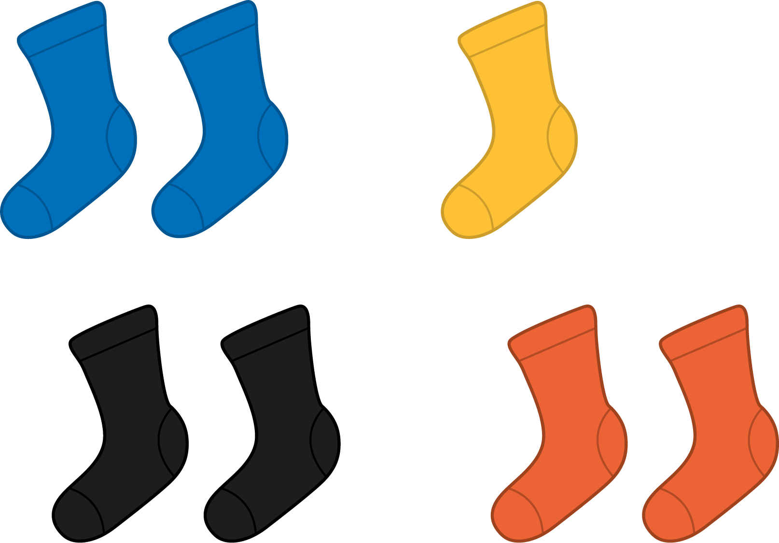
Odd
$3+3+1=7$
Even
$4+4=8$
© CC BY 2021 Illustrative Mathematics®

