Unit 3 Lesson 8: Subtraction Algorithms (Part 1)

WU Number Talk: Subtraction Strategies (Warm up)

Student Task Statement
Find the value of each expression mentally.
- $100−98$
- $101−99$
- $200−98$
- $204−98$

1 From Drawings to an Algorithm

Student Task Statement
Jada and Kiran found the value of $391−215$. Their work is shown.
Jada’s drawing
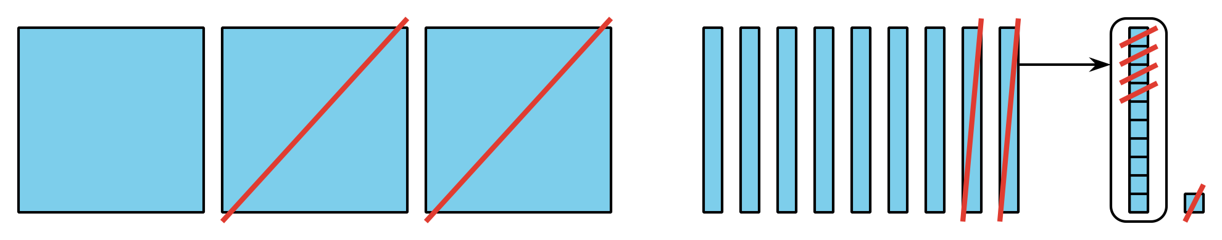
Kiran’s algorithm
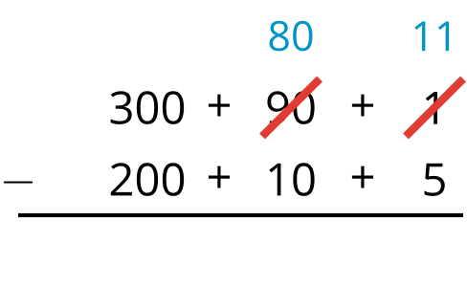
- Explain how Kiran’s algorithm starts.
- Explain how Kiran recorded the decomposition of the ten into more ones.
- Finish Kiran’s work.

2 Card Sort: Diagrams and Algorithms

Student Task Statement
Your teacher will give you a set of cards. Match each diagram with an algorithm.
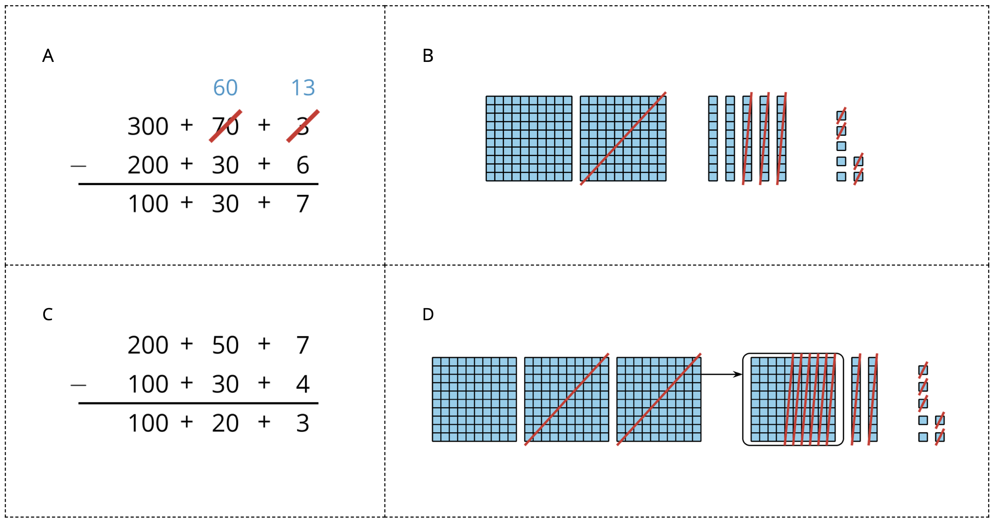
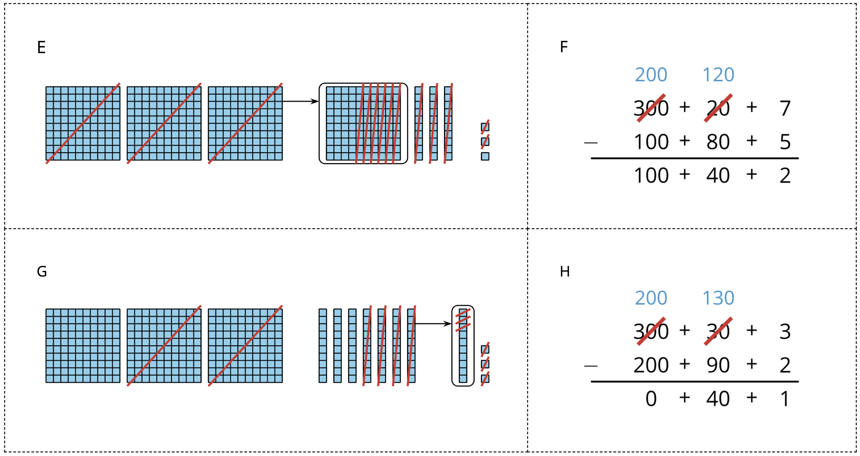

Images for Activity Synthesis
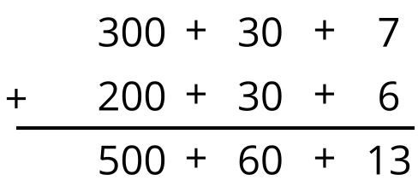
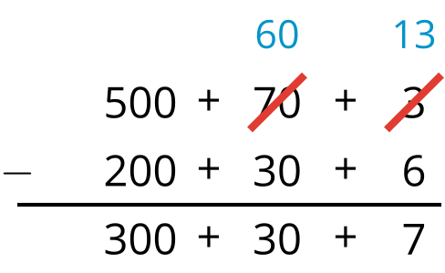
© CC BY 2021 Illustrative Mathematics®

