Lesson 7: Center Day 1
- Let’s play games to practice adding.

7.2: Centers: Choice Time
Choose a center.
Number Puzzles
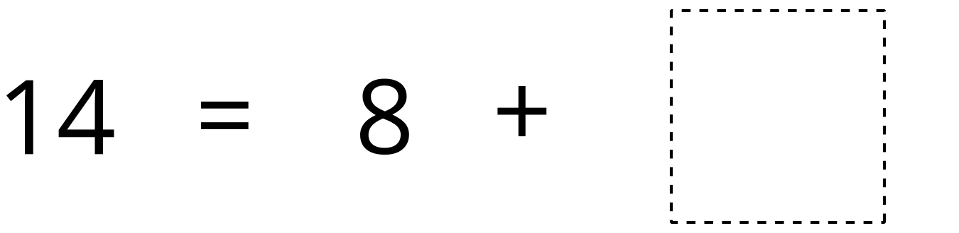
Find the Pair
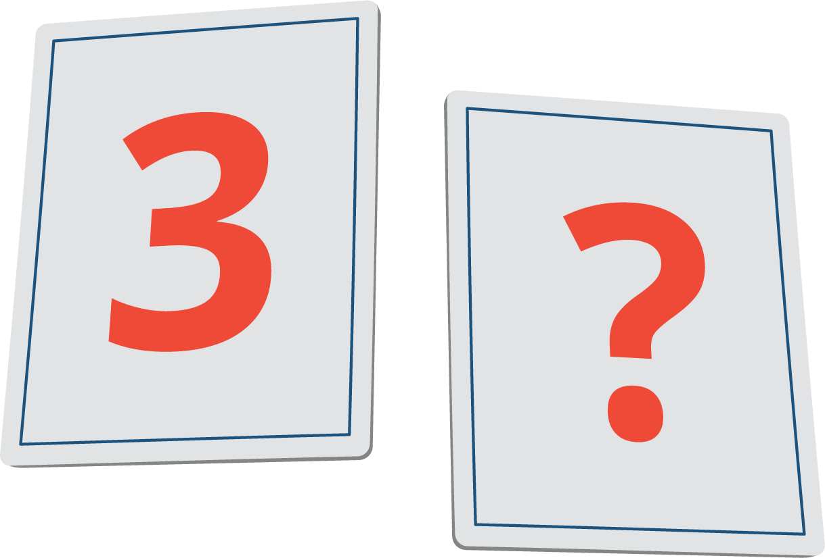
Compare
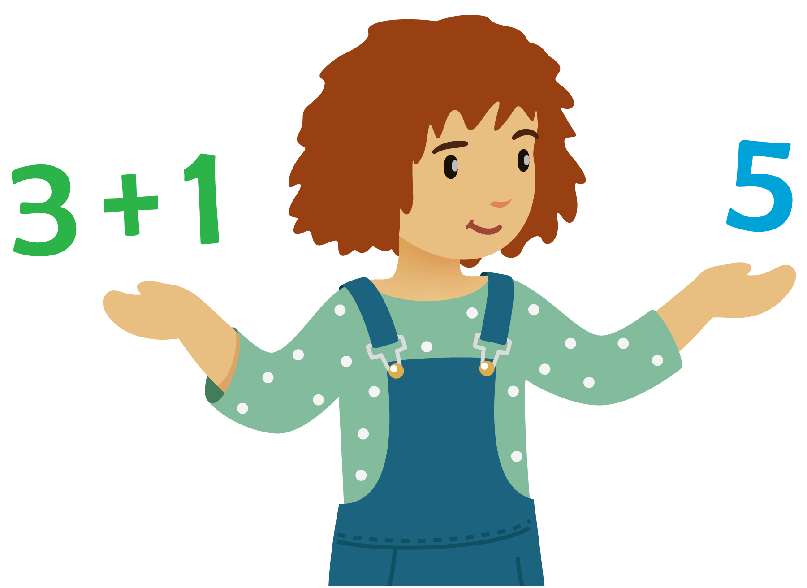
© CC BY 2021 Illustrative Mathematics®

