Lesson 22: Center Day 4
- Let’s play games about tens and ones.

Warm-up: True or False: Tens and Ones
Decide if each statement is true or false.
Be prepared to explain your reasoning.
- $92=90+2$
- $90+2>80+12$
- $20+13<30+13$

22.2: Center: Choice Time
Choose a center.
Mystery Number
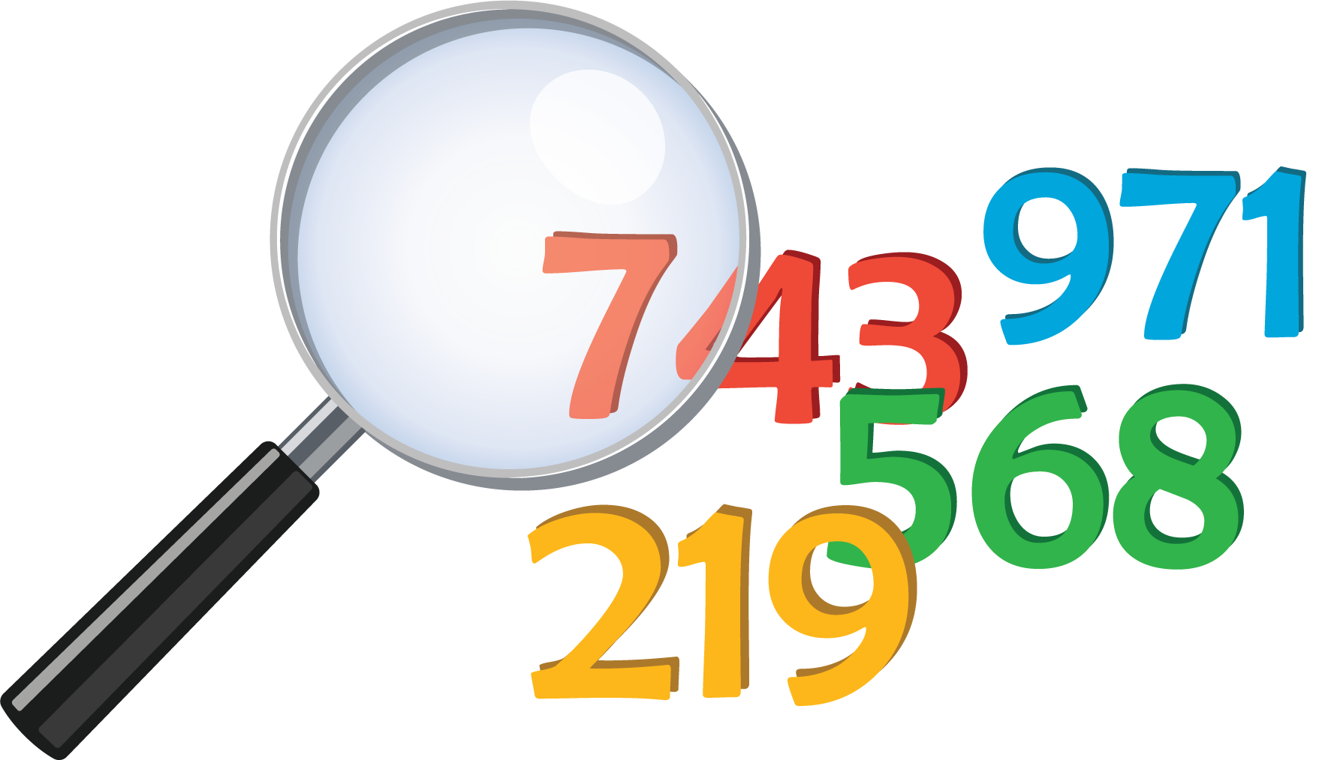
Get Your Numbers in Order
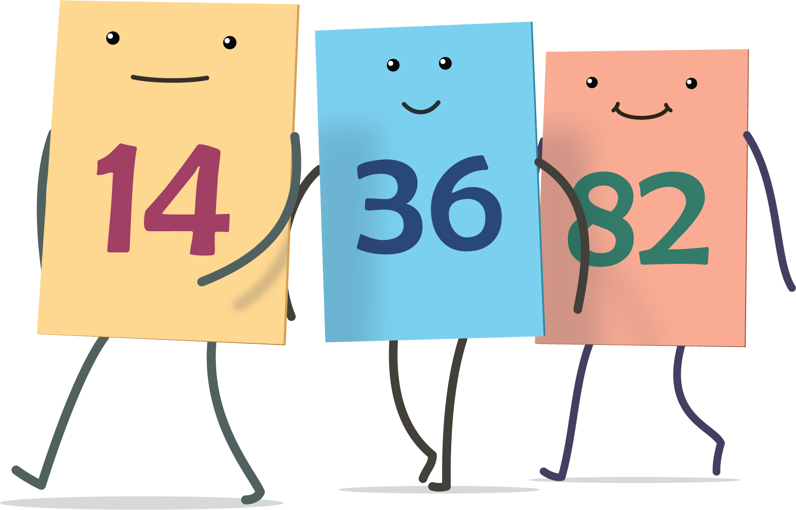
Greatest of Them All
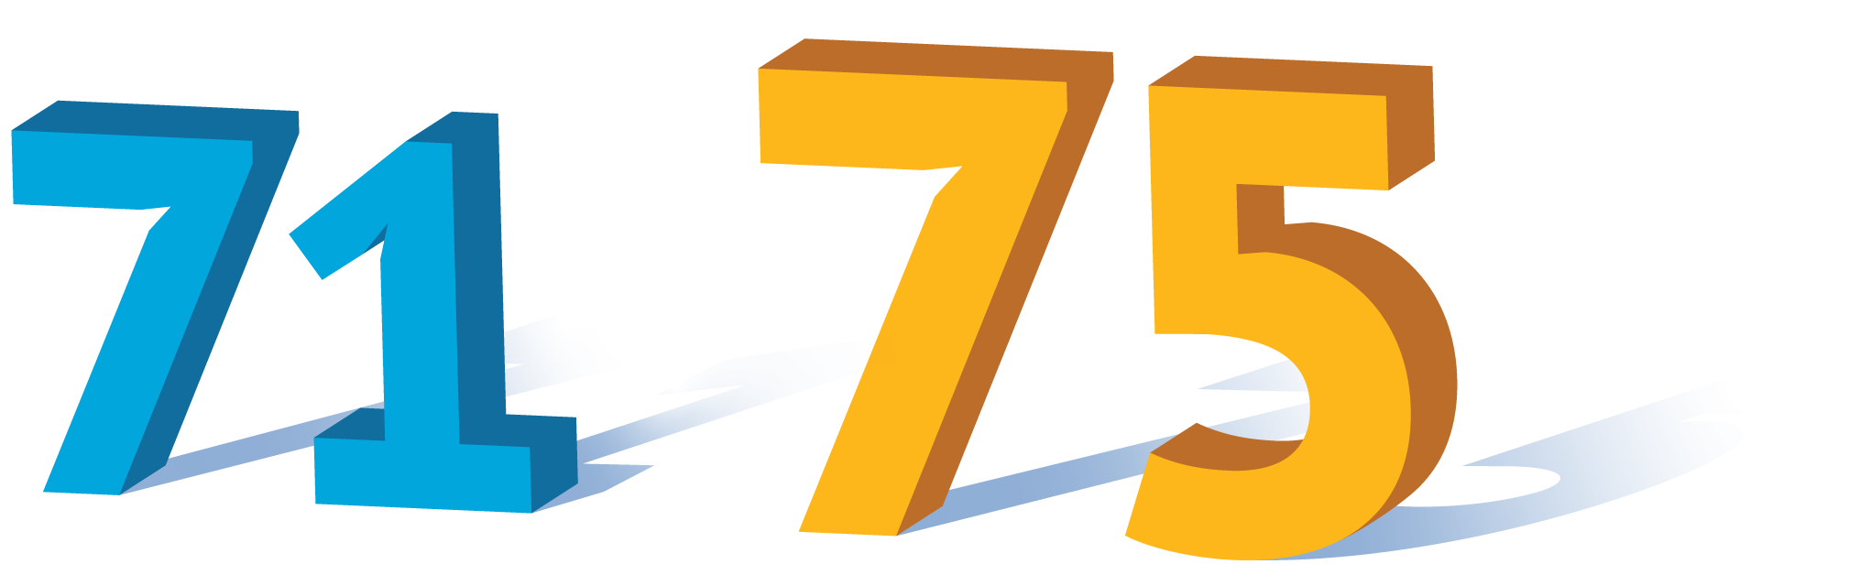
© CC BY 2021 Illustrative Mathematics®

