Lesson 4 Practice Problems
- Here is a picture of a Ferris wheel. It has a diameter of 80 meters.
- 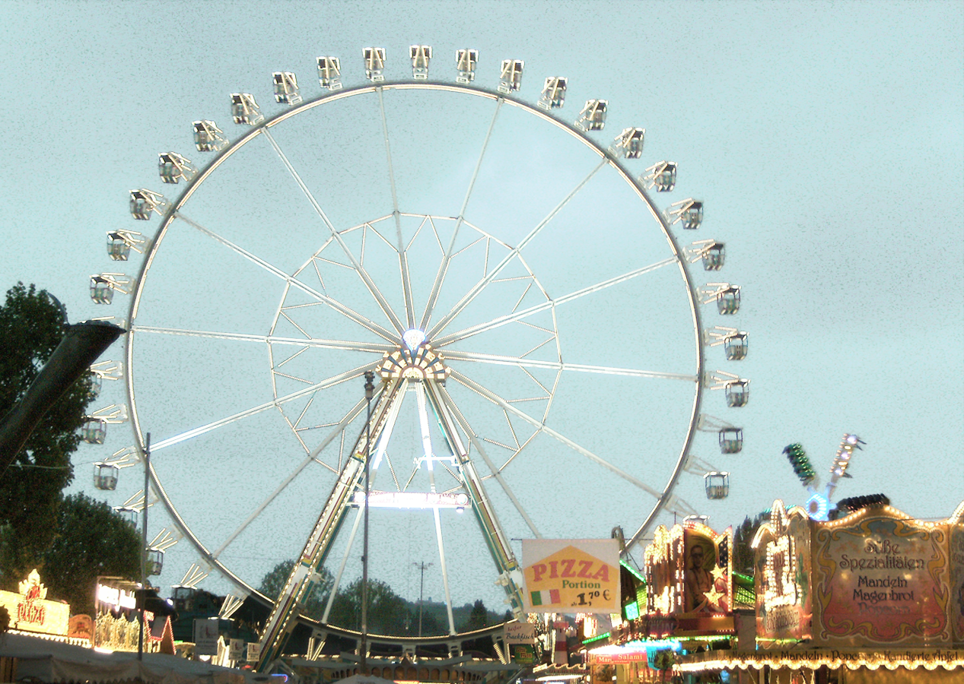
  - On the picture, draw and label a diameter.
  - How far does a rider travel in one complete rotation around the Ferris wheel?
- Identify each measurement as the diameter, radius, or circumference of the circular object. Then, estimate the other two measurements for the circle.
  - The length of the minute hand on a clock is 5 in.
  - The distance across a sink drain is 3.8 cm.
  - The tires on a mining truck are 14 ft tall.
  - The fence around a circular pool is 75 ft long.
  - The distance from the tip of a slice of pizza to the crust is 7 in.
  - Breaking a cookie in half creates a straight side 10 cm long.
  - The length of the metal rim around a glass lens is 190 mm.
  - From the center to the edge of a DVD measures 60 mm.
- A half circle is joined to an equilateral triangle with side lengths of 12 units. What is the perimeter of the resulting shape?
- 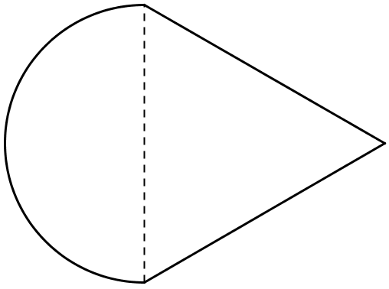
- Circle A has a diameter of 1 foot. Circle B has a circumference of 1 meter. Which circle is bigger? Explain your reasoning. (1 inch = 2.54 centimeters)
- The circumference of Tyler's bike tire is 72 inches. What is the diameter of the tire?
- (From Unit 3, Lesson 3.)
© CC BY Open Up Resources. Adaptations CC BY IM.

