Lesson 14 Practice Problems
- Solve each of these equations. Explain or show your reasoning.
- $2b+8−5b+3=\text{-}13+8b−5$
- $2x+7−5x+8=3\left(5+6x\right)−12x$
- $2c−3=2\left(6−c\right)+7c$
- Solve each equation and check your solution.
- $\text{-}3w−4=w+3$
- $3\left(3−3x\right)=2\left(x+3\right)−30$
- $\frac{1}{3}\left(z+4\right)−6=\frac{2}{3}\left(5−z\right)$
- Elena said the equation $9x+15=3x+15$ has no solutions because $9x$ is greater than $3x$. Do you agree with Elena? Explain your reasoning.
- Which of the changes would keep the hanger in balance?
- Select all that apply.
- 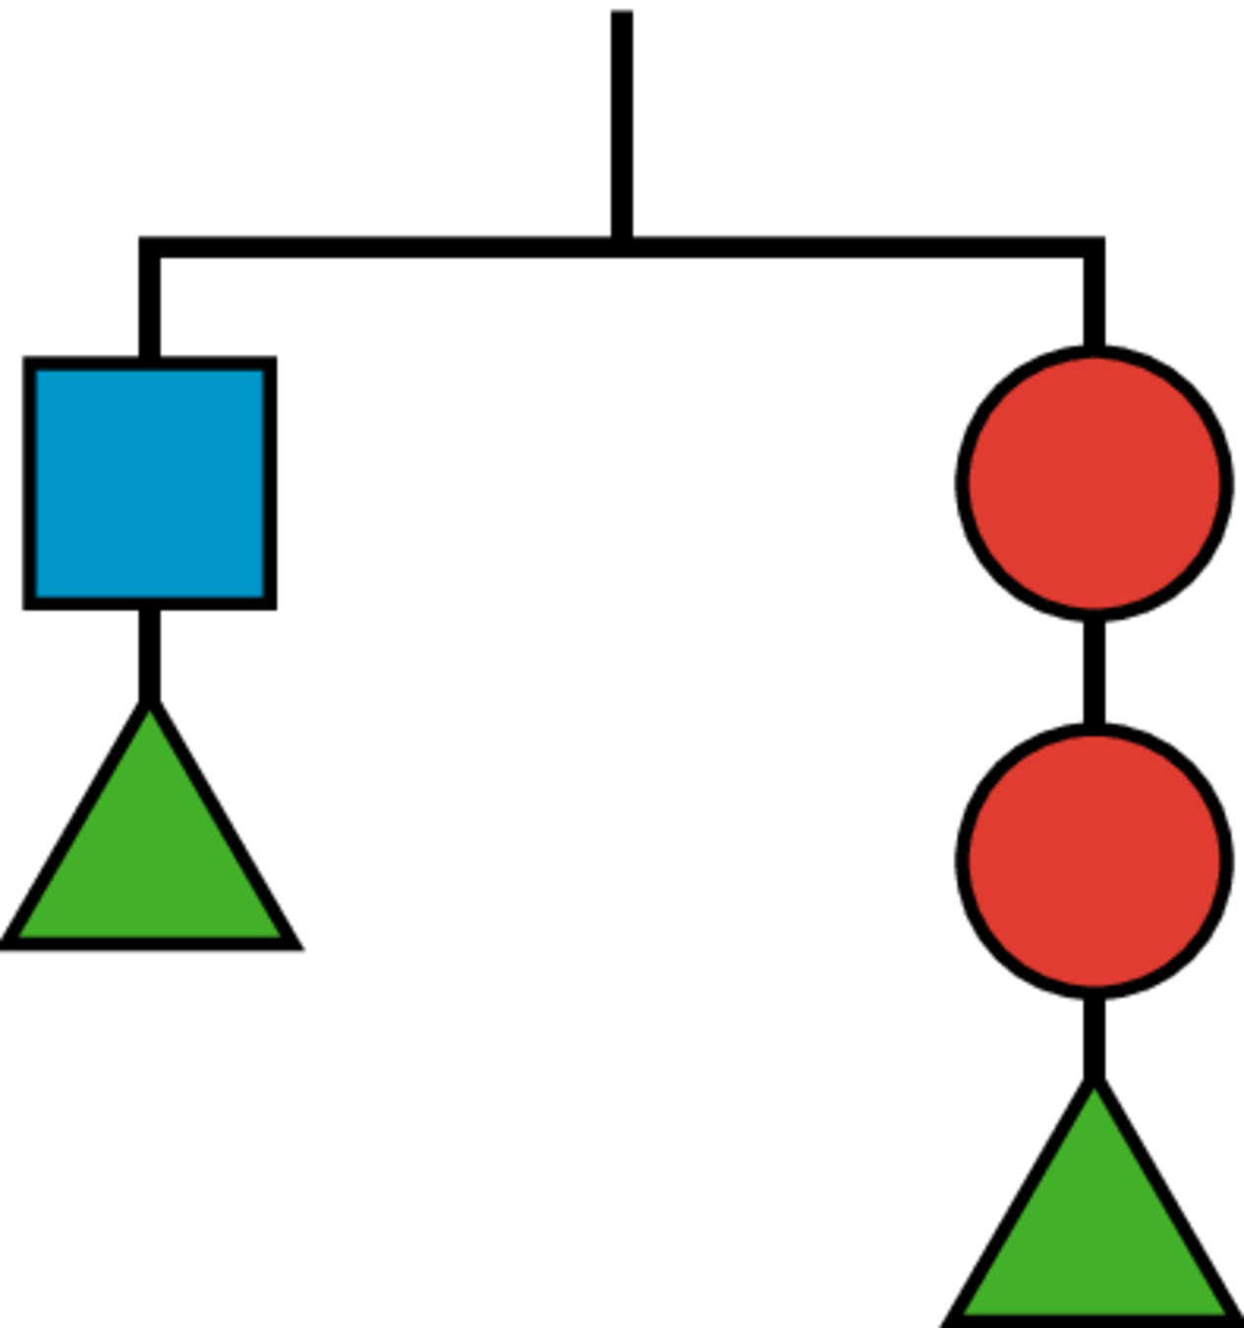

  - Adding two circles on the left and a square on the right
  - Adding 2 triangles to each side
  - Adding two circles on the right and a square on the left
  - Adding a circle on the left and a square on the right
  - Adding a triangle on the left and a square on the right
- (From Unit 4, Lesson 12.)
© CC BY Open Up Resources. Adaptations CC BY IM.

