Unit 2 Lesson 11: Slopes and Intercepts

1 Notice and Wonder: Sugar and Flour (Warm up)

Student Task Statement
What do you notice? What do you wonder?
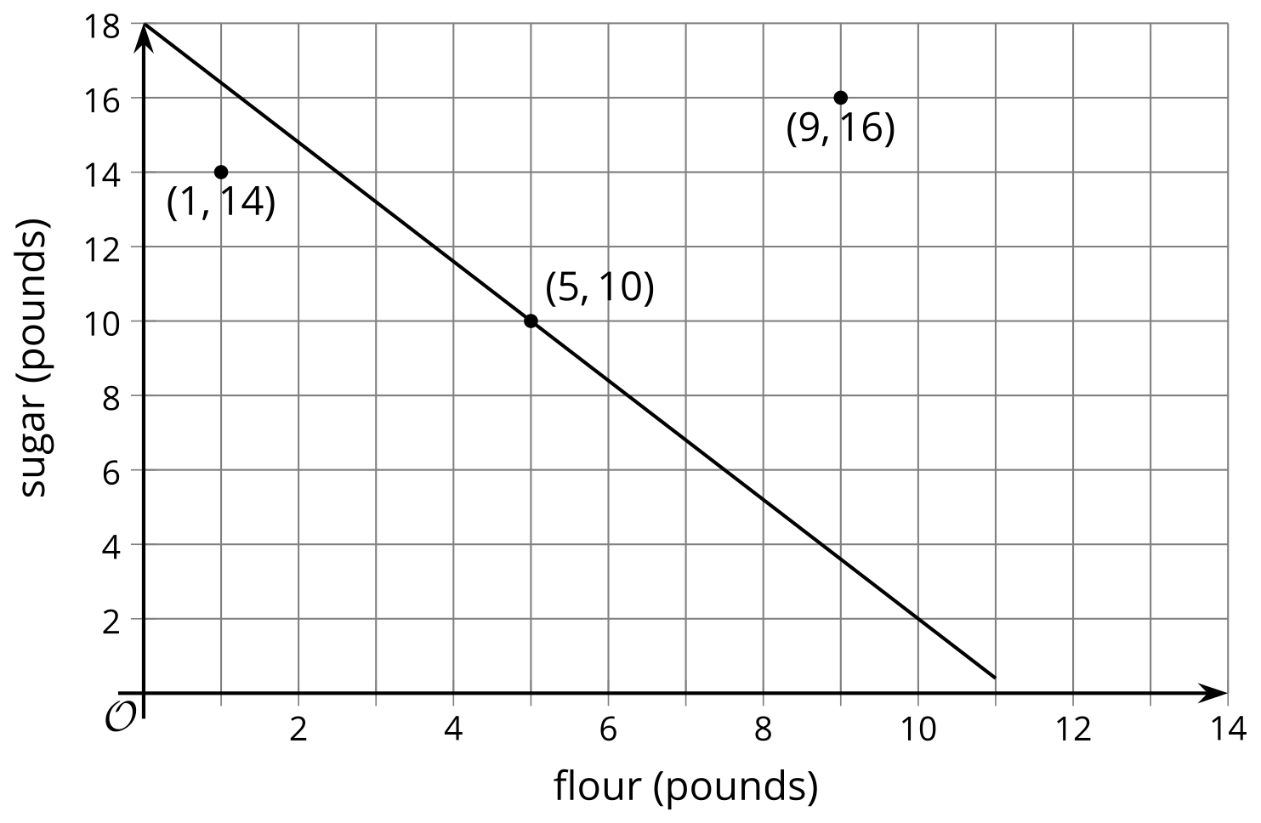

2 Matching Matching

Student Task Statement
- Deal out the graph cards, face up. Take turns with your partner to name the three things in each graph:
  - slope
  - $x$-intercept
  - $y$-intercept
  - For each graph you find, tell your partner the slope, $x$-intercept, and $y$-intercept of each graph.
  - For each graph your partner finds, see if you agree with their thinking. If you agree, write their answers down on the graph for them. If you disagree, discuss your thinking and work to reach an agreement.
- Deal out the equation cards face up, leaving the graph cards face up as well. Take turns with your partner to match each graph with an equation.
  - For each match that you find, explain to your partner how you know it’s a match.
  - For each match that your partner finds, listen carefully to their explanation. If you disagree, discuss your thinking and work to reach an agreement.

3 Part of Linear Equations

Student Task Statement
For each equation, identify the slope and $y$-intercept of its graph.
- $y=3x−8$
- $y=10−2x$
- $y=\frac{x}{2}+1$
- $y+1=9x$
- $y=\frac{1}{3}\left(9x+12\right)$
© CC BY 2019 by Illustrative Mathematics®

