Lesson 7 Practice Problems
- A forest fire has been burning for several days. The burned area, in acres, is given by the equation $y=\left(4,​800\right)⋅2^{d}$, where $d$ is the number of days since the area of the fire was first measured.
  - Complete the table.
  - Look at the value of $y=4,​800⋅2^{d}$ when $d=\text{-}1$. What does it tell you about the area burned in the fire? What about when $d=\text{-}3$?
  - How much area had the fire burned a week before it measured 4,800 acres? Explain your reasoning.
- $d$, days since first  measurement | - $y$, acres burned  since fire started
- 0
- -1
- -2
- -3
- -5
- The value of a home in 2015 was $400,000. Its value has been doubling each decade.
  - If $v$ is the value of the home, in dollars, write an equation for $v$ in terms of $d$, the number of decades since 2015.
  - What is $v$ when $d=\text{-}1$? What does this value mean?
  - What is $v$ when $d=\text{-}3$? What does this value mean?
- A fish population, $p$, can be represented by the equation $p=800⋅{\left(\frac{1}{2}\right)}^{t}$ where $t$ is time in years since the beginning of 2015.
- What was the fish population at the beginning of 2012?
  - 100
  - 800
  - 2,400
  - 6,400
- The area, $A$, of a forest, in acres, is modeled by the equation $A=5,​000⋅{\left(\frac{5}{4}\right)}^{d}$ where $d$ is the number of decades since the beginning of the year 1950.
  - Is the area of the forest increasing or decreasing with time? Explain how you know.
  - What was the area of the forest in 1950?
  - What was the area of the forest in 1940?
  - Was the area of the forest less than 1,000 acres in 1900? Explain how you know.
- A population of mosquitos $p$ is modeled by the equation $p=1,​000⋅2^{w}$ where $w$ is the number of weeks after the population was first measured.
  - Find and plot the mosquito population for $w=0,1,2,3,4$.
  - Where on the graph do you see the 1,000 from the equation for $p$?
  - Where on the graph can you see the 2 from the equation?
- 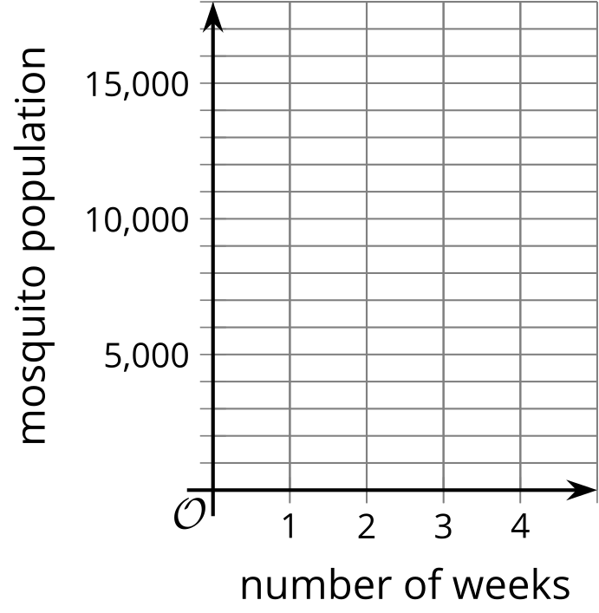
- (From Unit 5, Lesson 3.)
- The number of copies of a book sold the year it was released was 600,000. Each year after that, the number of copies sold decreased by $\frac{1}{2}$.
  - Complete the table showing the number of copies of the book sold each year.
  - Write an equation representing the number of copies, $c$, sold $y$ years after the book was released.
  - Use your equation to find $c$ when $y=6$. What does this mean in terms of the book?
- years since published | - number of copies sold
- 0
- 1
- 2
- 3
- $y$
- (From Unit 5, Lesson 4.)
- The graph shows a population of butterflies, $t$ weeks since their migration began.
- 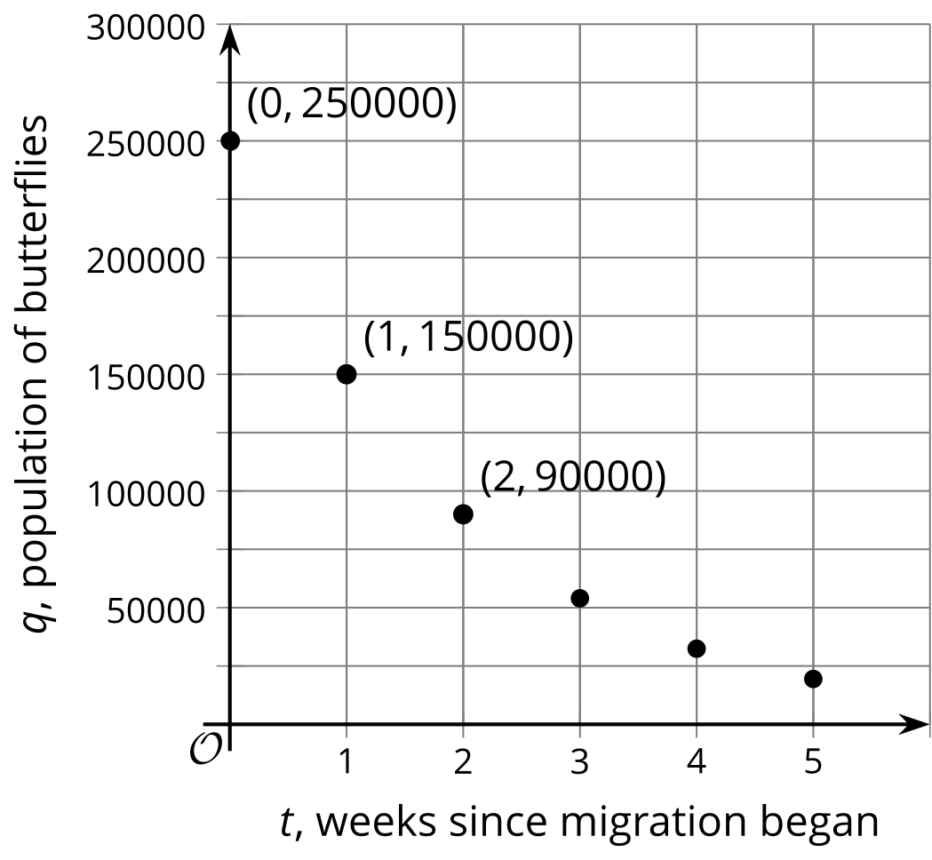
  - How many butterflies were in the population when they started the migration? Explain how you know.
  - How many butterflies were in the population after 1 week? What about after 2 weeks?
  - Write an equation for the population, $q$, after $t$ weeks.
- (From Unit 5, Lesson 5.)
© CC BY 2019 by Illustrative Mathematics®

