Lesson 14 Practice Problems
- A quadrilateral has vertices $A=\left(0,0\right),B=\left(1,3\right),C=\left(0,4\right),$ and $D=\left(\text{-}1,1\right)$. Prove that $ABCD$ is a parallelogram.
- A rhombus has vertices at $\left(0,0\right),\left(5,0\right),\left(3,4\right),$ and $\left(8,4\right)$.
  - Find the slopes of the 2 diagonals of the rhombus.
  - What do the slopes tell you about the diagonals in this rhombus?

  - Show that the triangle formed with vertices at $\left(0,0\right),\left(4,3\right),$ and $\left(\text{-}2,11\right)$ is a right triangle.
  - Find the area of the triangle.
- For each pair of figures, at how many points is it possible that they intersect? List all possibilities.
  - two distinct lines
  - a line and a circle
  - a line and a parabola
- (From Unit 6, Lesson 13.)
- Here are the graphs of the circle centered at $\left(0,0\right)$ with radius 8 and the line given by $4x+7y=65$. Determine whether the circle and the line intersect at the point $\left(4,7\right)$.
- 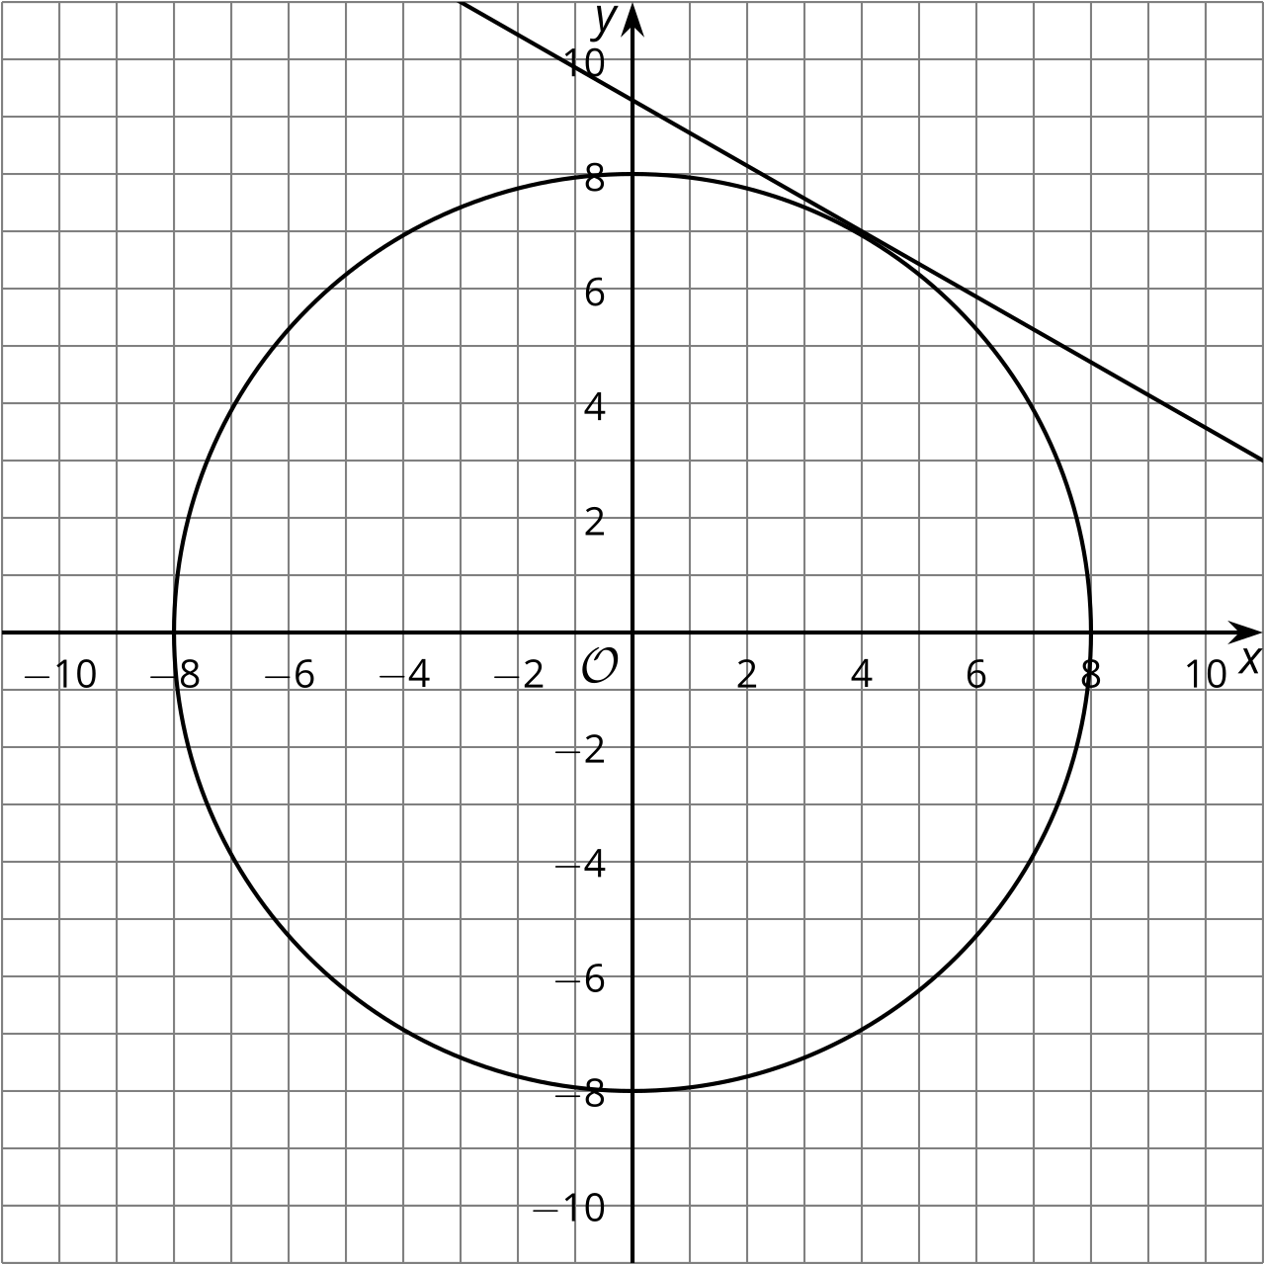
- (From Unit 6, Lesson 13.)
- Here is a line $ℓ$. Write equations for and graph 2 different lines perpendicular to $ℓ$ and 2 different lines parallel to $ℓ$.
- 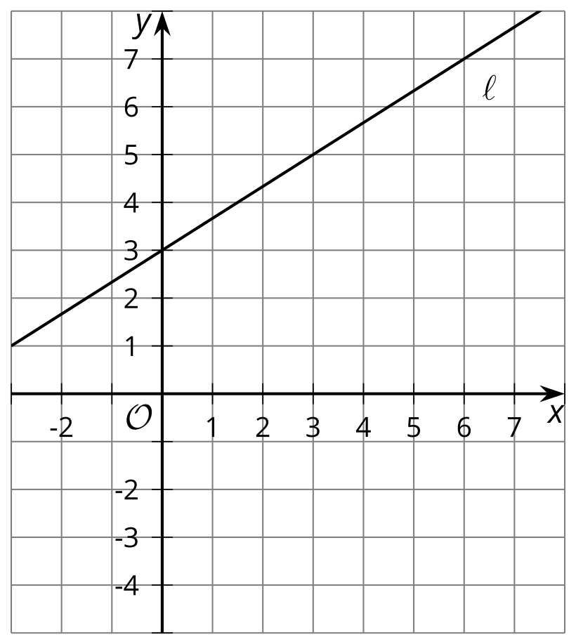
- (From Unit 6, Lesson 12.)
- The line shown is rotated 90 degrees clockwise around the origin. What is the slope of its image?
- 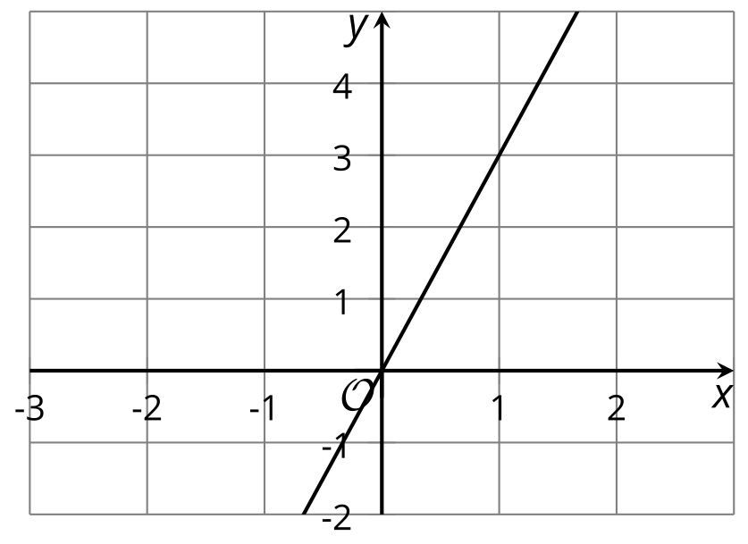
- (From Unit 6, Lesson 11.)
- Elena is writing an explanation on completing the square for circle equations for Diego because he missed class. Here is what Elena wrote:
- “Suppose we want to rewrite an equation in the form ${\left(x−h\right)}^{2}+{\left(y−k\right)}^{2}=r^{2}$. First, move any numbers to the right side and group terms with the same variables together on the left. Second, figure out what must be added to the set of $x$-terms and the set of $y$-terms to create 2 perfect square trinomials. Add those numbers to both the left and right sides of the equation. Next, rewrite the perfect square trinomials as squared binomials, and rewrite the right side in the form $r^{2}$. The center and radius can now be read directly from the equation.”
- Diego is unsure how to determine what needs to be added in order to get 2 perfect square trinomials. Explain how to determine the values.
- (From Unit 6, Lesson 6.)
- The semaphore alphabet is a way to use flags to signal messages. Here's how to signal the letter U. Describe a transformation that would take the left hand flag to the right hand flag.

- U
- 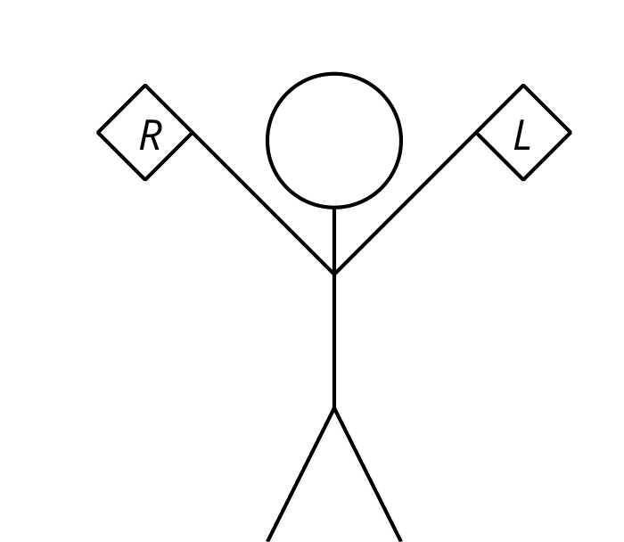
- (From Unit 1, Lesson 13.)
© CC BY 2019 by Illustrative Mathematics®

