Unit 2 Lesson 10 Cumulative Practice Problems
- Of the three lines in the graph, one has slope 1, one has slope 2, and one has slope $\frac{1}{5}.$ Label each line with its slope.
- 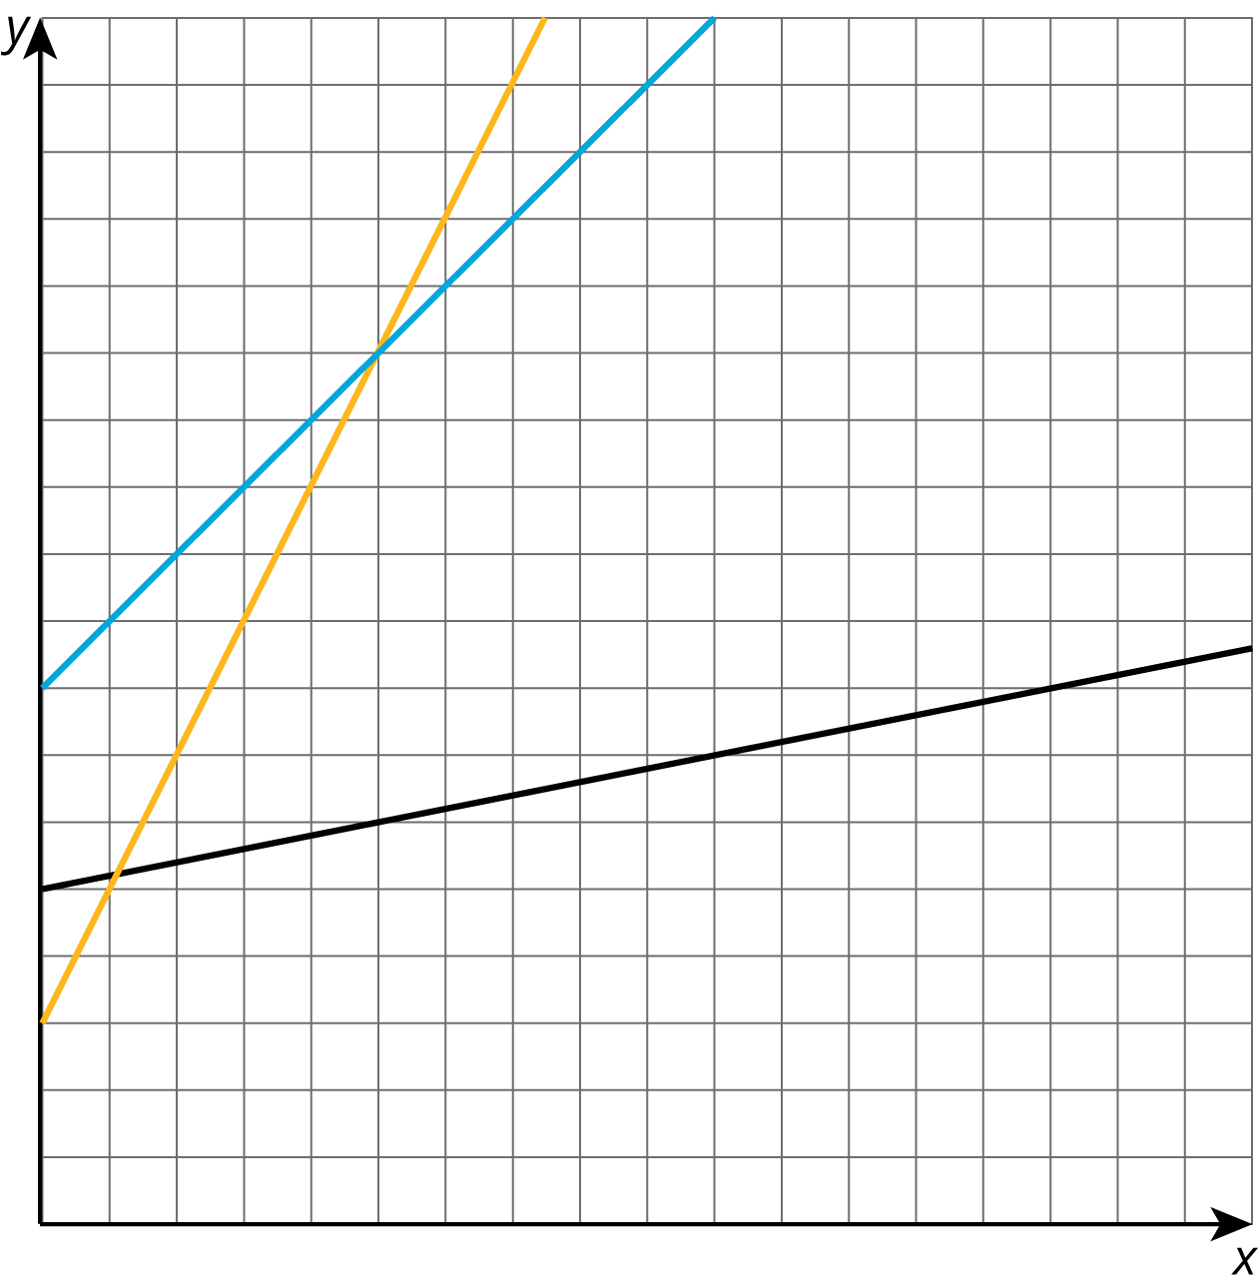
- Draw three lines with slope 2, and three lines with slope $\frac{1}{3}$. What do you notice?
- The figure shows two right triangles, each with its longest side on the same line.
- 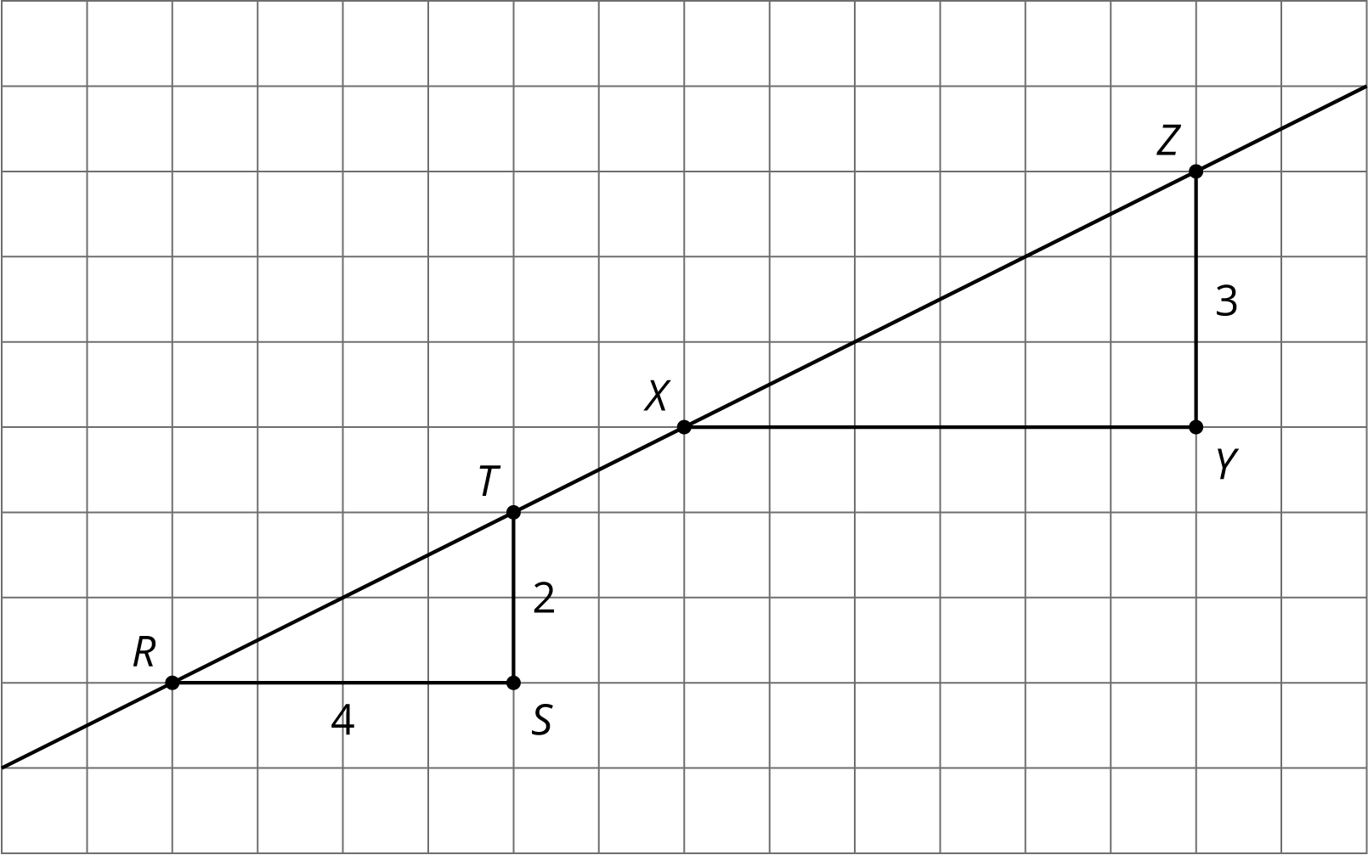
  - Explain how you know the two triangles are similar.
  - How long is $XY$?
  - For each triangle, calculate (vertical side) $÷$ (horizontal side).
  - What is the slope of the line? Explain how you know.
- Triangle $A$ has side lengths 3, 4, and 5. Triangle $B$ has side lengths 6, 7, and 8.
  - Explain how you know that Triangle $B$ is not similar to Triangle $A$.
  - Give possible side lengths for Triangle $B$ so that it is similar to Triangle $A$.
- (From Unit 2, Lesson 9.)
© CC BY Open Up Resources. Adaptations CC BY IM.

