Lesson 8: Add and Subtract Fractions

Standards Alignments
Addressing | 5.NF.A.1

Teacher-facing Learning Goals
- Add and subtract fractions with unlike denominators in a way that makes sense to them.

Student-facing Learning Goals
- Let’s add and subtract fractions.

Lesson Purpose
The purpose of this lesson is for students to add fractions with unlike denominators in a way that makes sense to them.
In this lesson, students add and subtract fractions in a way that makes sense to them. They consider several important cases:
- The denominators of the two fractions are the same, which is review of work from a previous grade.
- One denominator is a multiple of the other so the fractions can be added by replacing only one of the fractions with an equivalent fraction.
- Neither denominator is a multiple of the other so a third new common denominator is needed to add the fractions.
Students describe how the situations are different and find the sums and differences in a way that makes sense to them. The denominators of the fractions used in this lesson are familiar from grade 3, inviting students to use a variety of different familiar representations.

Access for:

Students with Disabilities
- Action and Expression (Activity 2)

English Learners
- MLR8 (Activity 1)

Instructional Routines
5 Practices (Activity 2), Which One Doesn’t Belong? (Warm-up)

Materials to Copy
- Fraction Add and Subtract Sort (groups of 2): Activity 1

Lesson Timeline
Warm-up | 10 min
Activity 1 | 15 min
Activity 2 | 20 min
Lesson Synthesis | 10 min
Cool-down | 5 min

Teacher Reflection Question
Which students had opportunities to share their diagrams and thinking during whole-class discussion? How did you select these students?

Cool-down
(to be completed at the end of the lesson) 5min
Sum of Fractions

Standards Alignments
Addressing | 5.NF.A.1

Student-facing Task Statement
Find the value of each expression. Explain or show your reasoning.
- $\frac{5}{6}−\frac{1}{3}$
- $\frac{3}{4}+\frac{1}{2}$

Student Responses
- $\frac{3}{6}$ or $\frac{1}{2}$. Sample response:
- 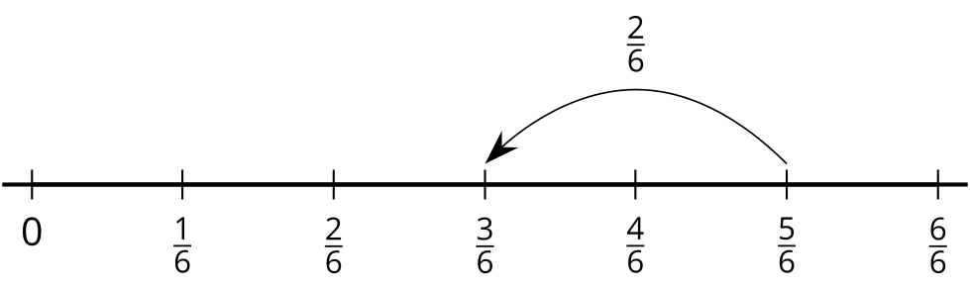
- 1$\frac{1}{4}$ or $\frac{5}{4}$. Sample response: I know that $\frac{3}{4}$ = $\frac{1}{2}+\frac{1}{4}$ so I added the two halves to make 1 and then I added $\frac{1}{4}$.

