Lesson 1: Add Tens or Ones
- Let’s add tens or ones to two-digit numbers.

Warm-up: How Many Do You See: 10-frames
How many do you see?
How do you see them?
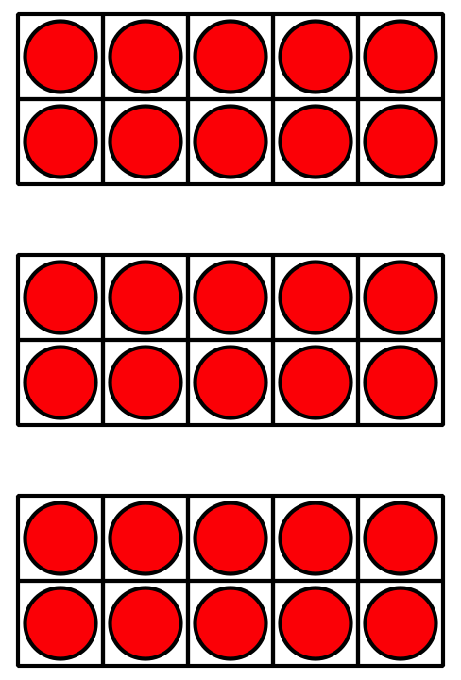
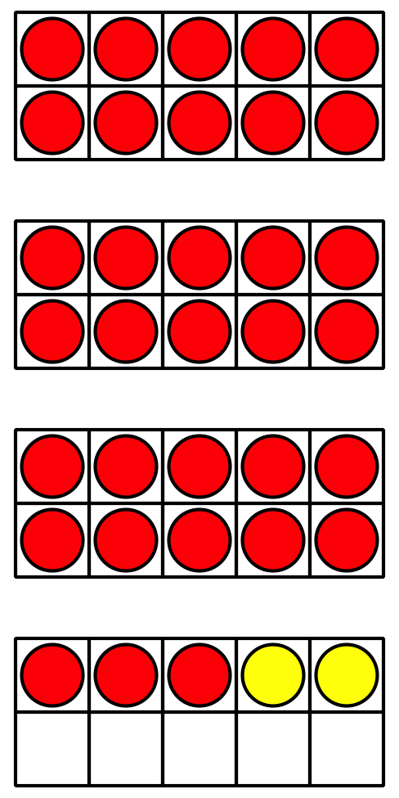
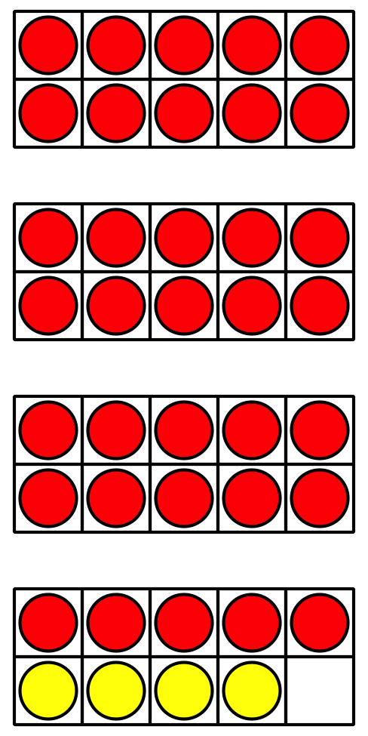

1.1: What Did I Add?
- Partner A: Spin to get a starting number.
- 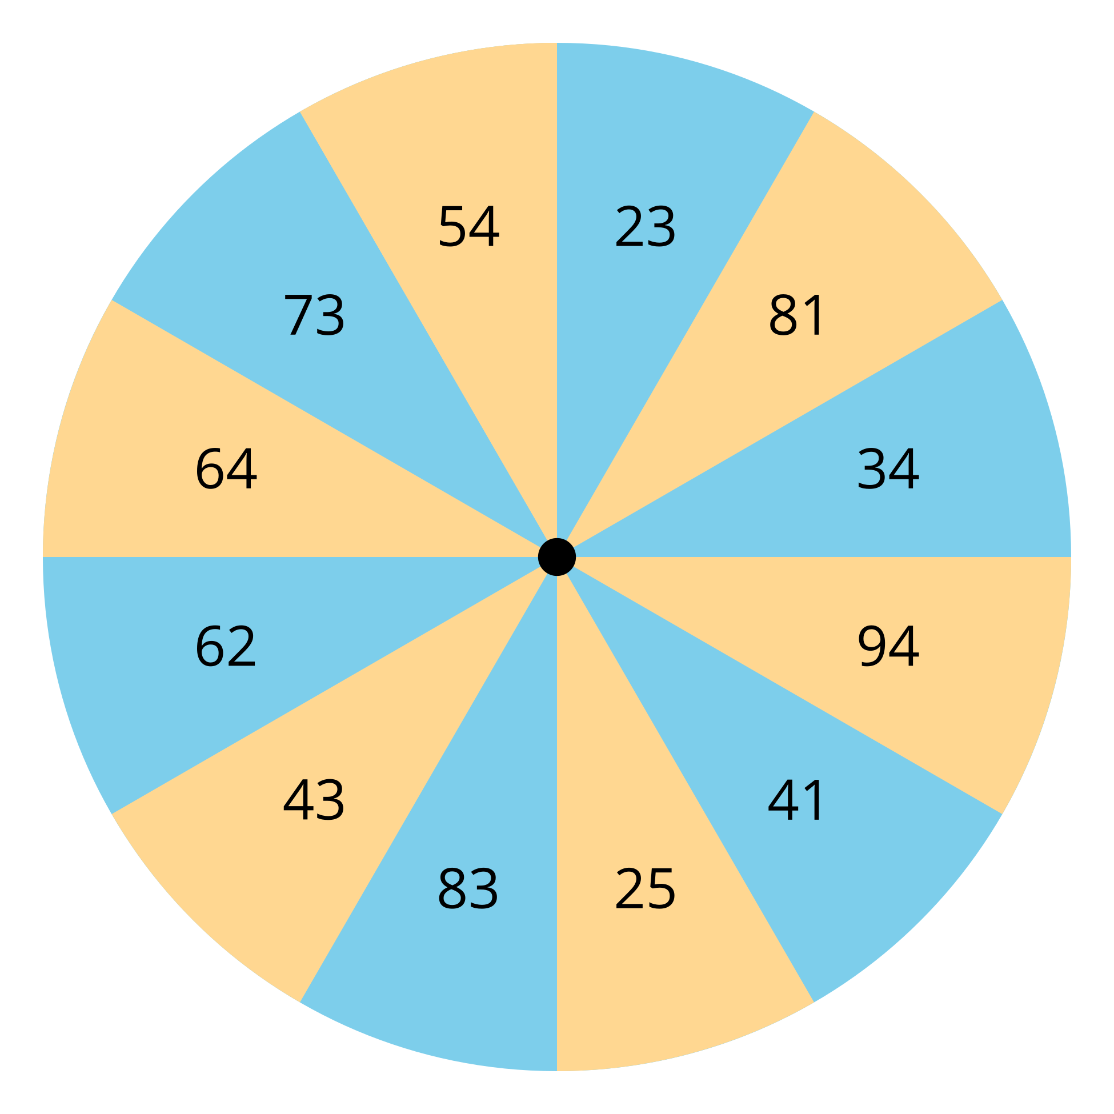
- Partner B: Pick a number card without showing your partner. Choose whether to add that many ones or tens to your starting number. Make sure you don't go over 100. Tell your partner the sum.
- Partner A: Tell your partner what number you think they added and explain your thinking.
- Switch roles and repeat.

1.2: Add Tens or Ones
Find the number that makes each equation true.

  - 43+5=aaaiaaai
  - 43+50=aaaiaaai

  - 51+3=aaaiaaai
  - 51+30=aaaiaaai

  - 2+75=aaaiaaai
  - 20+75=aaaiaaai
- 93+6=aaaiaaai
- Show your thinking using drawings, numbers, or words.
- 60+28=aaaiaaai
- Show your thinking using drawings, numbers, or words.
- 5+74=aaaiaaai
- Show your thinking using drawings, numbers, or words.
© CC BY 2021 Illustrative Mathematics®

