Lesson 5: Patterns with Even and Odd Numbers
- Let’s look for patterns with even and odd numbers.

Warm-up: How Many Do You See: Even or Odd
How many do you see? How do you see them?
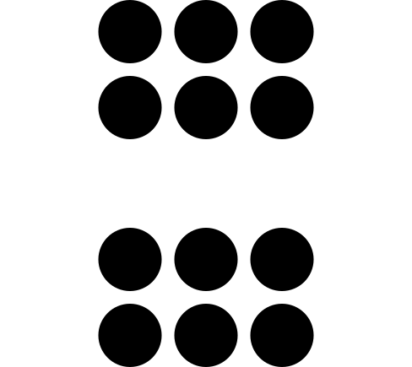
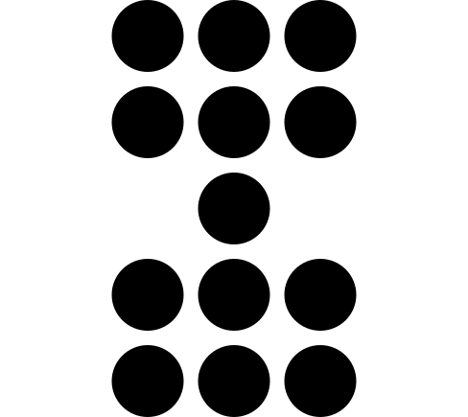
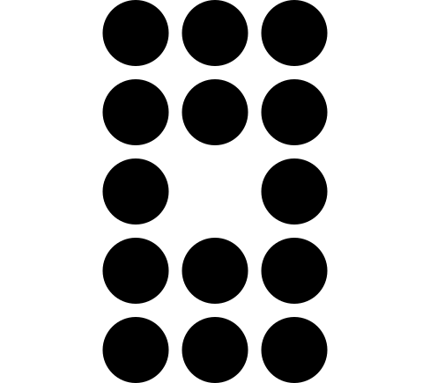

5.1: Even and Odd Round-about
What did you notice? What do you wonder?

5.2: Presto Chango
- In the first column of your recording sheet, decide whether each student has an even or odd number of counters. Show your reasoning and circle your choice.
- Complete the gray column. Does adding 1 change whether the number of counters is even or odd? Explain.
- Complete the last column. Does adding 2 change whether the number of counters is even or odd? Explain.
© CC BY 2021 Illustrative Mathematics®

