Unit 3 Lesson 9: Subtraction Algorithms (Part 2)

WU True or False: Does It Commute? (Warm up)

Student Task Statement
Decide if each statement is true or false. Be prepared to explain your reasoning.
- $4×5=5×4$
- $125+200=200+125$
- $300−100=100−300$

1 Revise Subtraction Work

Student Task Statement
Lin’s work for finding the value of $428−156$ is shown.
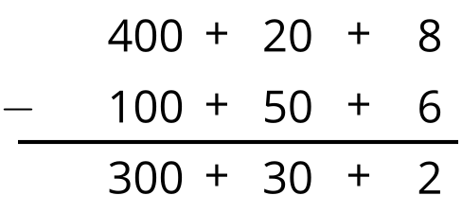
- What error do you see in Lin's work?
- What would you tell or show Lin so she can revise her work?

Activity Synthesis
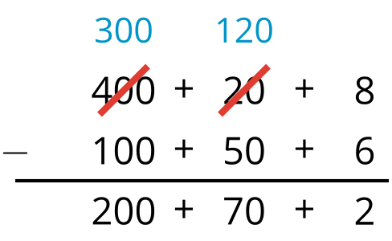

2 Try the Algorithm

Student Task Statement
Here is a subtraction algorithm you saw in an earlier lesson:
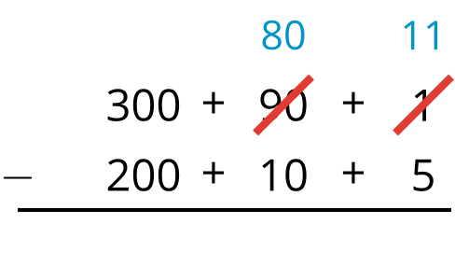
Try using this algorithm to find the value of each difference. Show your reasoning. Organize it so it can be followed by others.
- $283−159$
- $425−192$
- $639−465$
- $591−128$
- $832−575$

Images for Activity Synthesis
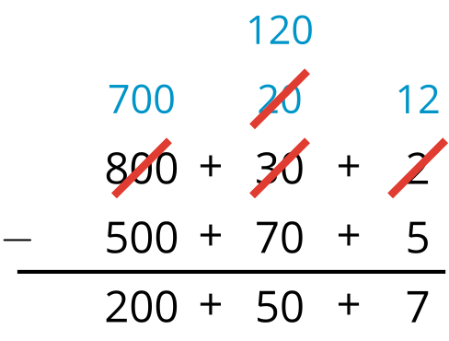
© CC BY 2021 Illustrative Mathematics®

