Lesson 8: Ten as a Unit
- Let's explore teen numbers.

Warm-up: Which One Doesn’t Belong: Groups of 10
Which one doesn’t belong?
A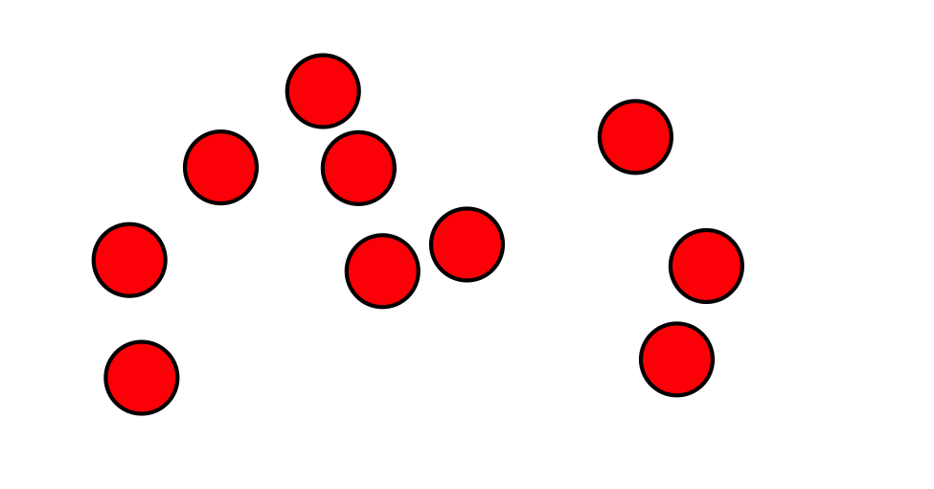
B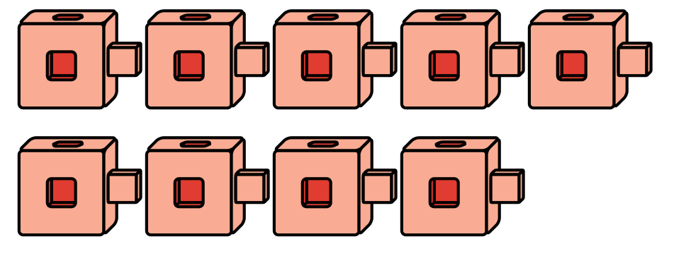
C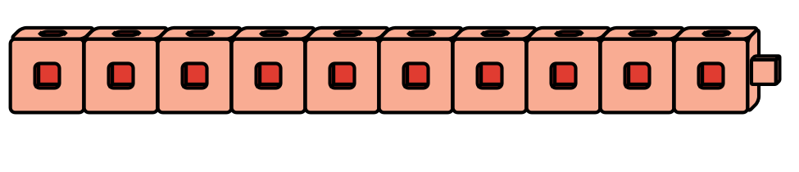
D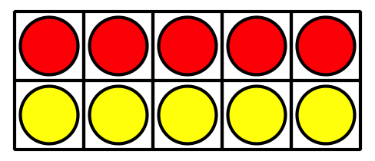

8.2: Building Teen Numbers
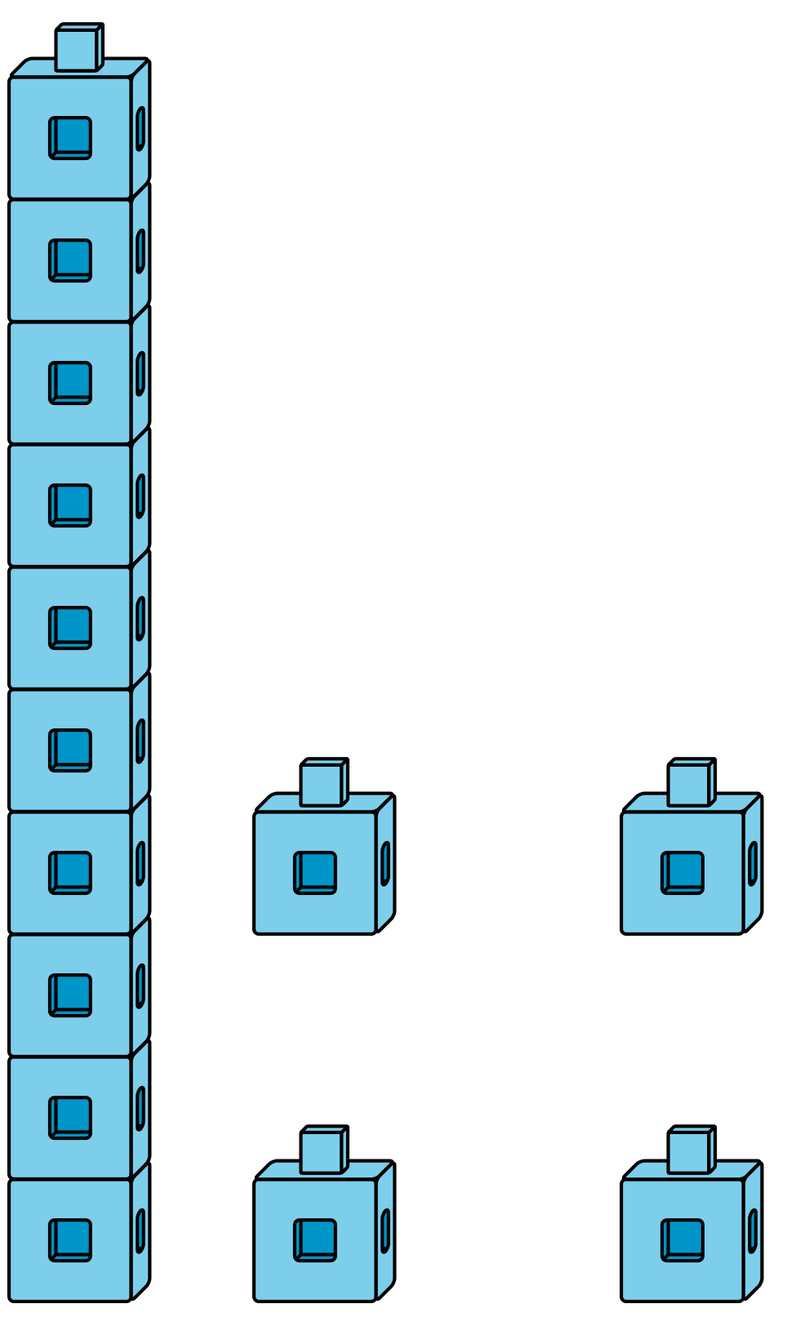
Choose 4 numbers to represent.
Circle them.
10
11
12
13
14
15
16
17
18
19
Use connecting cubes to show each number like Clare did.
What did you notice as you were showing each number?
© CC BY 2021 Illustrative Mathematics®

