Unit 6 Lesson 21: Combining Like Terms (Part 2)

1 True or False? (Warm up)

Student Task Statement
Select all the statements that are true. Be prepared to explain your reasoning.
- $4−2\left(3+7\right)=4−2⋅3−2⋅7$
- $4−2\left(3+7\right)=4+\text{-}2⋅3+\text{-}2⋅7$
- $4−2\left(3+7\right)=4−2⋅3+2⋅7$
- $4−2\left(3+7\right)=4−\left(2⋅3+2⋅7\right)$

2 Seeing it Differently

Student Task Statement
Some students are trying to write an expression with fewer terms that is equivalent to $8−3\left(4−9x\right)$.
Noah says, “I worked the problem from left to right and ended up with $20−45x$.”
$8−3\left(4−9x\right)$
$5\left(4−9x\right)$
$20−45x$
Lin says, “I started inside the parentheses and ended up with $23x$.”
$8−3\left(4−9x\right)$
$8−3\left(\text{-}5x\right)$
$8+15x$
$23x$
Jada says, “I used the distributive property and ended up with $27x−4$.”
$8−3\left(4−9x\right)$
$8−\left(12−27x\right)$
$8−12−\left(\text{-}27x\right)$
$27x−4$
Andre says, “I also used the distributive property, but I ended up with $\text{-}4−27x$.”
$8−3\left(4−9x\right)$
$8−12−27x$
$\text{-}4−27x$
- Do you agree with any of them? Explain your reasoning.
- For each strategy that you disagree with, find and describe the errors.

Activity Synthesis
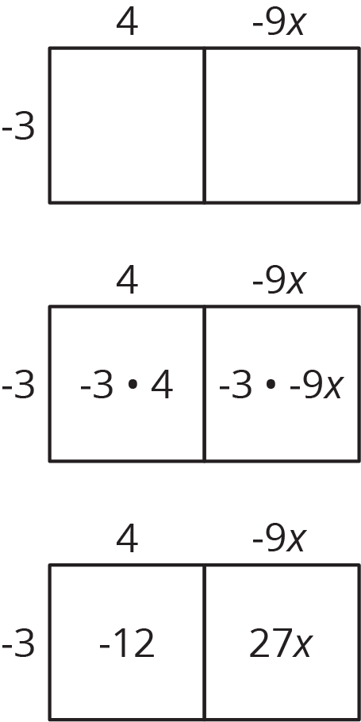

3 Grouping Differently

Student Task Statement
Diego was taking a math quiz. There was a question on the quiz that had the expression $8x−9−12x+5$. Diego’s teacher told the class there was a typo and the expression was supposed to have one set of parentheses in it.
- Where could you put parentheses in $8x−9−12x+5$ to make a new expression that is still equivalent to the original expression? How do you know that your new expression is equivalent?
- Where could you put parentheses in $8x−9−12x+5$ to make a new expression that is not equivalent to the original expression? List as many different answers as you can.
© CC BY Open Up Resources. Adaptations CC BY IM.

