Lesson 9 Practice Problems
- Priya collected 2,400 grams of pennies in a fundraiser. Each penny has a mass of 2.5 grams. How much money did Priya raise? If you get stuck, consider using the table.
- number of pennies | - mass in grams
- 1 | - 2.5
 | - 2,400
- Kiran reads 5 pages in 20 minutes. He spends the same amount of time per page. How long will it take him to read 11 pages? If you get stuck, consider using the table.
- time in minutes | - number of pages
- 20 | - 5
 | - 1
 | - 11
- Mai is making personal pizzas. For 4 pizzas, she uses 10 ounces of cheese.
- number of pizzas | - ounces of cheese
- 4 | - 10
- a. How much cheese does Mai use per pizza?
- b. At this rate, how much cheese will she need to make 15 pizzas?
- Clare is paid $90 for 5 hours of work. At this rate, how many seconds does it take for her to earn 25 cents?
- A car that travels 20 miles in $\frac{1}{2}$ hour at constant speed is traveling at the same speed as a car that travels 30 miles in $\frac{3}{4}$ hour at a constant speed. Explain or show why.
- (From Unit 2, Lesson 7.)
- Lin makes her favorite juice blend by mixing cranberry juice with apple juice in the ratio shown on the double number line. Complete the diagram to show smaller and larger batches that would taste the same as Lin's favorite blend.
- 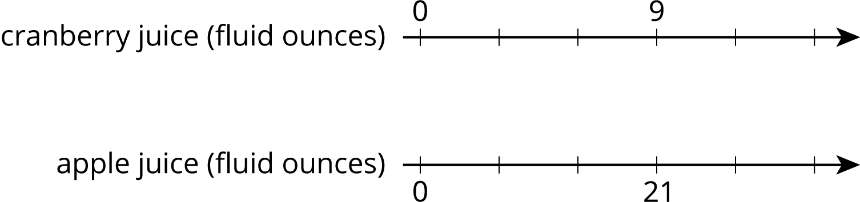
- (From Unit 2, Lesson 4.)
- Each of these is a pair of equivalent ratios. For each pair, explain why they are equivalent ratios or draw a representation that shows why they are equivalent ratios.
  - $600:450$ and $60:45$
  - $60:45$ and $4:3$
  - $600:450$ and $4:3$
- (From Unit 2, Lesson 3.)
© CC BY Open Up Resources. Adaptations CC BY IM.

