Unit 2 Lesson 12: Connecting Situations and Graphs

1 Notice and Wonder: Snacks for Sale (Warm up)

Student Task Statement
What do you notice? What do you wonder?
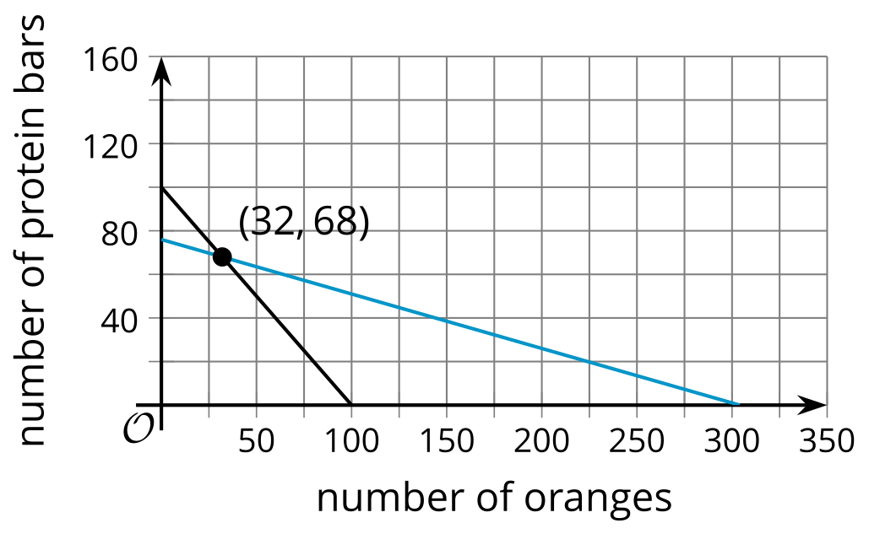
A club is selling snacks at a track meet. Oranges cost $1 each and protein bars cost $4 each. They sell a total of 100 items, and collect $304.

2 Matching Graphs to Situations

Student Task Statement

D
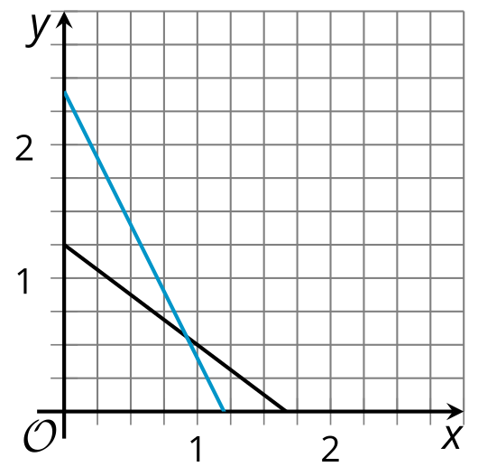

E
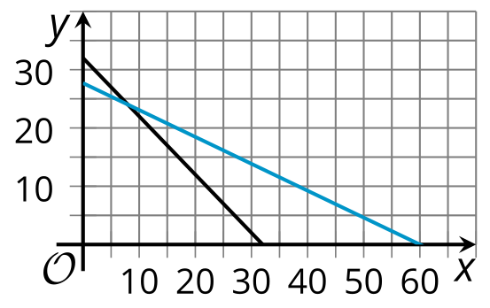

F
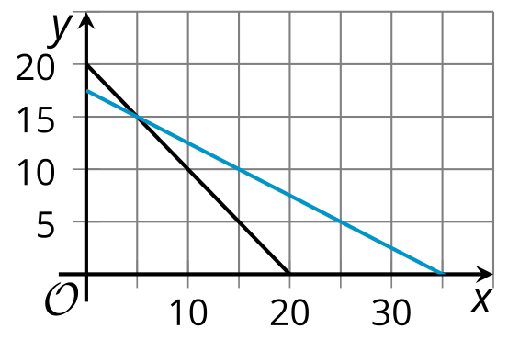
- Match each pair of graphs to a situation.
  - A restaurant has a total of 20 tables—round tables that seat 2 people and rectangular tables that seat 4 people. All 70 seats in the restaurant are occupied.
  - A family buys a total of 32 tickets at a carnival. Ride tickets cost $1.50 each and food tickets cost $3.25 each. The family pays a total of $90 for the tickets.
  - Tyler and Andre are shopping for snacks in bulk at the grocery store. Tyler pays $10 for 6 ounces of almonds and 8 ounces of raisins. Andre pays $12 for 10 ounces of almonds and 5 ounces of raisins.
- Answer these questions about each situation:
  - What do $x$ and $y$ represent in the situation?
  - At what point do the graphs intersect? What do the coordinates mean in this situation?

3 Ride Sharing Among Friends

Student Task Statement
A ride sharing company offers two options: riding in small cars that can carry up to 3 passengers each, or riding in large vans that can carry up to 6 passengers each. A group of 27 people is going to use the ride sharing service to take a trip. The trip in a small car costs $10 and the trip in a large van costs $15. The group ends up spending $80 total.
- An equation that represents one of the constraints is $3x+6y=a$.
  - What is the value of $a$?
  - What do $x$ and $y$ represent?
- An equation that represents the other constraint is $cx+15y=80$. What is the value of $c$?
- 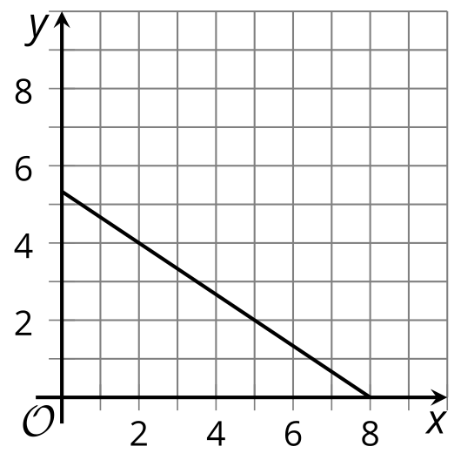
- Here is a graph that represents one of the constraints. Which one? Explain how you know.
- Sketch another line on the graph that represents the other constraint.
- For each coordinate pair, describe its meaning in the situation and decide whether it satisfies the constraint on total number of people, the constraint on cost, or neither.
  - $\left(2,4\right)$
  - $\left(1,4\right)$
  - $\left(3,2\right)$
- At what point do the two lines intersect? What does this point mean in this situation?

Activity Synthesis
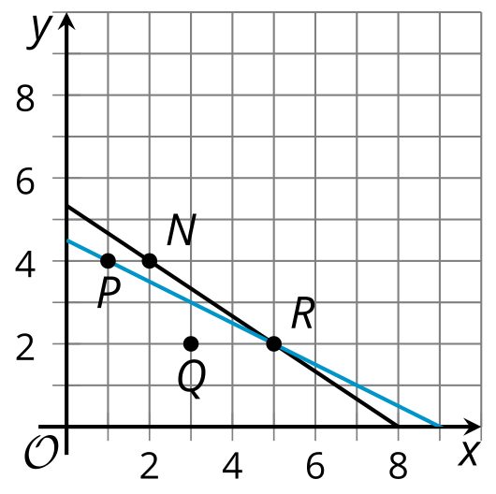
© CC BY 2019 by Illustrative Mathematics®

