Unit 4 Lesson 8: Sine and Cosine in the Same Right Triangle

1 Which One Doesn’t Belong: Four Triangles (Warm up)

Student Task Statement
Which one doesn’t belong?

A
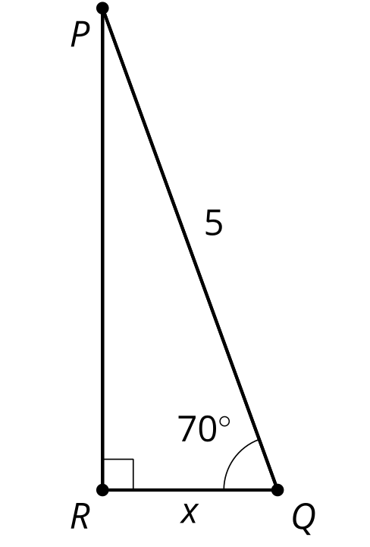

B
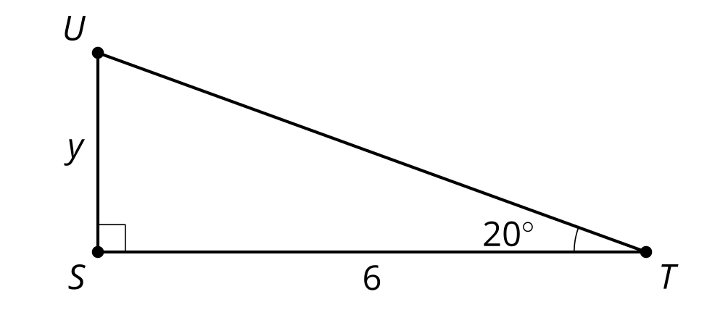

C
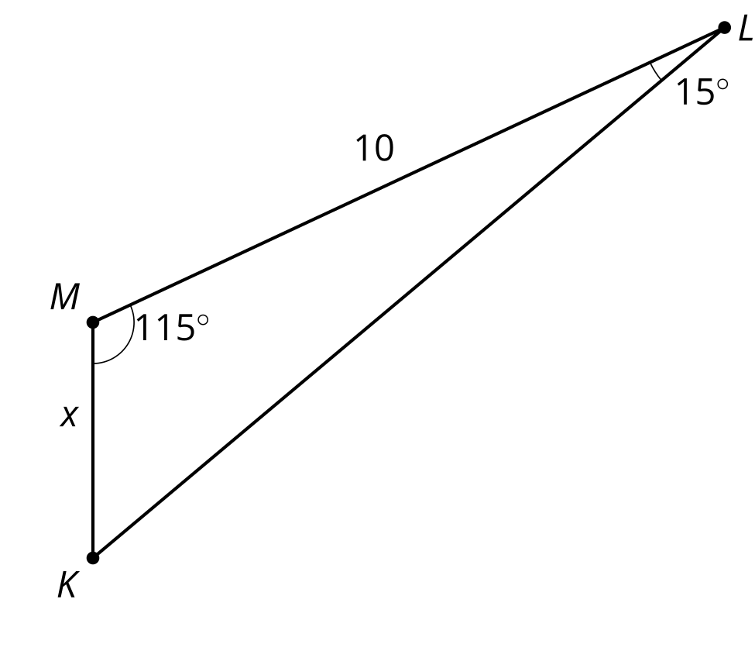

D
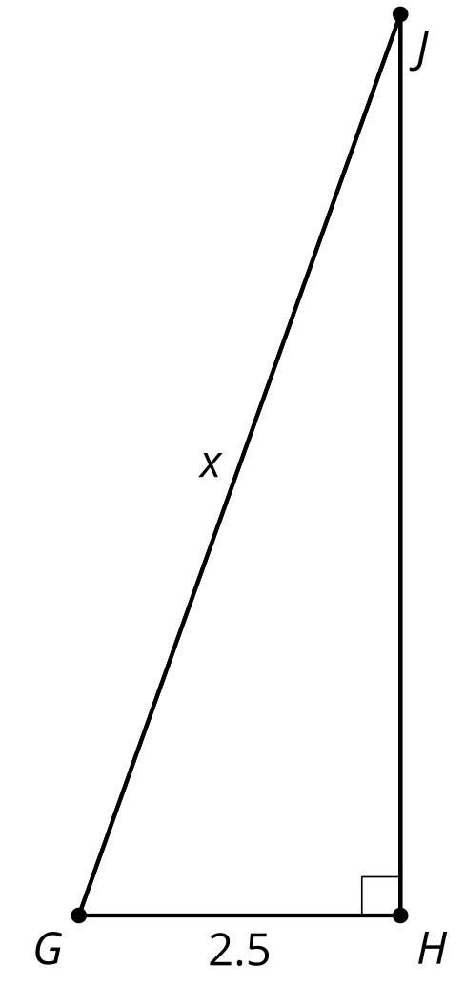

2 Twin Triangles

Student Task Statement
Your teacher will assign you to either Column A or Column B. Find the value of the variable for the problems in your column.
Column A:
Column B:

A1
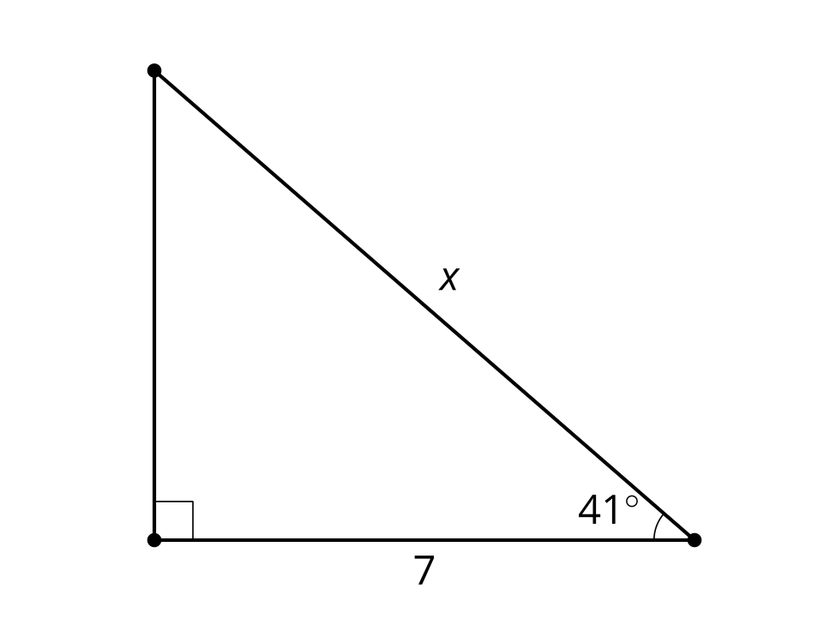

B1
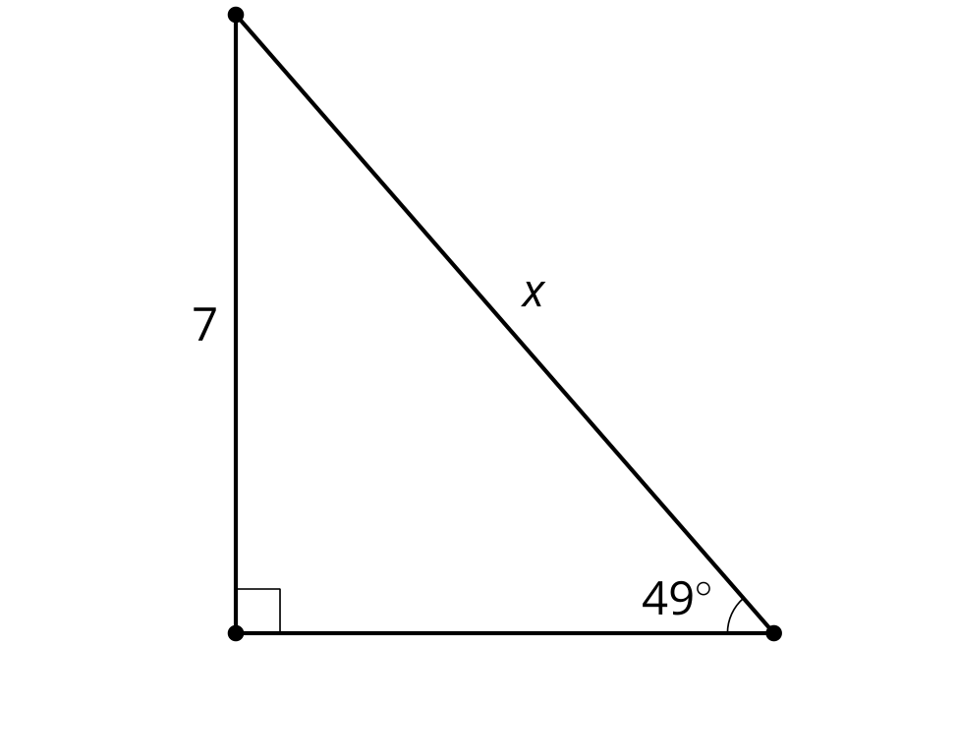

A2
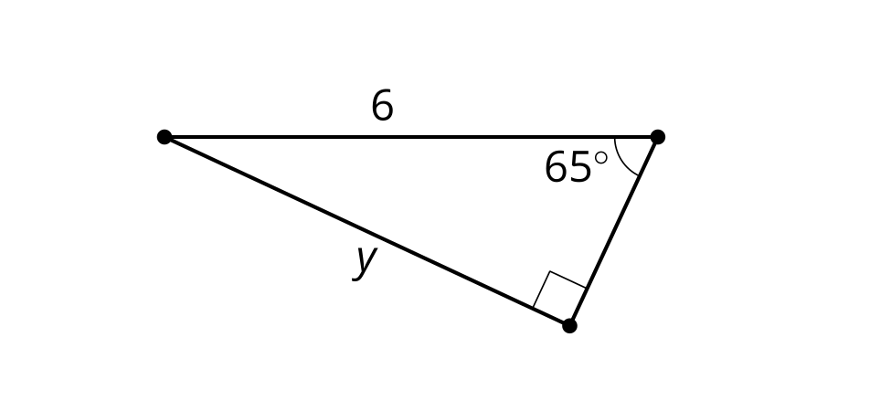

B2
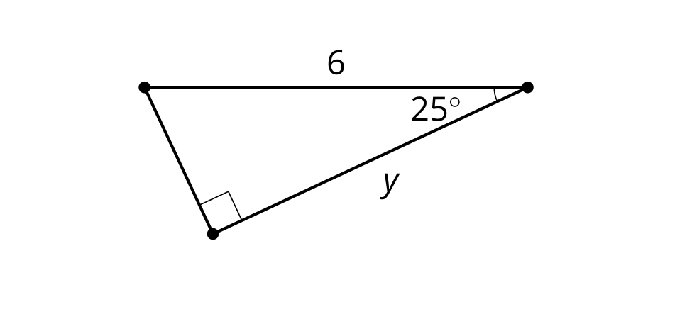

A3
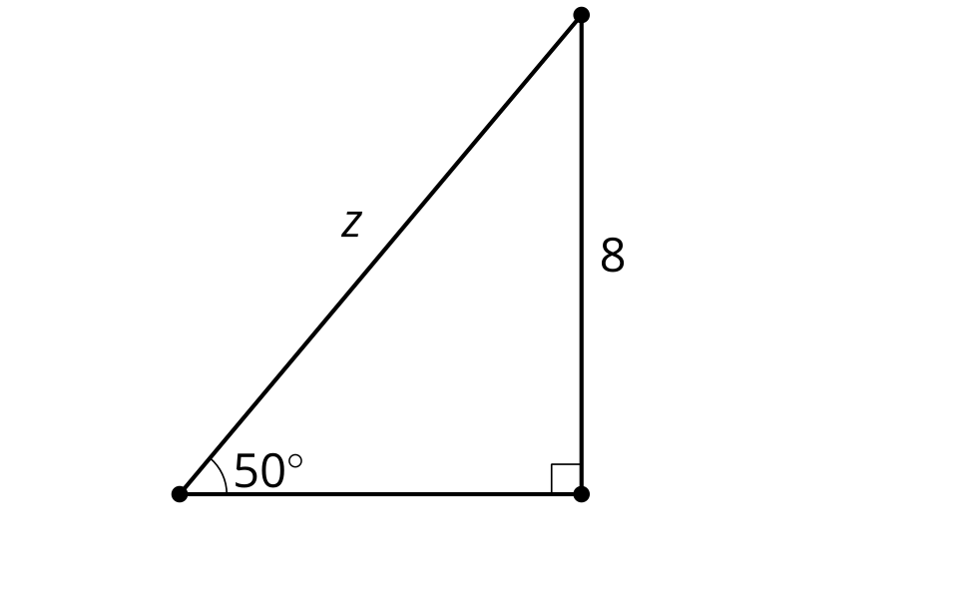

B3
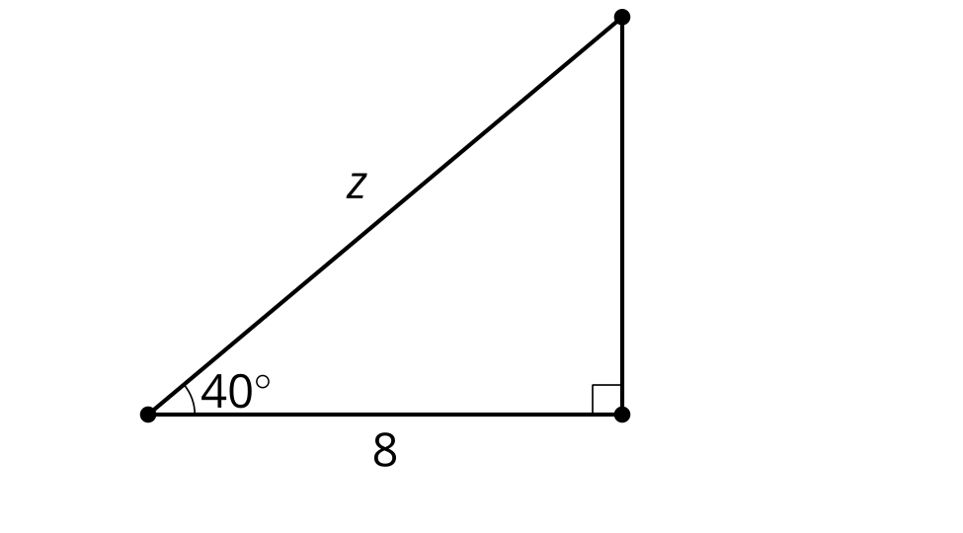
Compare your solutions with your group's solutions. Why did you get the same answers to different problems?

3 Explain the Co-nnection

Student Task Statement
- Draw a diagram that will help you explain why $sin\left(θ\right)=cos\left(90−θ\right)$.
- Explain why $sin\left(θ\right)=cos\left(90−θ\right)$.
Discuss your thinking with your group. If you disagree, work to reach an agreement.
Create a visual display that includes:
- A clearly-labeled diagram.
- An explanation using precise language.

Images for Activity Synthesis
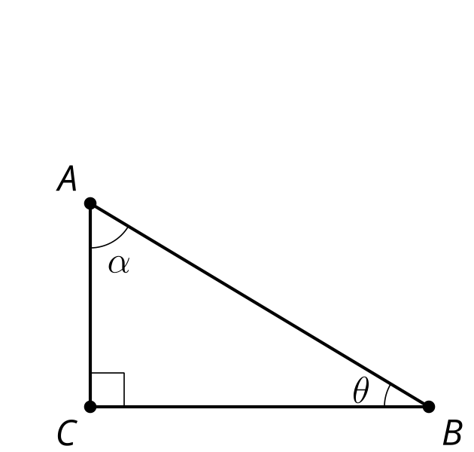
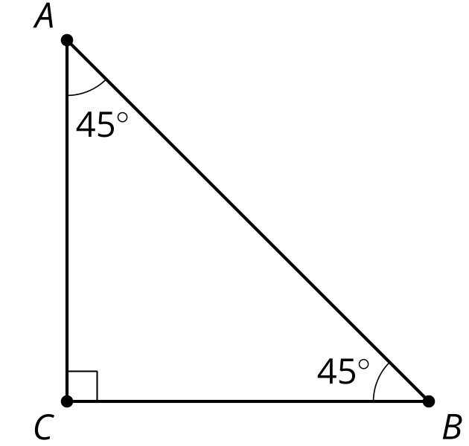
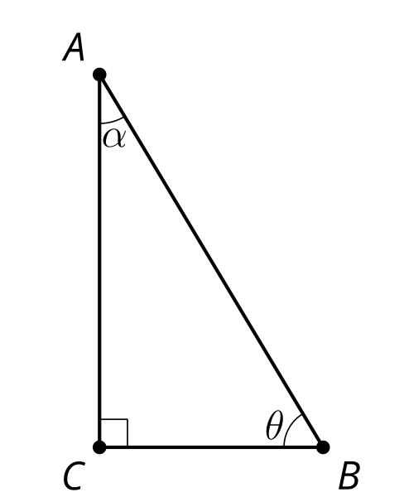
© CC BY 2019 by Illustrative Mathematics®

