Lesson 15 Practice Problems
- Consider the parallelogram with vertices at $\left(0,0\right),\left(4,0\right),\left(2,3\right),$ and $\left(6,3\right)$. Where do the diagonals of this parallelogram intersect?
  - $\left(3,1.5\right)$
  - $\left(4,2\right)$
  - $\left(2,4\right)$
  - $\left(3.5,3\right)$
- What is the midpoint of the line segment with endpoints $\left(1,\text{-}2\right)$ and $\left(9,8\right)$?
  - $\left(3,5\right)$
  - $\left(4,3\right)$
  - $\left(5,3\right)$
  - $\left(5,5\right)$
- Graph the image of triangle $ABC$ under a dilation with center $A$ and scale factor $\frac{2}{3}$.
- 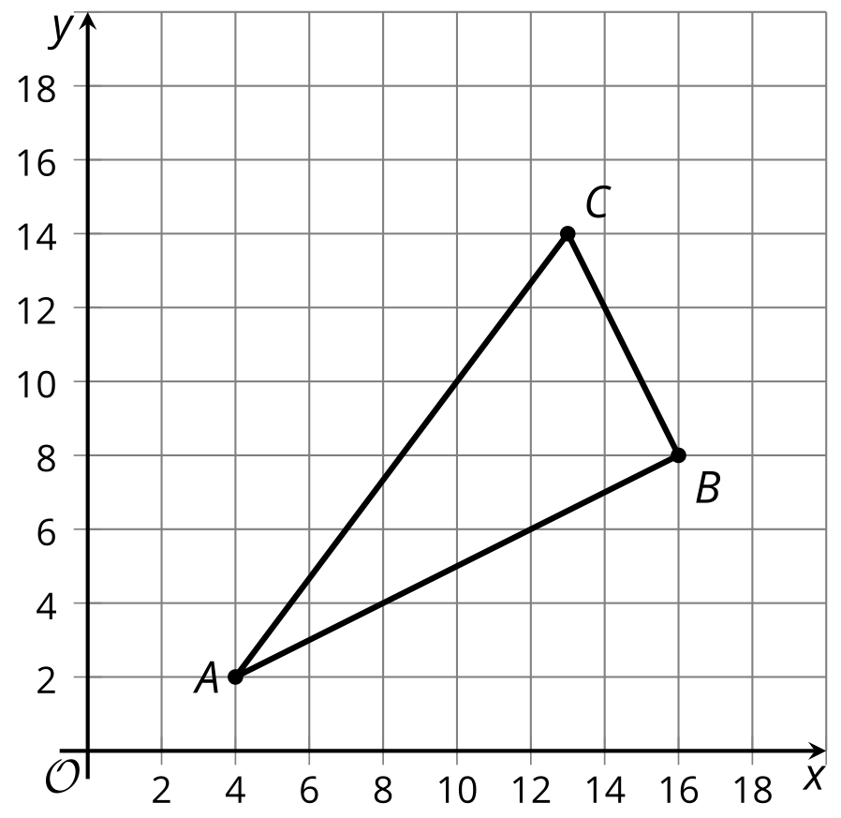
- A quadrilateral has vertices $A=\left(0,0\right),B=\left(2,4\right),C=\left(0,5\right),$ and $D=\left(\text{-}2,1\right)$. Prove that $ABCD$ is a rectangle.
- (From Unit 6, Lesson 14.)
- A quadrilateral has vertices $A=\left(0,0\right),B=\left(1,3\right),C=\left(0,4\right),$ and $D=\left(\text{-}1,1\right)$. Select the most precise classification for quadrilateral $ABCD$.
  - quadrilateral
  - parallelogram
  - rectangle
  - square
- (From Unit 6, Lesson 14.)
- Write an equation whose graph is a line perpendicular to the graph of $x=\text{-}7$ and which passes through the point $\left(\text{-}7,1\right)$.
- (From Unit 6, Lesson 12.)
- Graph the equations ${\left(x+1\right)}^{2}+{\left(y−1\right)}^{2}=64$ and $y=1$. Where do they intersect?
- 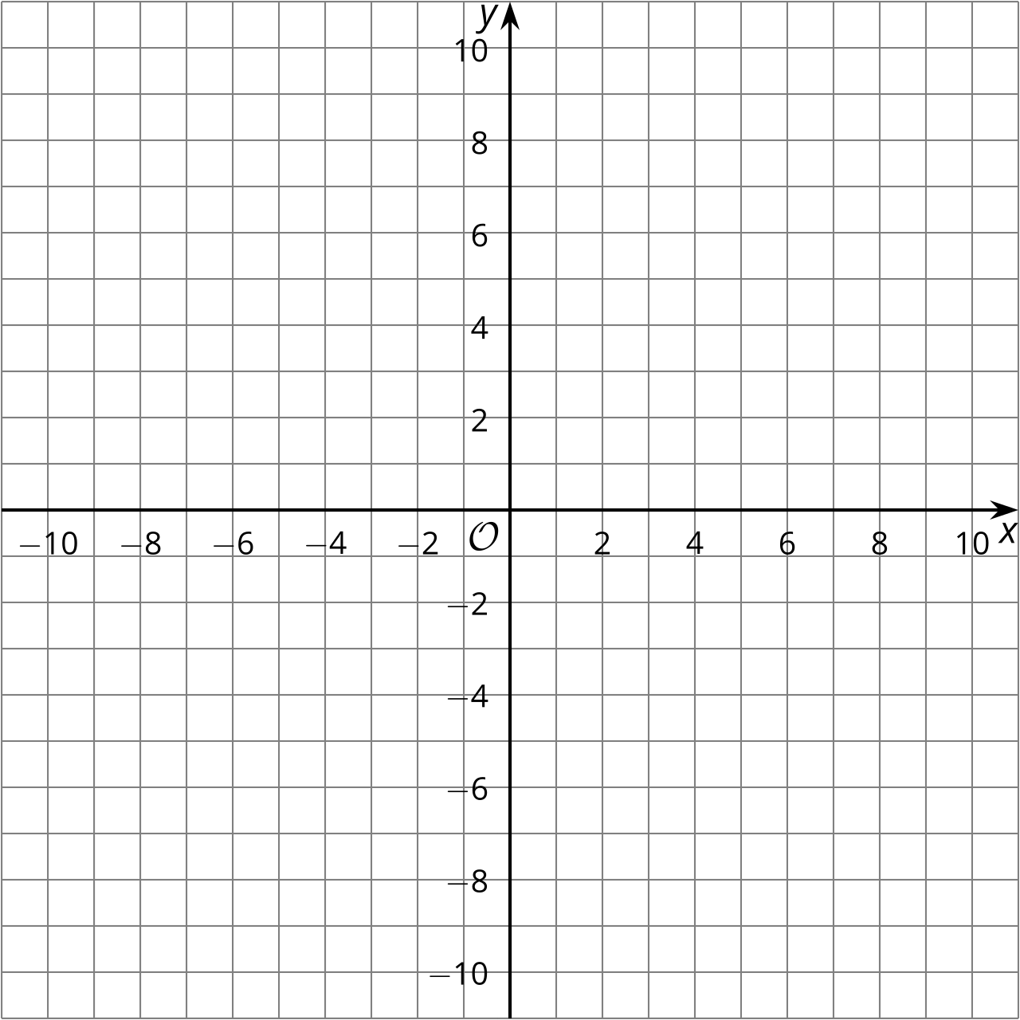
- (From Unit 6, Lesson 13.)
- A parabola has a focus of $\left(2,5\right)$ and a directrix of $y=1$. Decide whether each point on the list is on this parabola. Explain your reasoning.
  - $\left(\text{-}1,5\right)$
  - $\left(2,3\right)$
  - $\left(6,6\right)$
- (From Unit 6, Lesson 7.)
© CC BY 2019 by Illustrative Mathematics®

