Lesson 2: How Did You Add?
- Let’s add numbers and find matching equations.

2.1: Find the Value
Find the value of $23+45$.
Show your thinking using drawings, numbers, or words.

2.2: Elena and Andre Represent $63+25$
- Here are 2 drawings students made for $63+25$.
- Elena's work
- 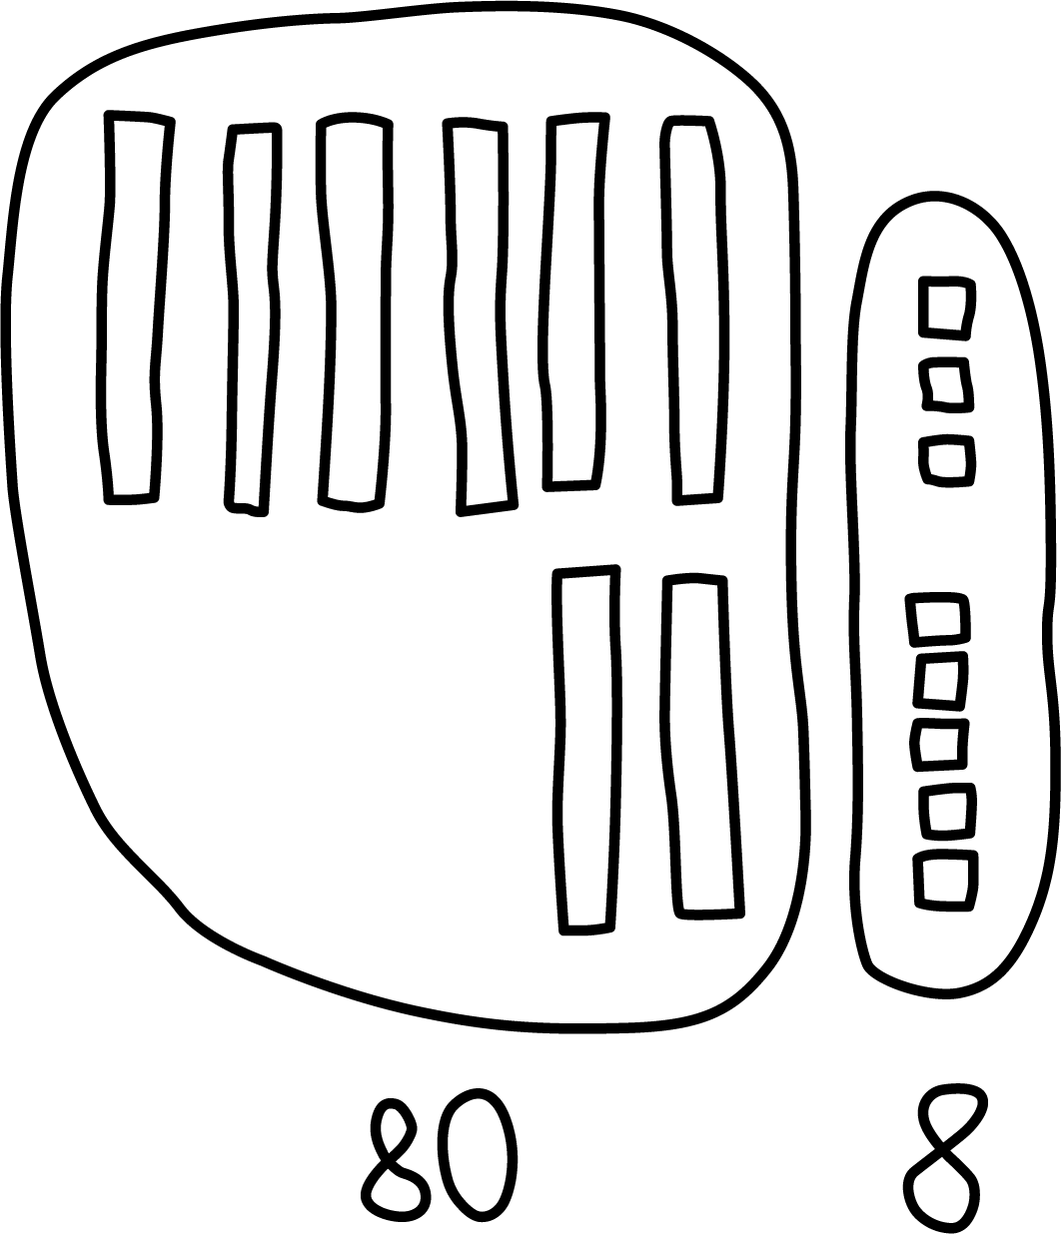
- Andre's work
- 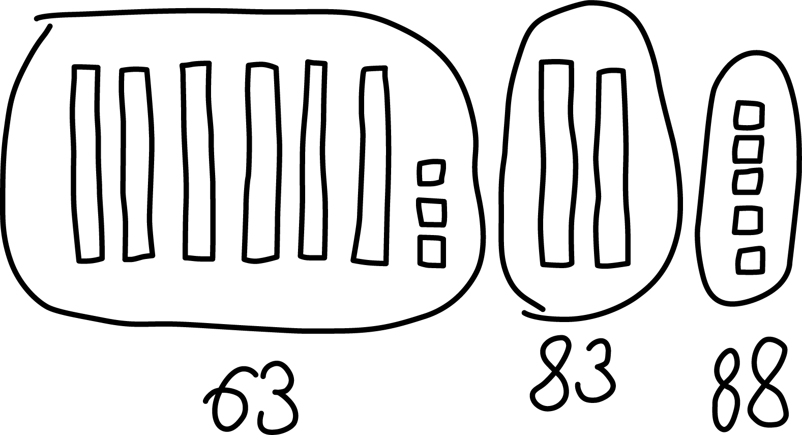
- Which equations go with which drawing?
Be ready to explain your thinking in a way others will understand.
- Set A
$63+20=83$
$83+5=88$
- Set B
$60+20=80$
$3+5=8$
$80+8=88$
© CC BY 2021 Illustrative Mathematics®

