Lesson 6: Center Day 1
- Let’s skip-count and practice addition and subtraction.

Warm-up: Number Talk: Two More
Find the value of each expression mentally.
- $2+2+2$
- $2+2+2+2$
- $2+2+2+2+2$
- $2+2+2+2+2+2$

6.2: Centers: Choice Time
Choose a center.
Write Numbers
Target Numbers
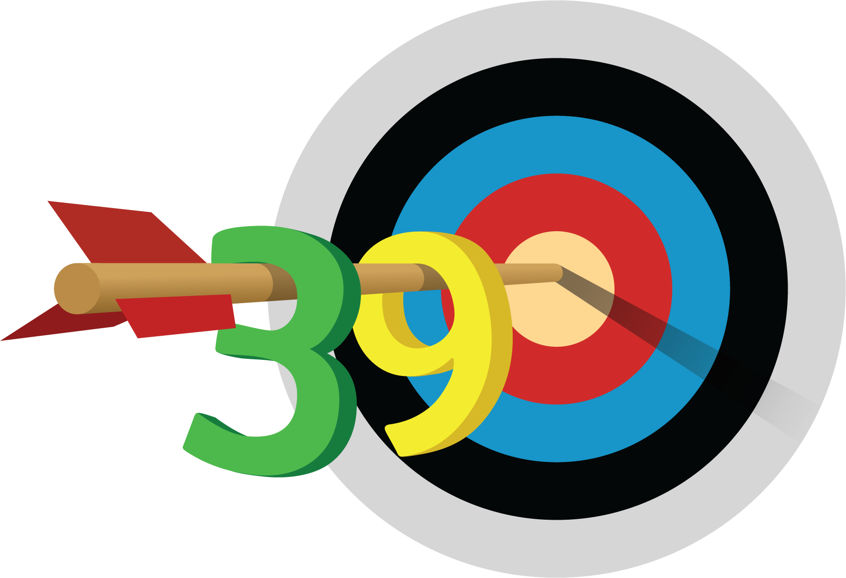
Five in a Row
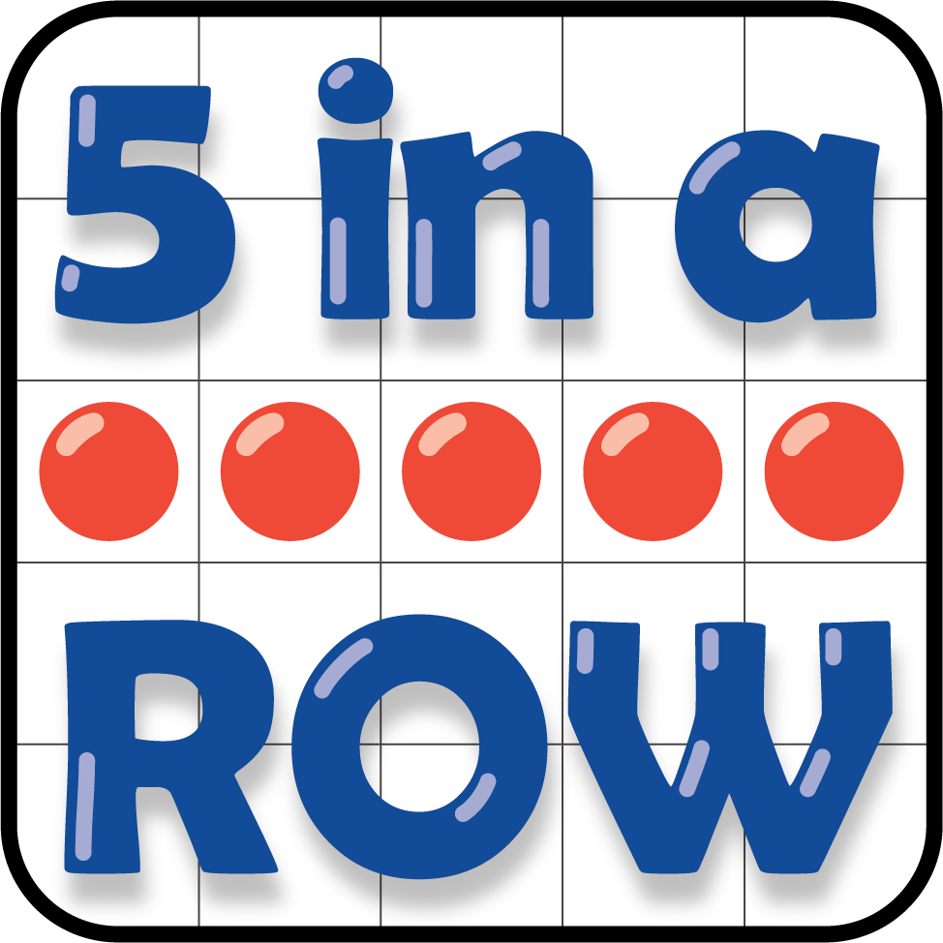
How Close
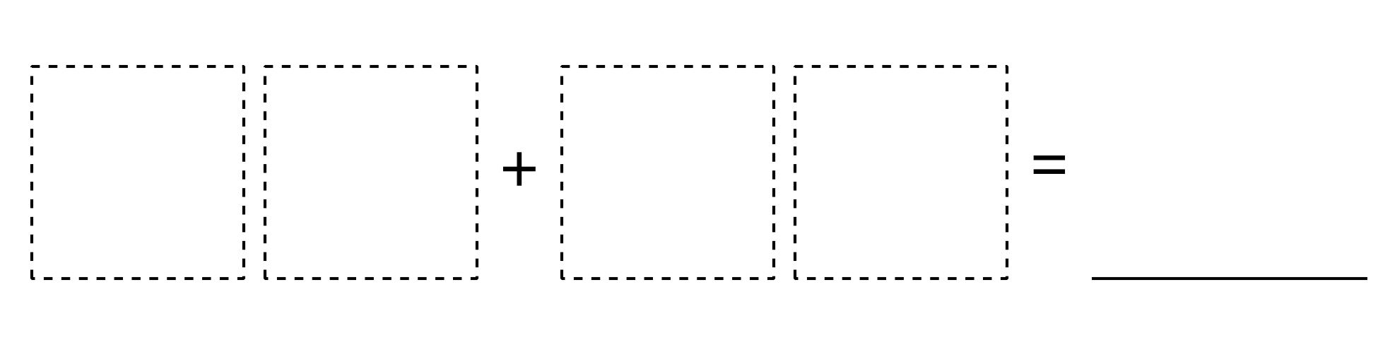
© CC BY 2021 Illustrative Mathematics®

