Lesson 9: Addition With a Ten
- Let's use a ten to make teen numbers.

Warm-up: Notice and Wonder: Teen Numbers
What do you notice?
What do you wonder?
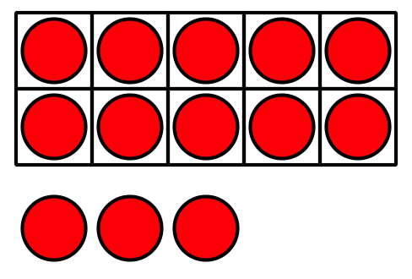
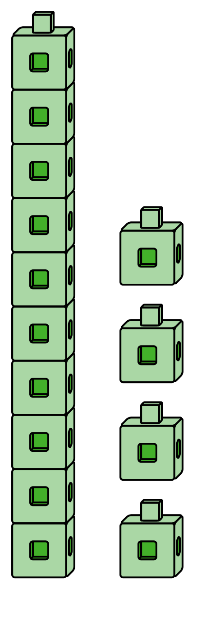

9.1: Make It: Teen Numbers and 10-Frames
Use your 10-frames to build teen numbers.
Write an equation that matches the teen number.
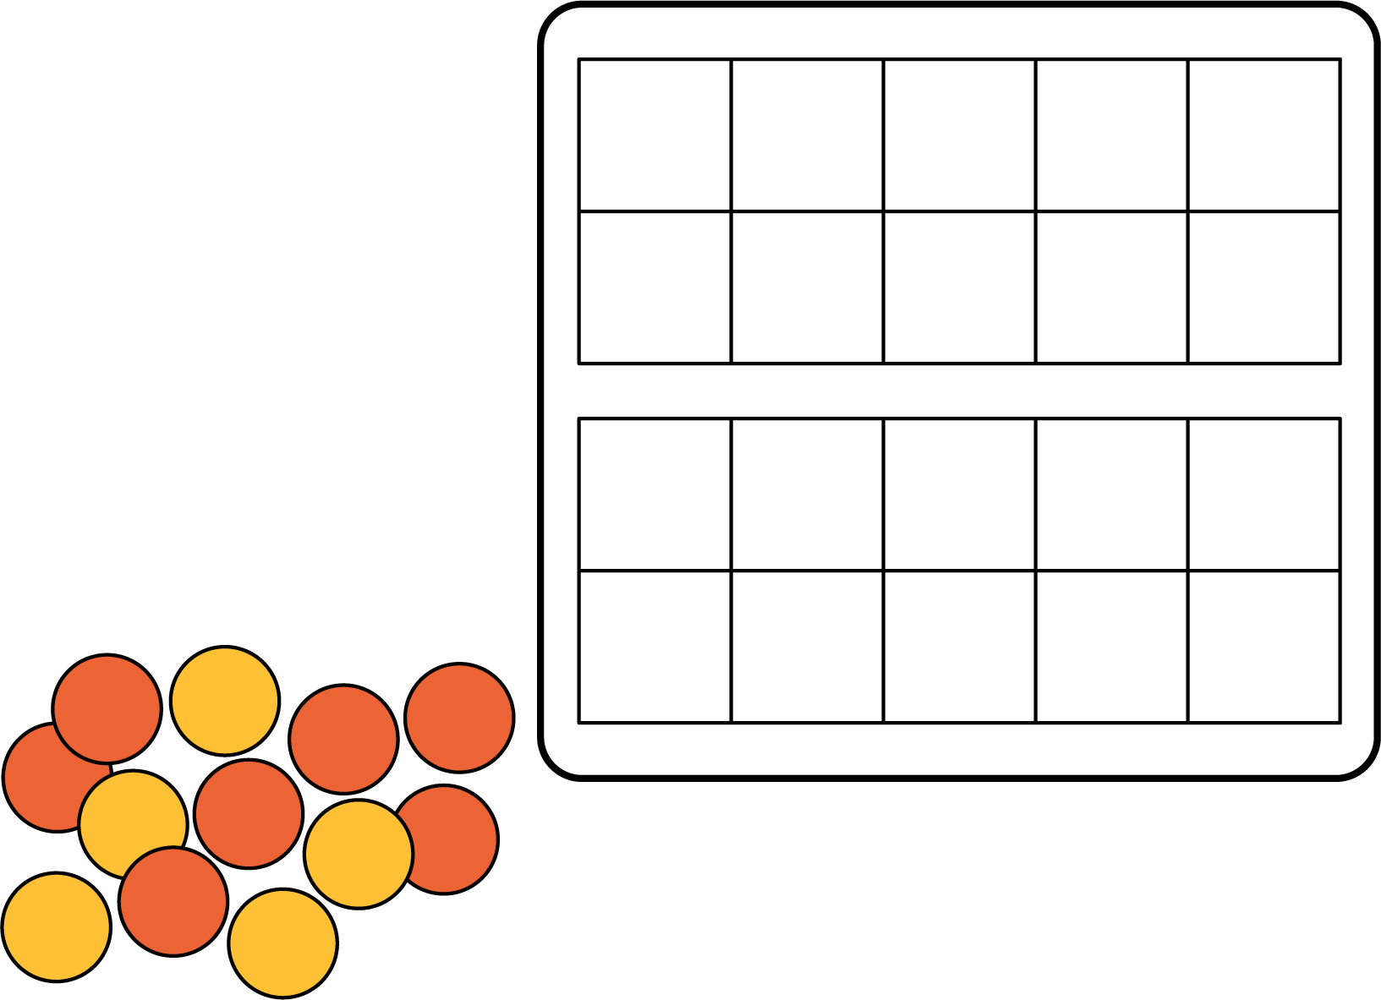
teen number | equation
If you have time, write another equation for each of the teen numbers.

9.2: Equations With a Ten
Find the number that makes each equation true.
Show your thinking using drawings, numbers, or words.
- 14=10+aaaiaaai
- 10+5=aaaiaaai
- 16=aaaiaaai+6
- 10+aaaiaaai=12
- aaaiaaai+3=13
- 13=aaaiaaai+10
© CC BY 2021 Illustrative Mathematics®

