Lesson 10 Practice Problems
- A store receives 2,000 decks of popular trading cards. The number of decks of cards is a function, $d$, of the number of days, $t$, since the shipment arrived. Here is a table showing some values of $d$.
- $t$ | - $d\left(t\right)$
- 0 | - 2,000
- 5 | - 1,283
- 10 | - 823
- 15 | - 528
- 20 | - 338
- Calculate the average rate of change for the following intervals:
  - day 0 to day 5
  - day 15 to day 20
- A study was conducted to analyze the effects on deer population in a particular area. Let $f$ be an exponential function that gives the population of deer $t$ years after the study began.
- If $f\left(t\right)=a⋅b^{t}$ and the population is increasing, select all statements that must be true.
  - $b>1$
  - $b<1$
  - The average rate of change from year 0 to year 5 is less than the average rate of change from year 10 to year 15.
  - The average rate of change from year 0 to year 5 is greater than the average rate of change from year 10 to year 15.
  - $a>0$
- Function $f$ models the population, in thousands, of a city $t$ years after 1930.
- The average rate of change of $f$ from $t=0$ to $t=70$ is approximately 14 thousand people per year.
- Is this value a good way to describe the population change of the city over that time period? Explain or show your reasoning.
- 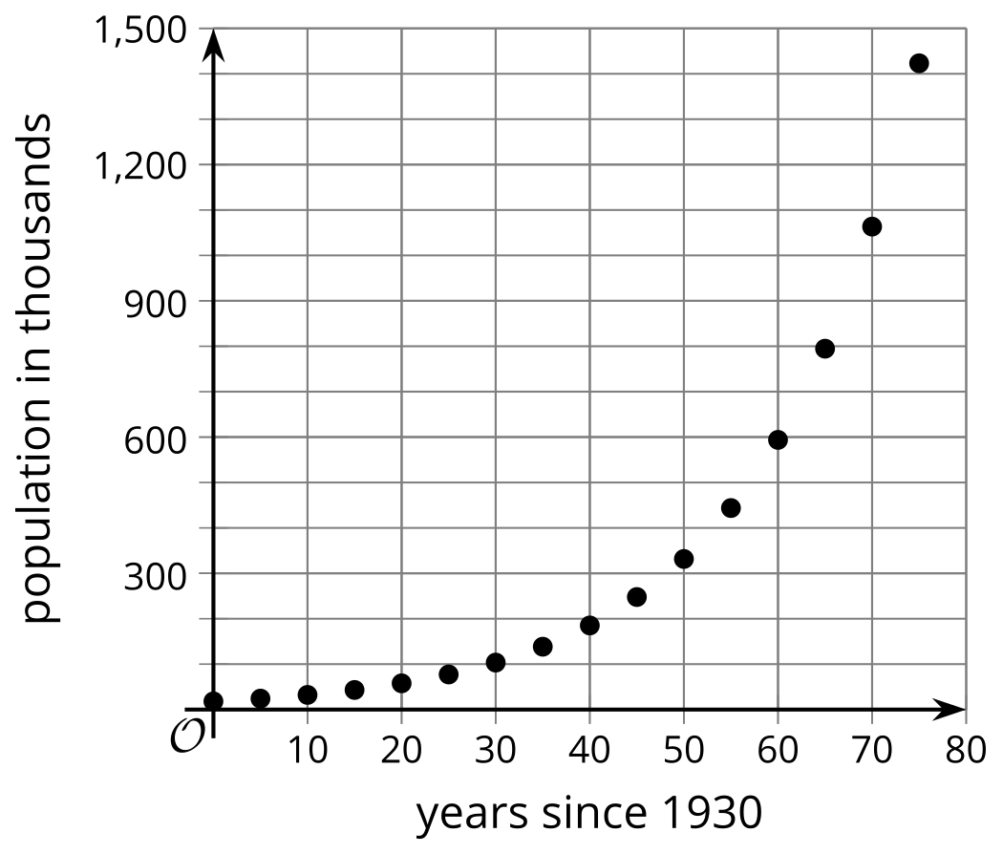
- The function, $f$, gives the number of copies a book has sold $w$ weeks after it was published. The equation $f\left(w\right)=500⋅2^{w}$ defines this function.
- Select all domains for which the average rate of change could be a good measure for the number of books sold.
  - $0≤w≤2$
  - $0≤w≤7$
  - $5≤w≤7$
  - $5≤w≤10$
  - $0≤w≤10$
- The graph shows a bacteria population decreasing exponentially over time.
- The equation $p=100,​000,​000⋅{\left(\frac{2}{3}\right)}^{h}$ gives the size of a second population of bacteria, where $h$ is the number of hours since it was measured at 100 million.
- Which bacterial population decays more quickly? Explain how you know.
- 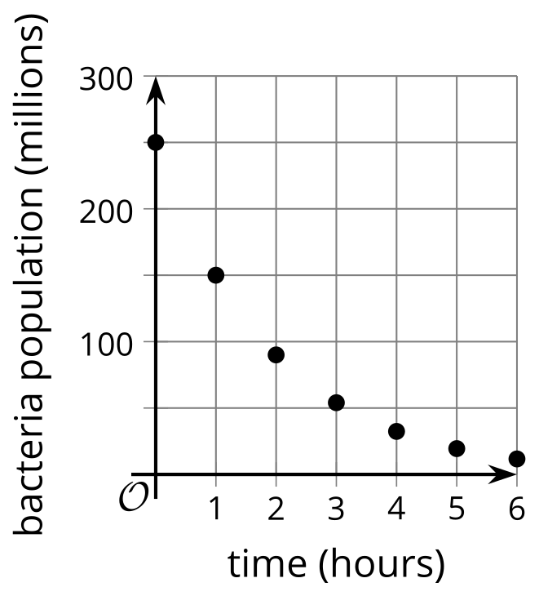
- ​​​​​​
- (From Unit 5, Lesson 6.)
- Technology required. A moth population, $p$, is modeled by the equation $p=500,​000⋅{\left(\frac{1}{2}\right)}^{w}$, where $w$ is the number of weeks since the population was first measured.
  - What was the moth population when it was first measured?
  - What was the moth population after 1 week? What about 1.5 weeks?
  - Use technology to graph the population and find out when it falls below 10,000.
- (From Unit 5, Lesson 9.)
- Give a value for $r$ that would indicate that a line of best fit has a positive slope and models the data well.
- (From Unit 3, Lesson 7.)
- The size of a district and the number of parks in it have a weak positive relationship.
- Explain what it means to have a weak positive relationship in this context.
- (From Unit 3, Lesson 8.)
- Here is a graph of Han’s distance from home as he drives.
- Identify the intercepts of the graph and explain what they mean in terms of Han’s distance from home.
- 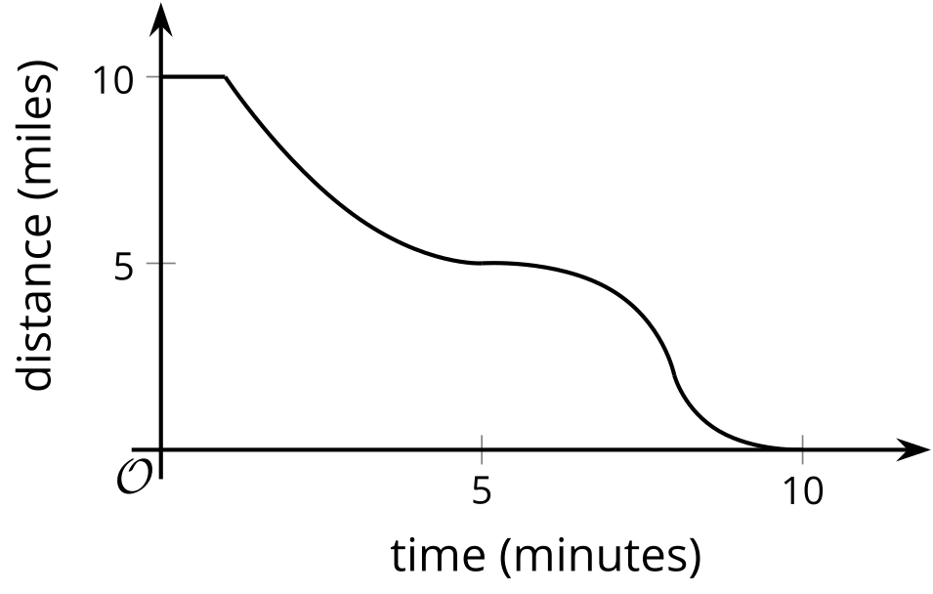
- (From Unit 4, Lesson 6.)
© CC BY 2019 by Illustrative Mathematics®

