Unit 4 Lesson 10: Solving Problems with Trigonometry

1 Notice and Wonder: Practicing Perimeter (Warm up)

Student Task Statement
What do you notice? What do you wonder?
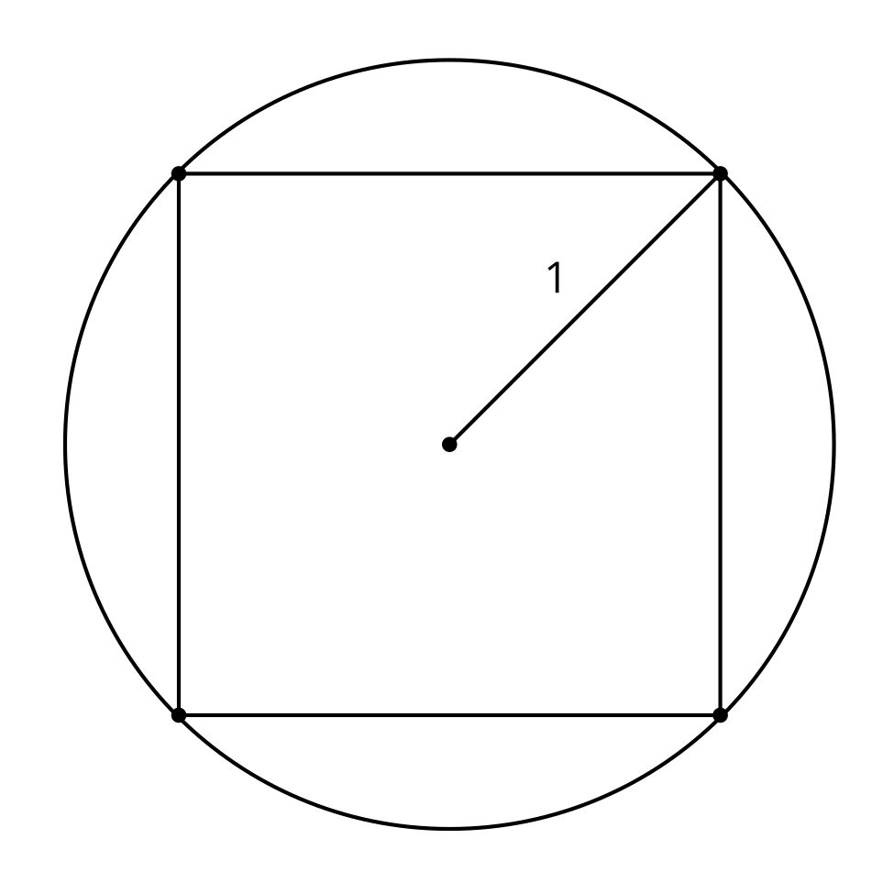
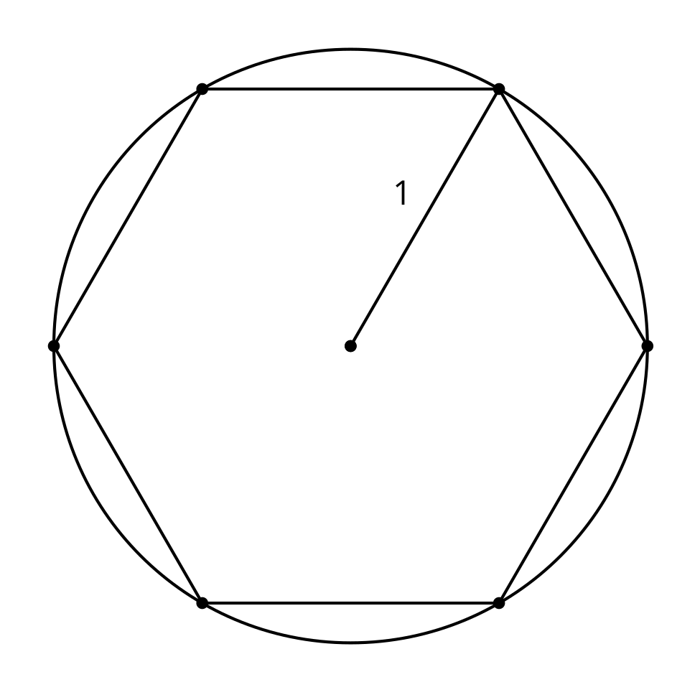
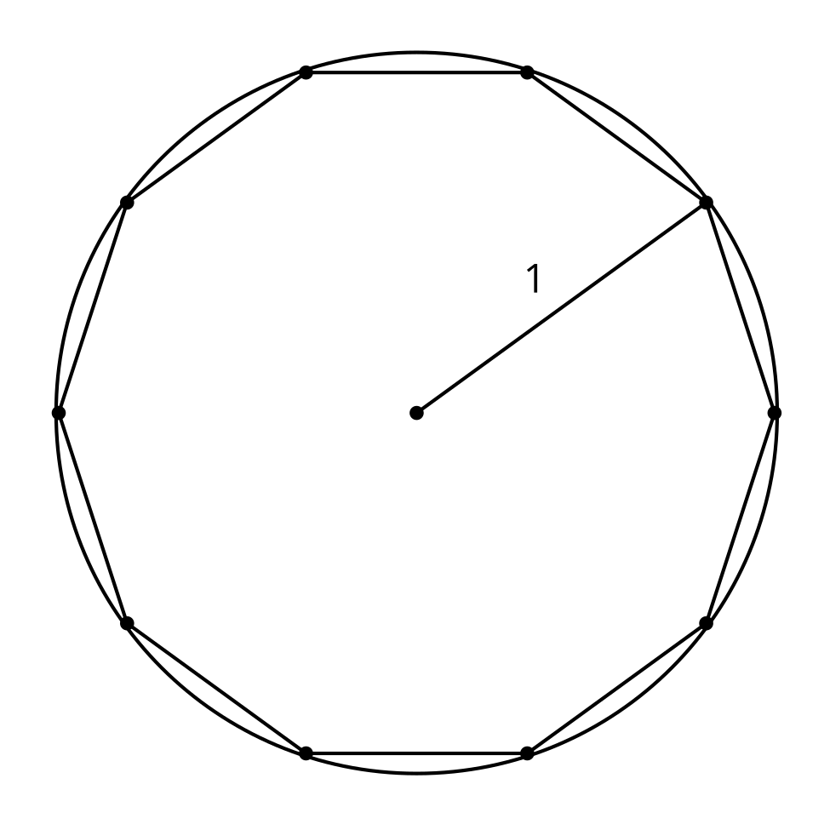

2 Growing Regular Polygons

Student Task Statement
- Here is a square inscribed in a circle with radius 1 meter. What is the perimeter of the square? Explain or show your reasoning.
- 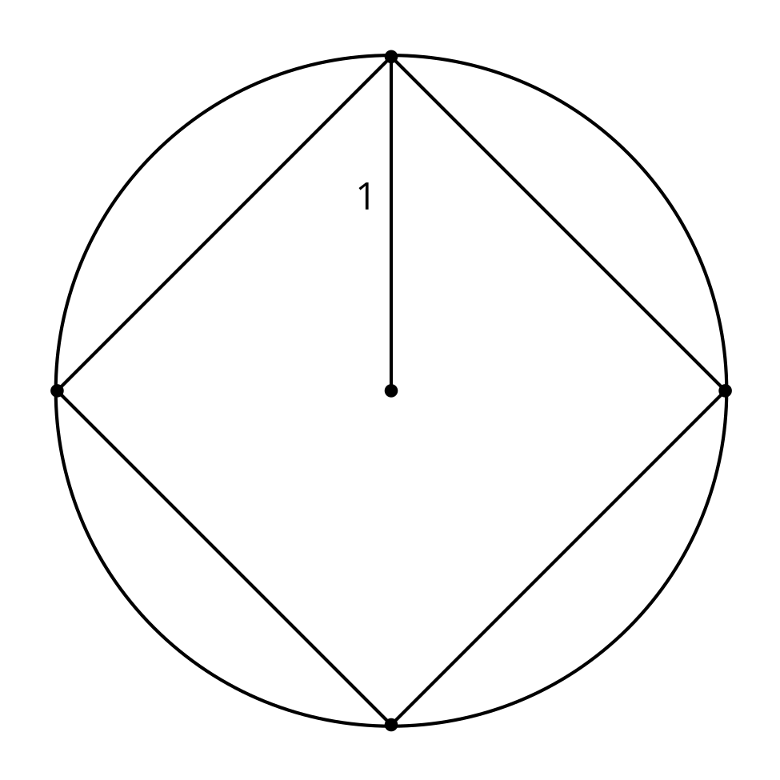
- What is the perimeter of a regular pentagon inscribed in a circle with radius 1 meter? Explain or show your reasoning.
- What is the perimeter of a regular decagon inscribed in a circle with radius 1 meter? Explain or show your reasoning.
- What is happening to the perimeter as the number of sides increases?

3 Gentle Descent

Student Task Statement
An airplane travels 150 miles horizontally during a decrease of 35,000 feet vertically.
- What is the angle of descent?
- How long is the plane's path?

Images for Activity Synthesis
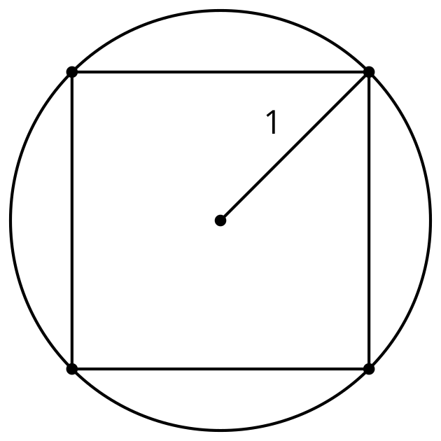
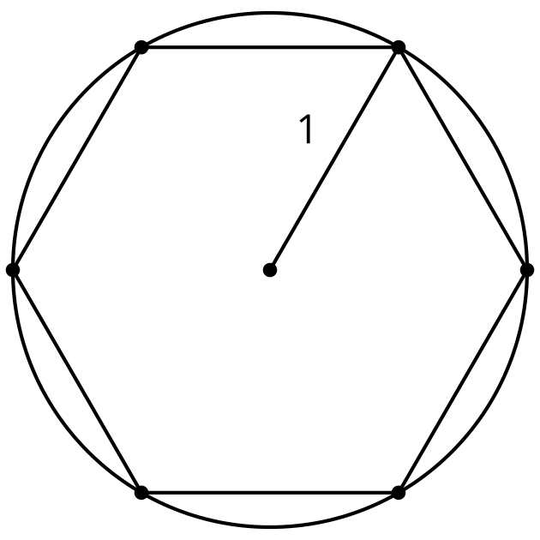
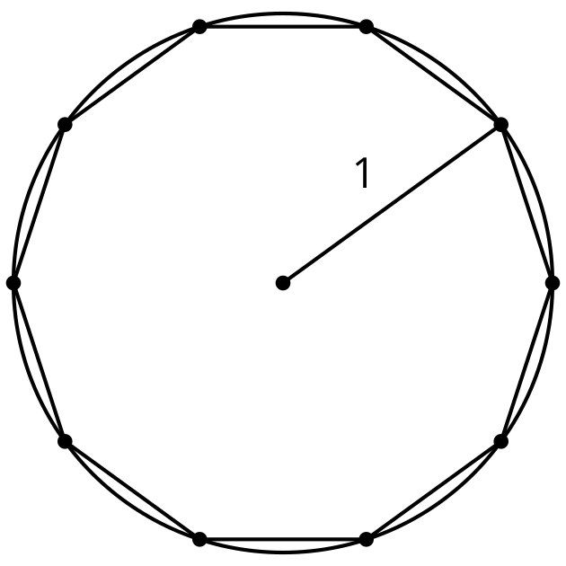
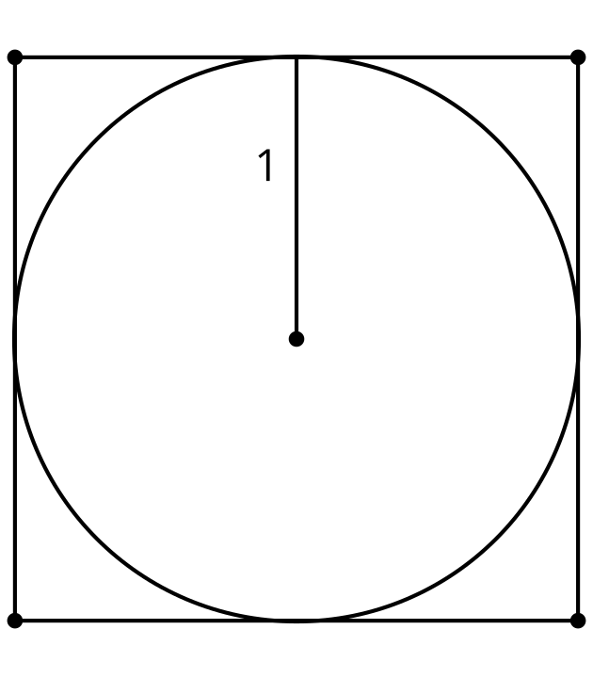
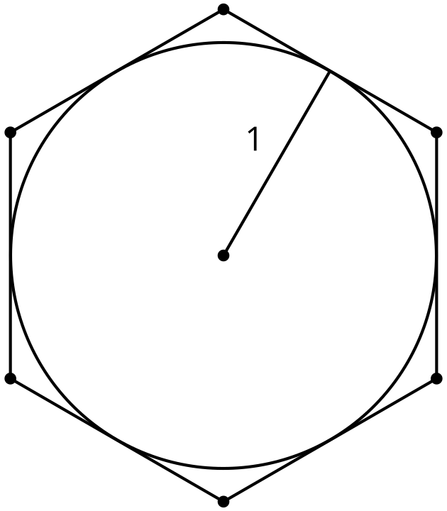
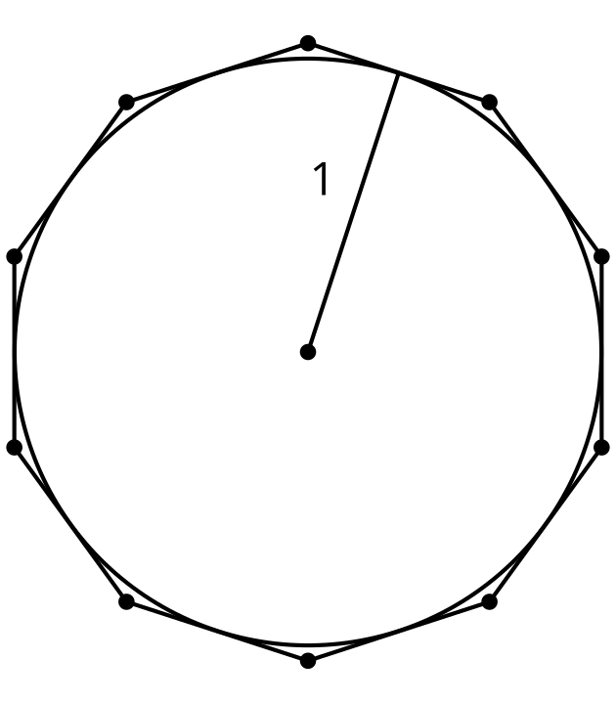
© CC BY 2019 by Illustrative Mathematics®

