Unit 3 Lesson 13: Center Day 2

WU Number Talk: Use Ten to Add (Warm up)

Student Task Statement
Find the value of each expression mentally.
- $58+10$
- $58+12$
- $58+13$
- $67+14$

1 Introduce Target Measurements, Inches and Centimeters

Student Task Statement

2 Centers: Introduce Number Puzzles, Within 100 with Composing

Student Task Statement
Choose a center.
Number Puzzles
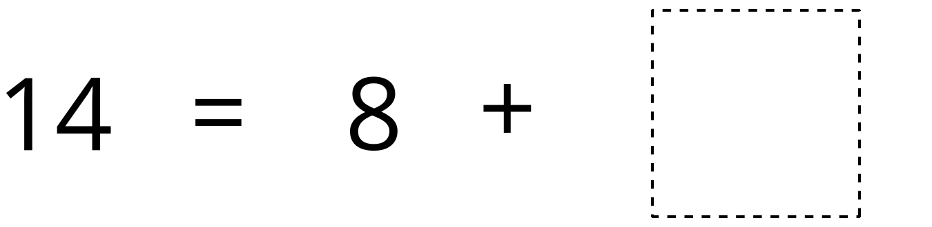
Estimate and Measure
Target Measurements
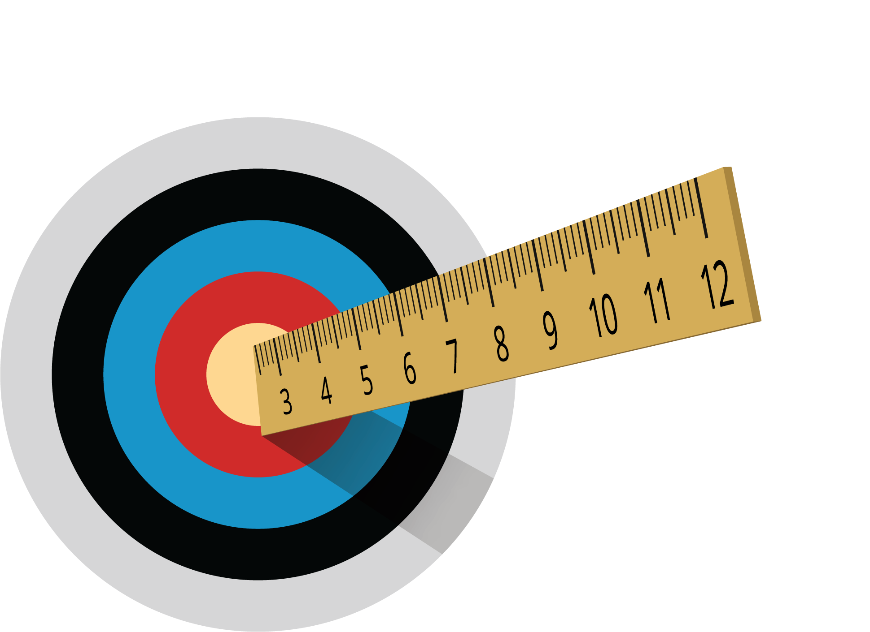
© CC BY 2021 Illustrative Mathematics®

