Unit 3 Lesson 12: Subtract Strategically

WU Number Talk: Threes (Warm up)

Student Task Statement
Find the value of each expression mentally.
- $2×6$
- $3×6$
- $2×7$
- $3×7$

1 How Would You Subtract?

Student Task Statement
Use a strategy or algorithm of your choice to find the value of each difference. Show your reasoning. Organize it so it can be followed by others.
- $451−329$
- $382−190$
- $924−285$
- $600−478$
- $505−417$

2 Greatest Difference, Smallest Difference

Student Task Statement
- Decide with your partner whether you will try to make the greatest difference or smallest difference.
- Take turns spinning and recording a digit in the hundreds, tens, or ones place. Continue until your numbers are complete.
- Find the difference.
- Compare your values.
- Write a comparison using >, <, or =.
- Play again.
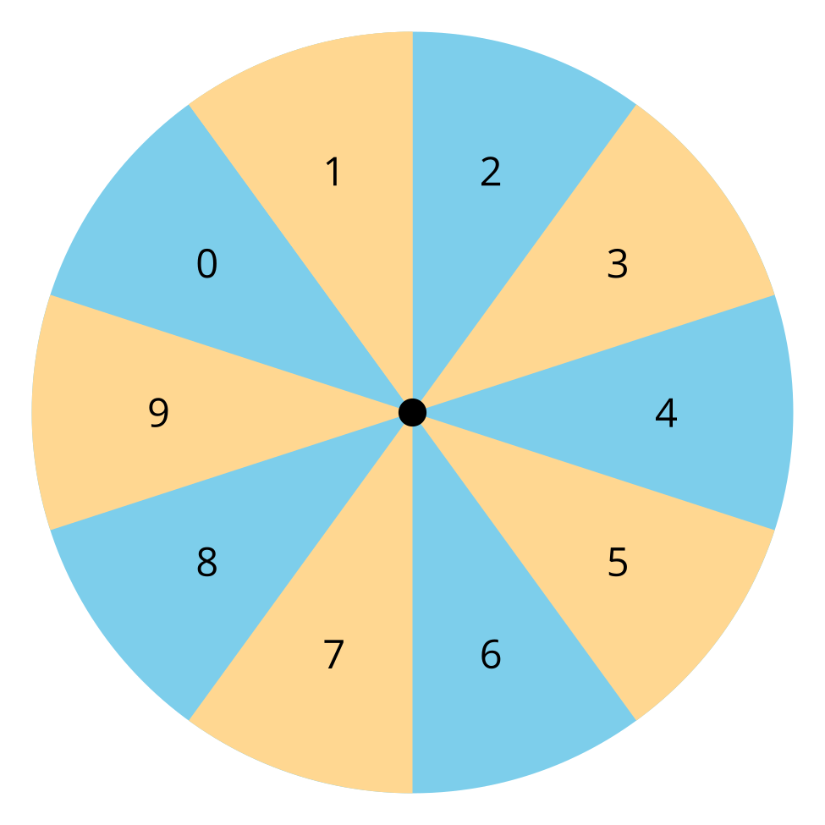
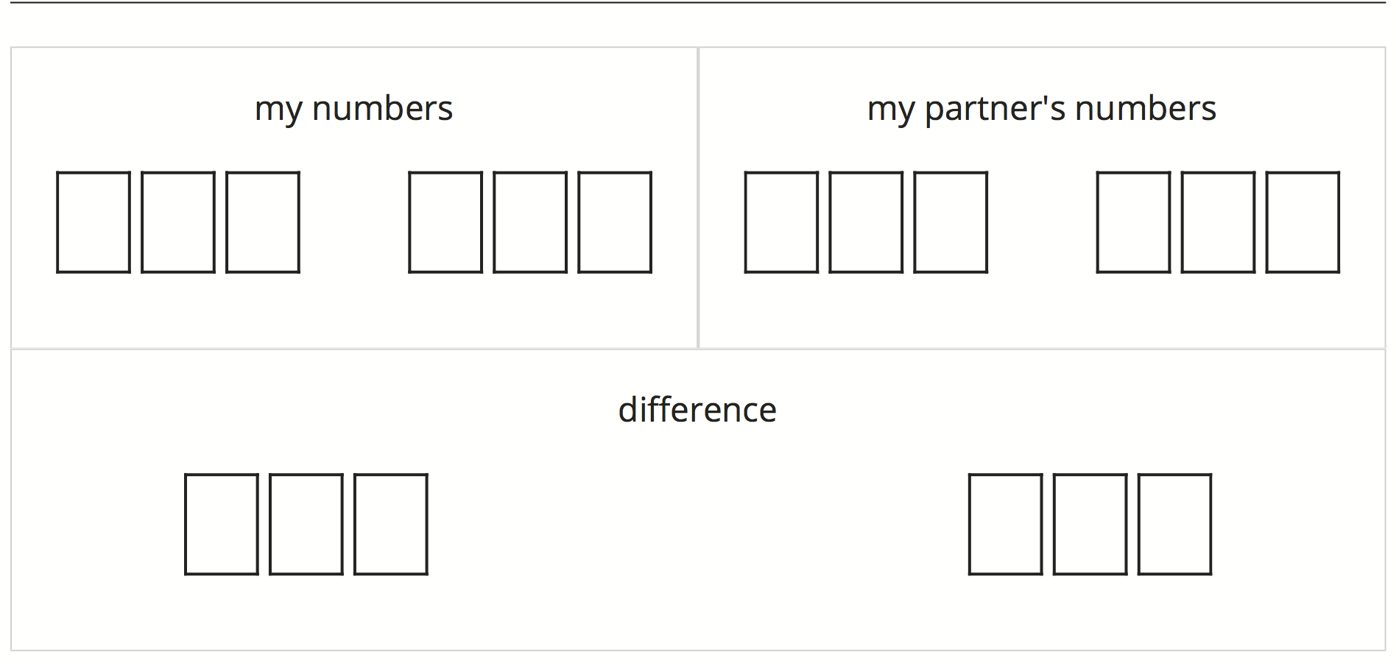
© CC BY 2021 Illustrative Mathematics®

