Lesson 11: Add to a Teen Number
- Let’s add to teen numbers.

Warm-up: True or False: Teen Numbers
Decide whether each statement is true or false.
Be prepared to explain your reasoning.
- $10+4=10+5$
- $10+3=2+1+10$
- $14=10+4+5$

11.1: Rock Collection
Kiran collects rocks.
So far he has 14 rocks.
He goes on a hike and collects 3 more rocks.
How many rocks does Kiran have?
Show your thinking using drawings, numbers, or words.
Equation: ________________________________

11.2: Write Equations: Adding on to Teen Numbers
Find the number that makes each equation true.
Show your thinking using drawings, numbers, or words.
- 12+5=aaaiaaai
- 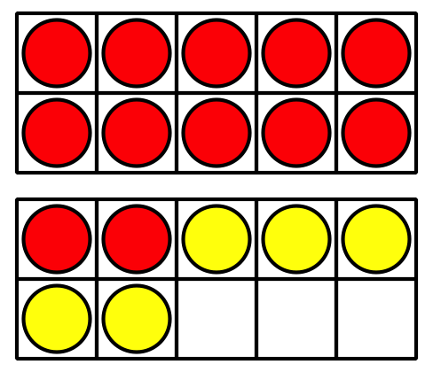
- 6+11=aaaiaaai
- aaaiaaai=17+2
- 4+14=aaaiaaai
- aaaiaaai=15+4
- 16+2=aaaiaaai

11.3: Centers: Choice Time
Choose a center.
Compare
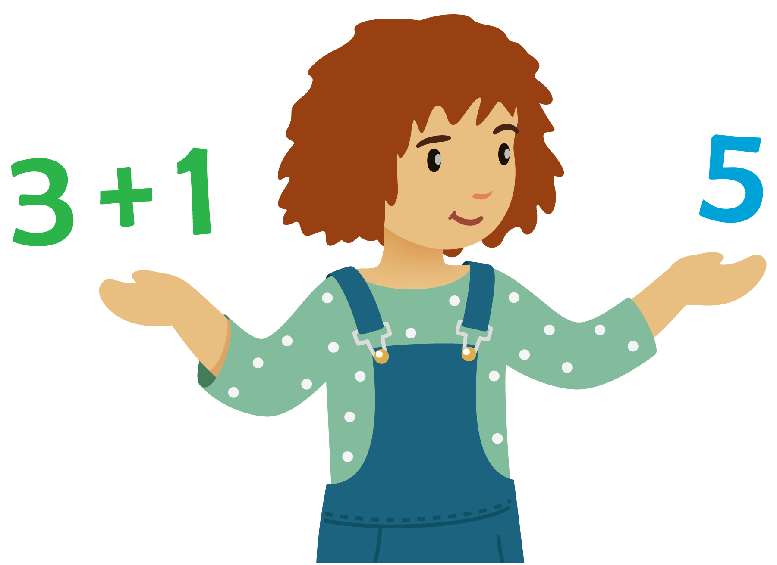
Number Puzzles
Find the Pair
© CC BY 2021 Illustrative Mathematics®

