Unit 1 Lesson 17 Cumulative Practice Problems
- Use a protractor to try to draw each triangle. Which of these three triangles is impossible to draw?
  - A triangle where one angle measures ${20}^{∘}$ and another angle measures ${45}^{∘}$
  - A triangle where one angle measures ${120}^{∘}$ and another angle measures ${50}^{∘}$
  - A triangle where one angle measures ${90}^{∘}$ and another angle measures ${100}^{∘}$
- A triangle has an angle measuring ${90}^{∘}$, an angle measuring ${20}^{∘}$, and a side that is 6 units long. The 6-unit side is in between the ${90}^{∘}$ and ${20}^{∘}$ angles.
  - Sketch this triangle and label your sketch with the given measures.
  - How many unique triangles can you draw like this?
- A triangle has sides of length 7 cm, 4 cm, and 5 cm. How many unique triangles can be drawn that fit that description? Explain or show your reasoning.
- A triangle has one side that is 5 units long and an adjacent angle that measures ${25}^{∘}$. The two other angles in the triangle measure ${90}^{∘}$ and ${65}^{∘}$. Complete the two diagrams to create two different triangles with these measurements.
- 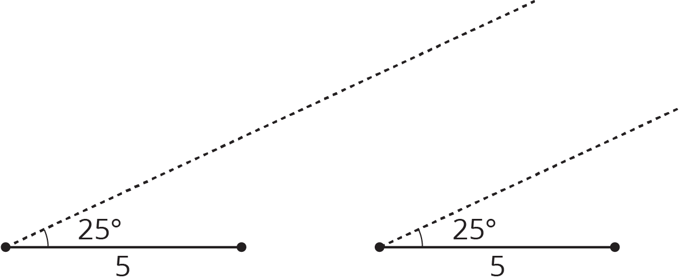
- Is it possible to make a triangle that has angles measuring 90 degrees, 30 degrees, and 100 degrees? If so, draw an example. If not, explain your reasoning.
© CC BY Open Up Resources. Adaptations CC BY IM.

