Lesson 3 Practice Problems
- Select all of the numbers that are greater than $\text{-}5$.
  - 1.3
  - $\text{-}6$
  - $\text{-}12$
  - $\frac{1}{7}$
  - $\text{-}1$
  - $\text{-}4$
- The table shows five states and the lowest point in each state.
- Put the states in order by their lowest elevation, from least to greatest.
- state | - lowest elevation (feet)
- California | - -282
- Colorado | - 3350
- Louisiana | - -8
- New Mexico | - 2842
- Wyoming | - 3099
- Here are the boiling points of certain elements in degrees Celsius:
  - Argon: -185.8
  - Chlorine: -34
  - Fluorine: -188.1
  - Hydrogen: -252.87
  - Krypton: -153.2
- List the elements from least to greatest boiling points.
- Decide which of the following quantities can be represented by a positive number and which can be represented by a negative number. Give an example of a quantity with the opposite sign in the same situation.
  - Tyler’s puppy gained 5 pounds.
  - The aquarium leaked 2 gallons of water.
  - Andre received a gift of $10.
  - Kiran gave a gift of $10.
  - A climber descended 550 feet.

  - On the number line, label the points that are 4 units away from 0.
  - 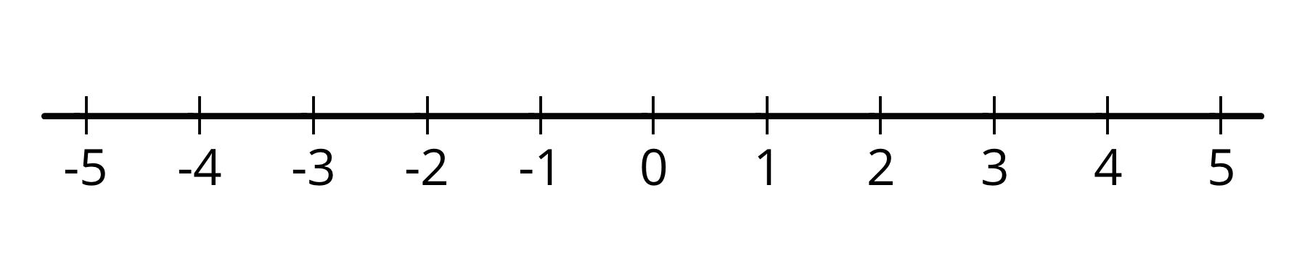
  - If you fold the number line so that a vertical crease goes through 0, the points you label would match up. Explain why this happens.
  - On the number line, label the points that are $\frac{5}{2}$ units from 0. What is the distance between these points?
- (From Unit 7, Lesson 1.)
© CC BY Open Up Resources. Adaptations CC BY IM.

