Unit 4 Lesson 11: Approximating Pi

1 More Sides (Warm up)

Student Task Statement
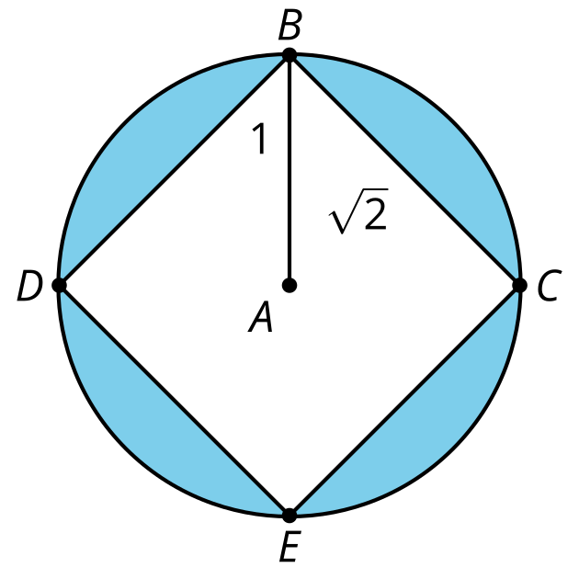
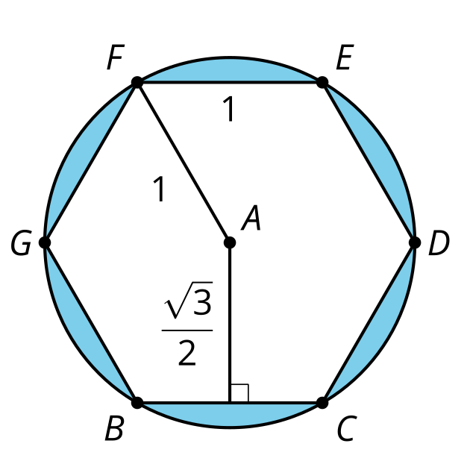
Calculate the area of the shaded regions.

2 N Sides

Student Task Statement
Here is one part of a regular $n$-sided polygon inscribed in a circle of radius 1.
Come up with a general formula for the perimeter of the polygon in terms of $n$. Explain or show your reasoning.
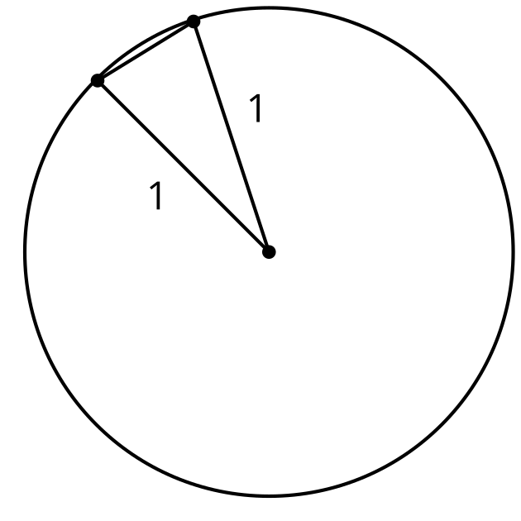

3 So Many Sides

Student Task Statement
Let's use the expression you came up with to approximate the value of $π$.
- How close is the approximation when $n=6$?
- How close is the approximation when $n=10$?
- How close is the approximation when $n=20$?
- How close is the approximation when $n=50$?
- What value of $n$ approximates the value of $π$ to the thousandths place?

Images for Activity Synthesis
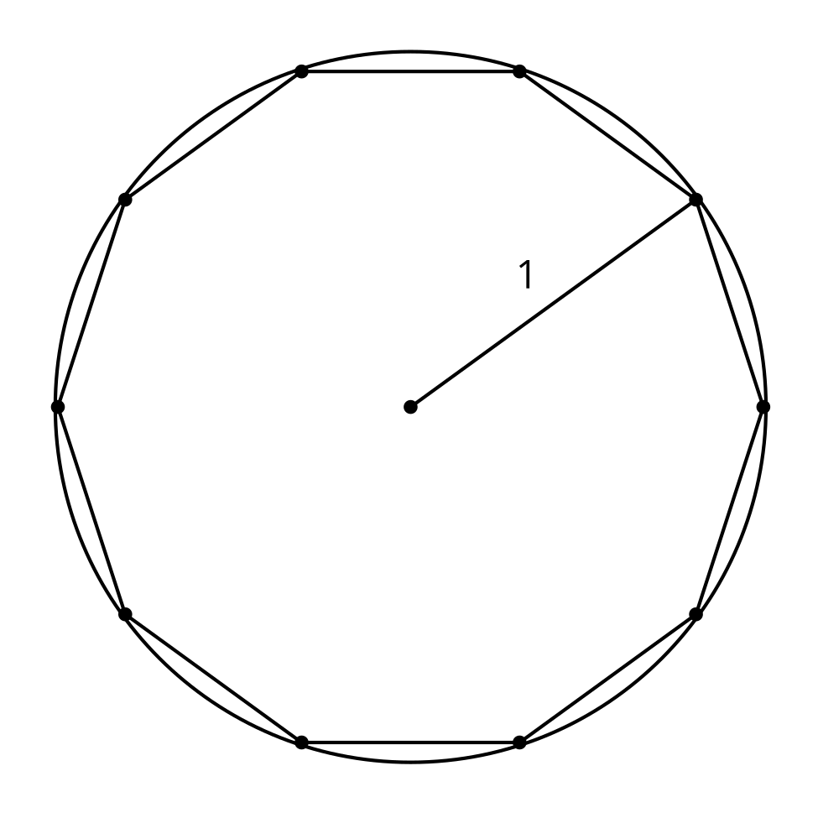
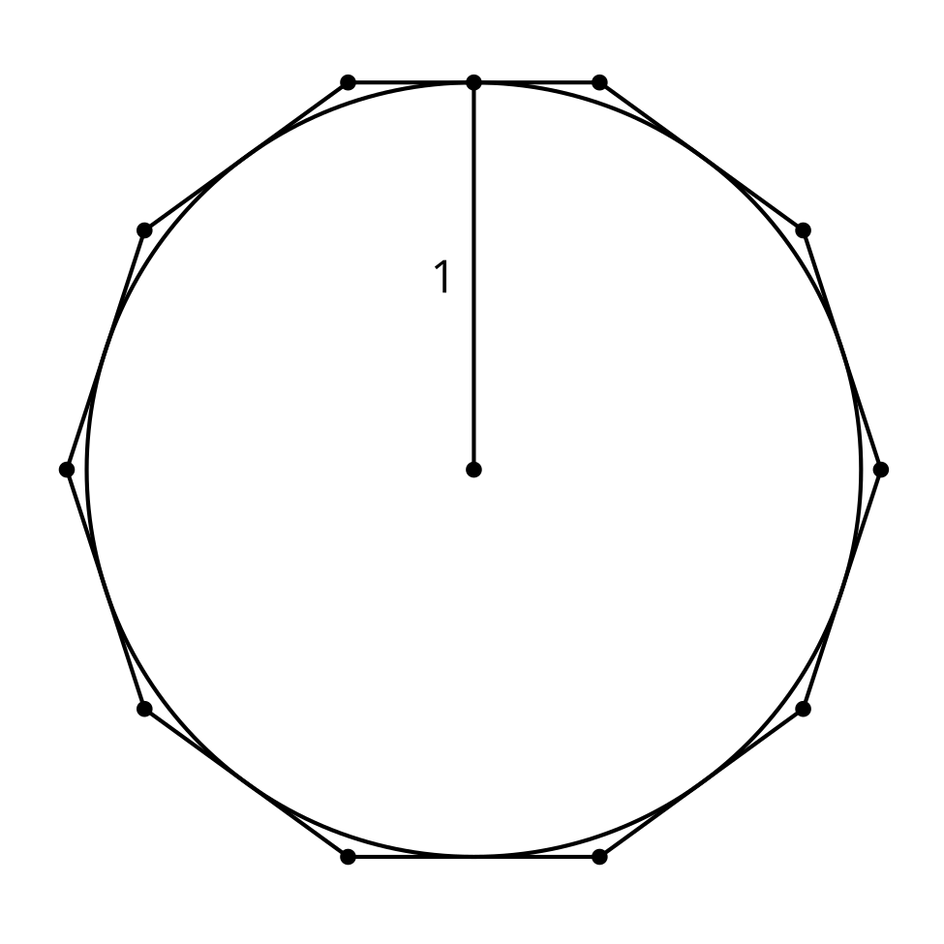
© CC BY 2019 by Illustrative Mathematics®

