Lesson 18: Graphs of Rational Functions (Part 2)
- Let’s learn about horizontal asymptotes.

18.1: Rewritten Equations
Decide if each of these equations is true or false for $x$ values that do not result in a denominator of 0. Be prepared to explain your reasoning.
- $\frac{x+7}{x}=1+\frac{7}{x}$
- $\frac{x}{x+7}=1+\frac{x}{7}$

18.2: Publishing a Paperback
Let $c$ be the function that gives the average cost per book $c\left(x\right)$, in dollars, when using an online store to print $x$ copies of a self-published paperback book. Here is a graph of $c\left(x\right)=\frac{120+4x}{x}.$
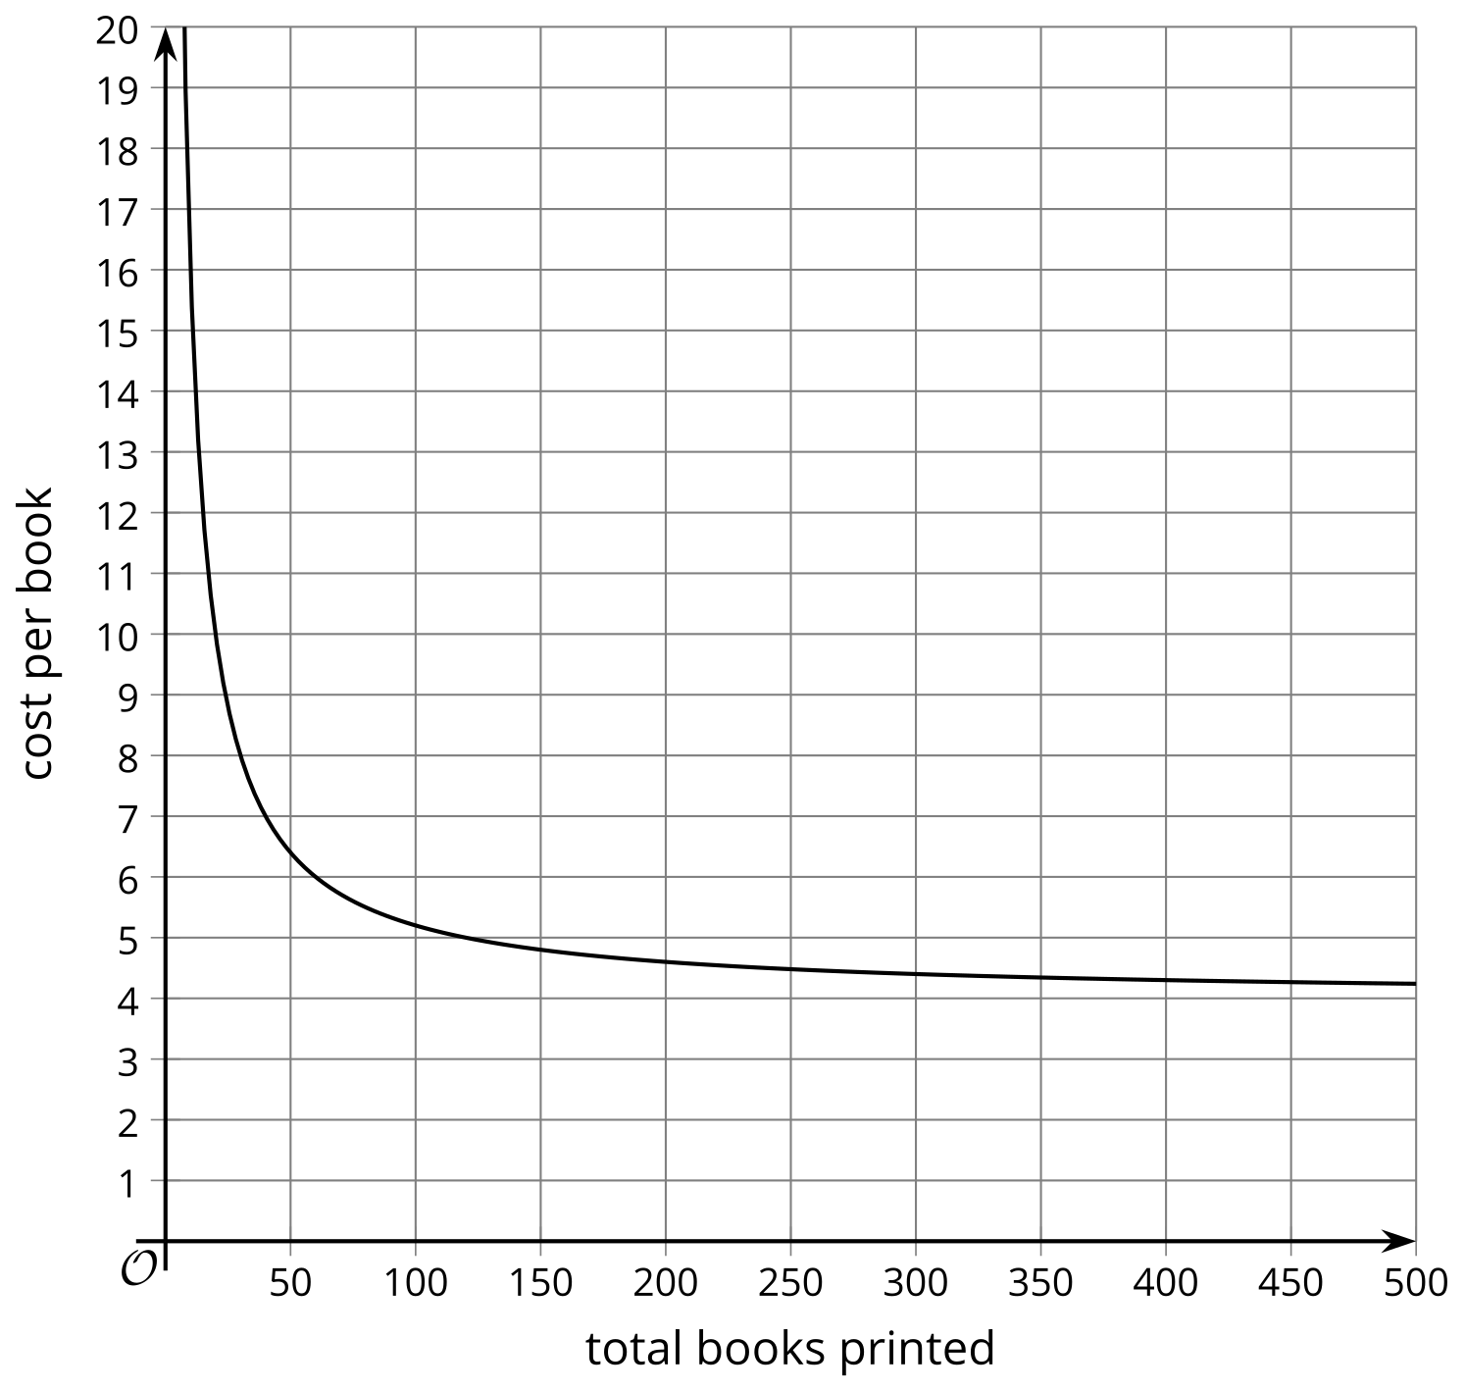
- What is the approximate cost per book when 50 books are printed? 100 books?
- The author plans to charge $8 per book. About how many should be printed to make a profit?
- What is the value of $c\left(x\right)$ when $x=\frac{1}{2}$? How does this relate to the context?
- What does the end behavior of the function say about the context?

18.3: Horizontal Asymptotes
Here are four graphs of rational functions.

A
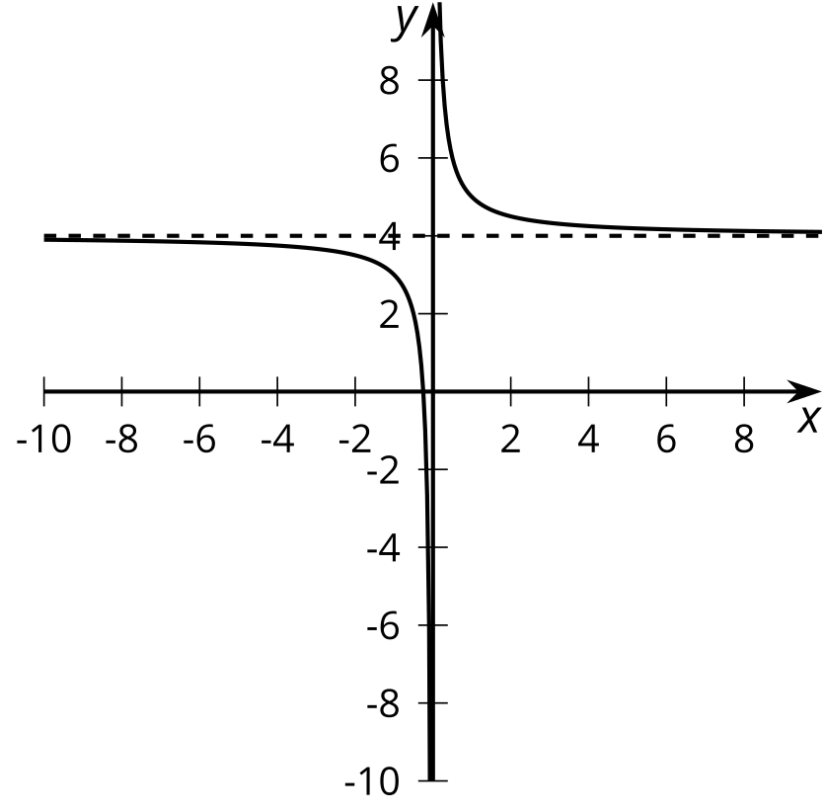

B
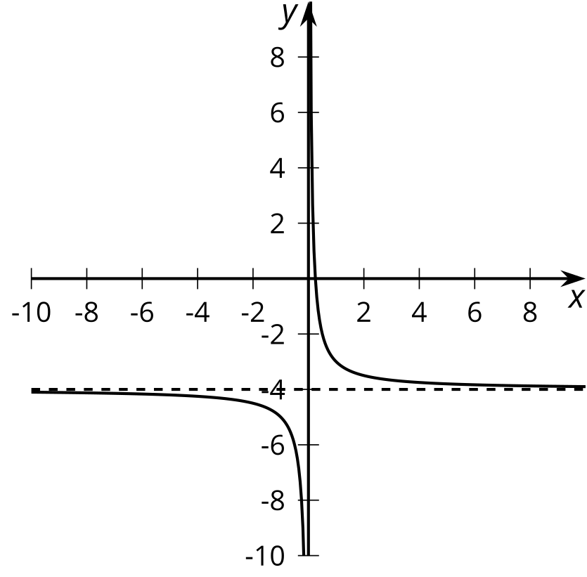

C
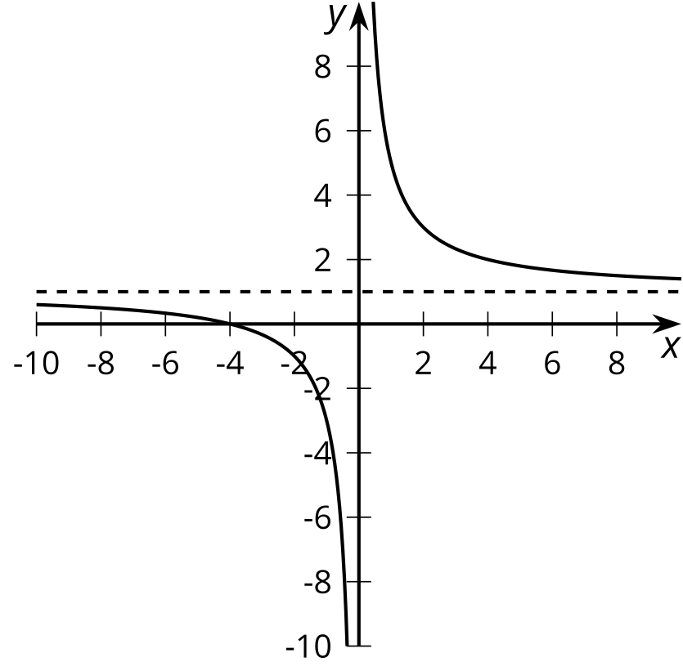

D
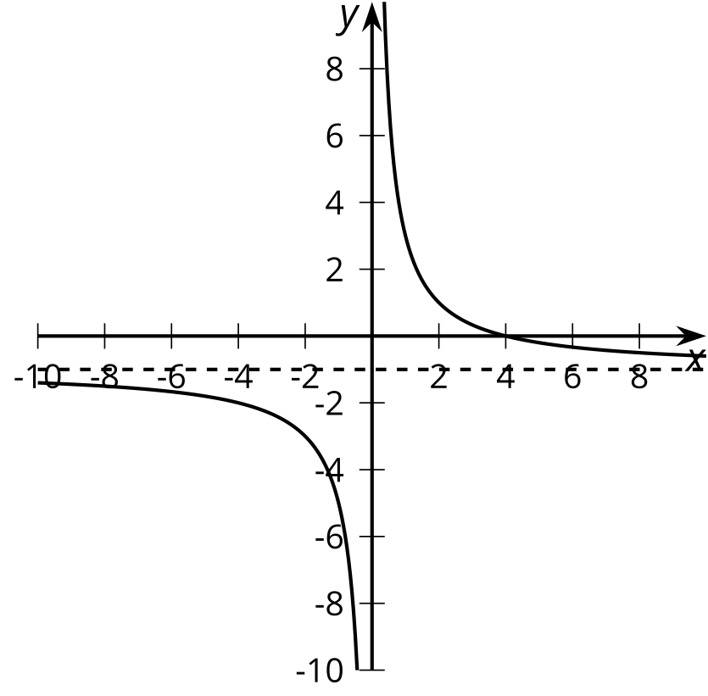
​​​​​
- Match each function with its graphical representation.
  - $a\left(x\right)=\frac{4}{x}−1$
  - $b\left(x\right)=\frac{1}{x}−4$
  - $c\left(x\right)=\frac{1+4x}{x}$
  - $d\left(x\right)=\frac{x+4}{x}$
  - $e\left(x\right)=\frac{1−4x}{x}$
  - $f\left(x\right)=\frac{4−x}{x}$
  - $g\left(x\right)=1+\frac{4}{x}$
  - $h\left(x\right)=\frac{1}{x}+4$
- Where do you see the horizontal asymptote of the graph in the expressions for the functions?

Are you ready for more?
Consider the function $a\left(x\right)=\frac{\frac{1}{2}x+1}{x−1}$.
- Predict where you think the vertical and horizontal asymptotes of $a\left(x\right)$ will be. Explain your reasoning.
- Use graphing technology to check your prediction.

Lesson 18 Summary
Consider the rational function $f\left(x\right)=\frac{3x+1}{x}$. Written this way, we can tell that the graph of the function has a vertical asymptote at $x=0$ by reading the denominator and identifying the value that would cause division by zero. But what can we tell about the value of $f\left(x\right)$ for values of $x$ far away from the vertical asymptote?
One way we can think about these values is to rewrite the expression for $f\left(x\right)$ by breaking up the fraction:
$f\left(x\right)=\frac{3x}{x}+\frac{1}{x}f\left(x\right)=3+\frac{1}{x}$
Written this way, it’s easier to see that as $x$ gets larger and larger in either the positive or negative direction, the $\frac{1}{x}$ term will get closer and closer to 0. Because of this, we can say that the value of the function will get closer and closer to 3.
More generally, if a rational function $g\left(x\right)=\frac{a\left(x\right)}{b\left(x\right)}$ can be rewritten as $g\left(x\right)=c+\frac{r\left(x\right)}{b\left(x\right)}$, where $c$ is a constant, and $r\left(x\right)$ and $b\left(x\right)$ are polynomial expressions where $\frac{r\left(x\right)}{b\left(x\right)}$ gets closer and closer to zero as $x$ gets larger and larger in both the positive and negative directions, then $g\left(x\right)$ will get closer and closer to $c$.
Rational functions of this type have a horizontal asymptote at the constant value. The line $y=c$ is a horizontal asymptote for $f$ if $f\left(x\right)$ gets closer and closer to $c$ as the magnitude of $x$ increases.
© CC BY 2019 by Illustrative Mathematics®

