Lesson 5: Make a Ten
- Let’s add two-digit and one-digit numbers.

Warm-up: How Many Do You See: Many 10-frames
How many do you see?
How do you see them?
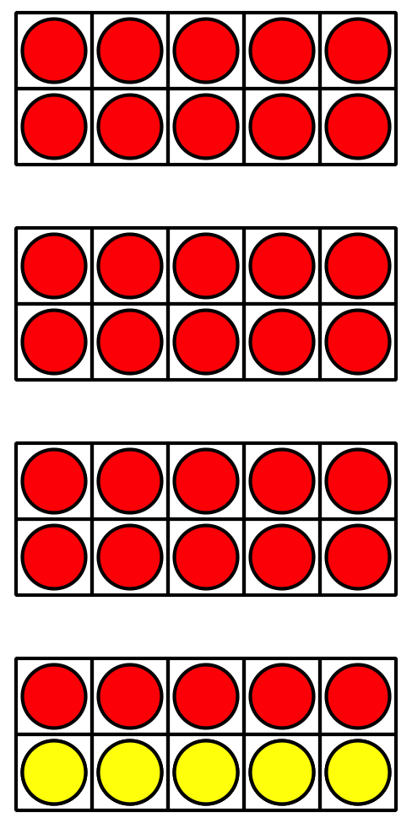
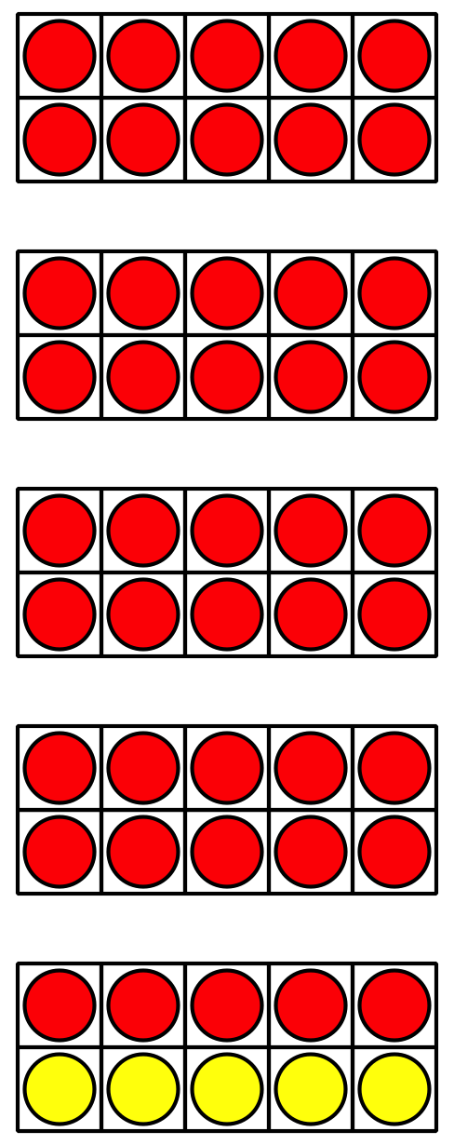
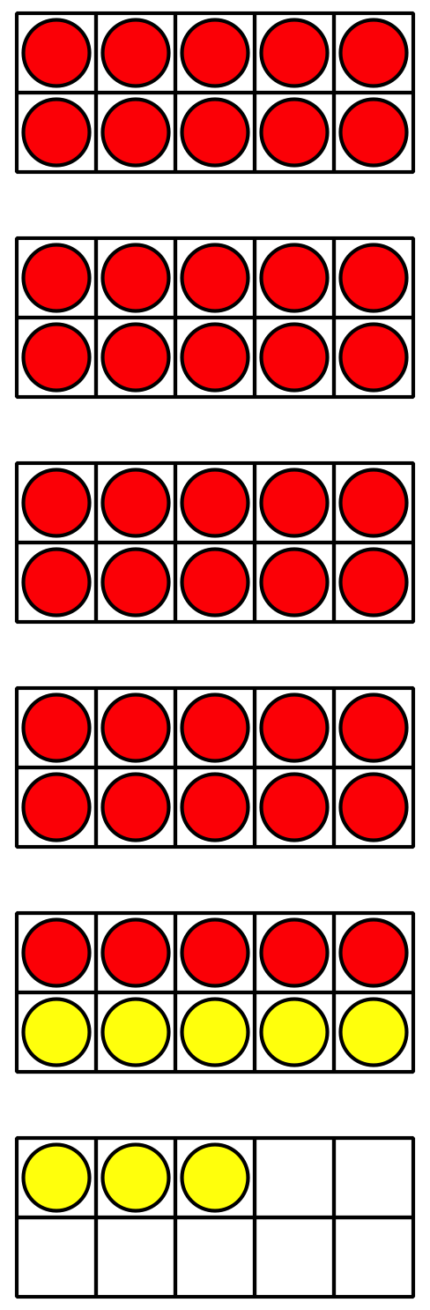

5.1: Choose a Way to Add
Find the value of $8+47$.
Show your thinking using drawings, numbers, or words.

5.2: Add ‘Em Up Partner
Practice Round:
Show your thinking using drawings, numbers, or words.
Equation: __________________________________
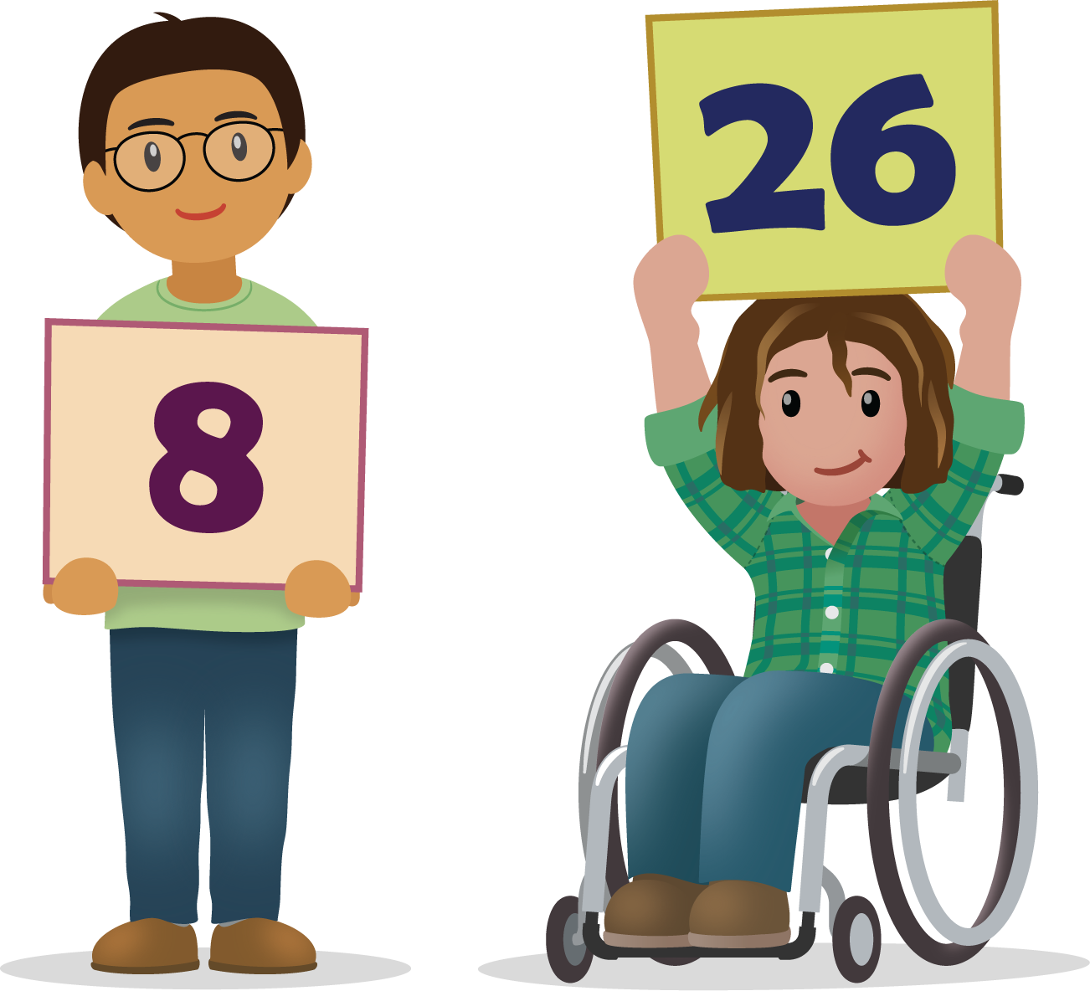
Round 1:
Show your thinking using drawings, numbers, or words.
Equation: __________________________________
Round 2:
Show your thinking using drawings, numbers, or words.
Equation: __________________________________
Round 3:
Show your thinking using drawings, numbers, or words.
Equation: __________________________________
Round 4:
Show your thinking using drawings, numbers, or words.
Equation: __________________________________
Round 5:
Show your thinking using drawings, numbers, or words.
Equation: __________________________________

5.3: Tyler’s Teacher
- Tyler’s teacher collected 37 dollars for the class field trip.
Then someone brought in 7 more dollars.
How much money did Tyler’s teacher collect?
Show your thinking using drawings, numbers, or words.
- Tyler’s teacher needs to know if all of his students are in the classroom.
There are 8 students sitting at tables and 26 students on the rug.
How many students are in the classroom?
Show your thinking using drawings, numbers, or words.
© CC BY 2021 Illustrative Mathematics®

