Unit 3 Lesson 14: What is a Line Plot?

WU Notice and Wonder: “Handy” Graphs (Warm up)

Student Task Statement
What do you notice? What do you wonder?
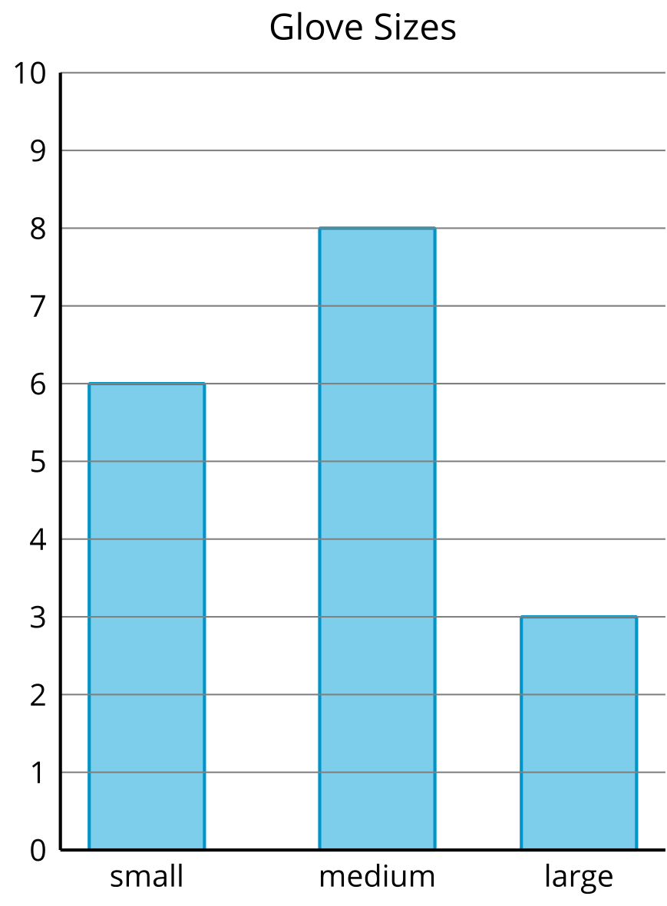
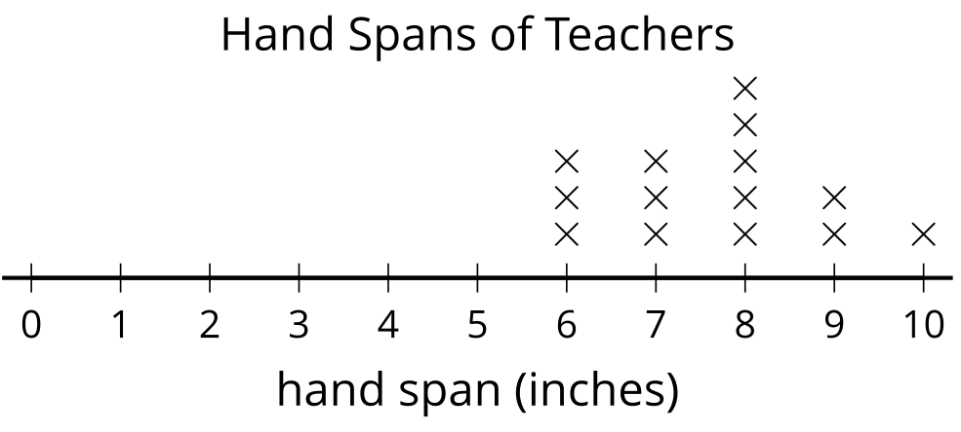

1 Measure Our Hand Spans

Student Task Statement
- Trace your hand. (Spread your fingers wide.)
- Draw a line from your thumb to your pinky. This line represents your hand span. Measure the length of your hand span in inches.
- My hand span is ____________ inches.
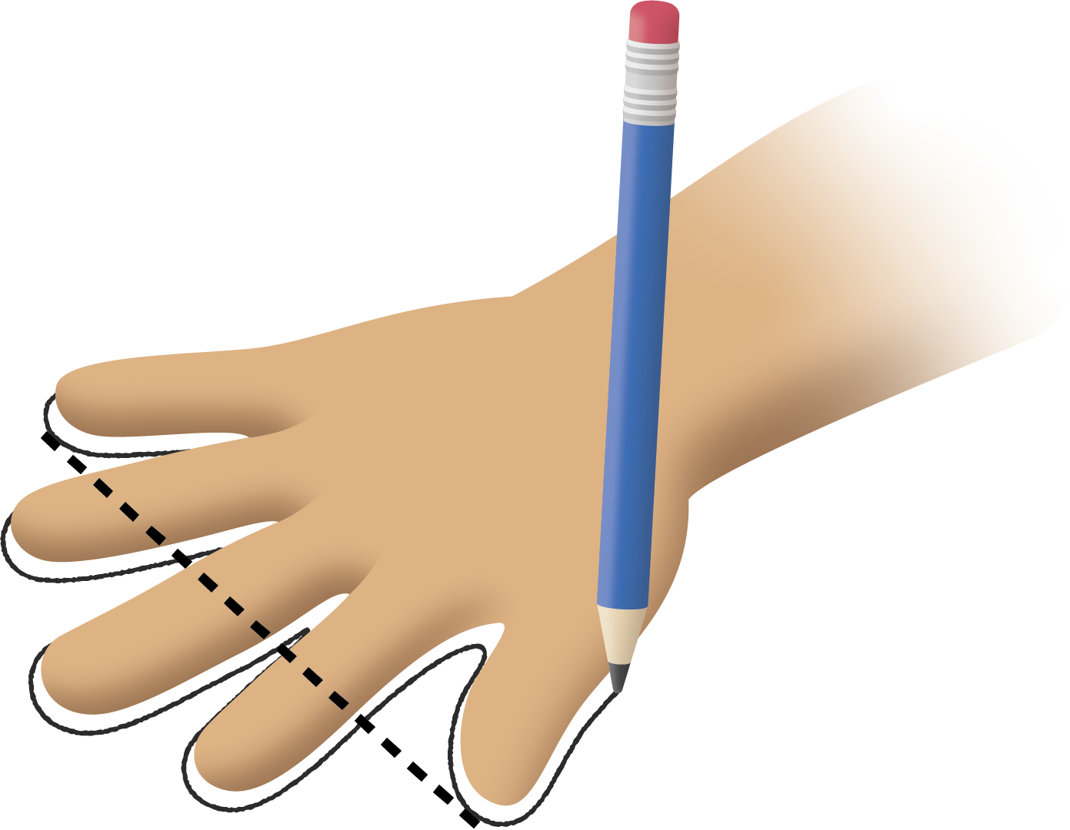

2 Interpret Our Numerical Data

Student Task Statement
- What was the longest hand span?
- What was the shortest hand span?
- Write another statement about our class’ hand spans based on the line plot.

Images for Activity Synthesis
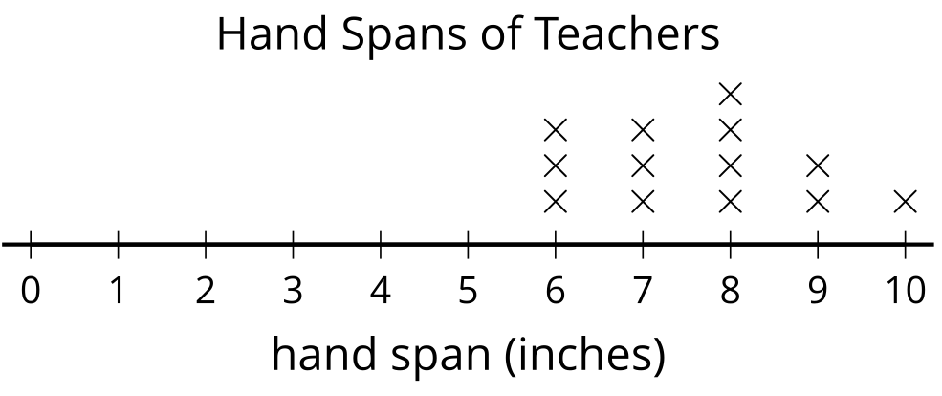
© CC BY 2021 Illustrative Mathematics®

