Lesson 9: A Sum of Equal Addends
- Let’s match expressions with arrays.

Warm-up: Estimation Exploration: How Many Waffles?
How many waffles are on the tray?
Record an estimate that is:
too low | about right | too high

9.1: Sums of Rows and Sums of Columns
Mai and Diego represented the same array with different expressions.
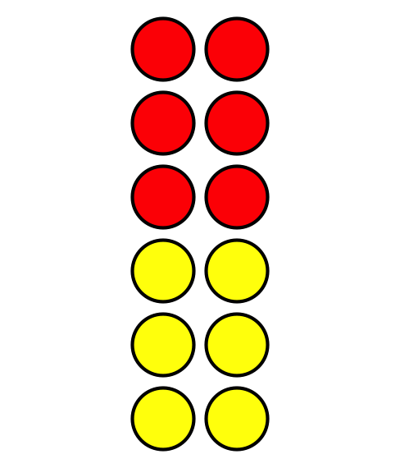
Diego’s expression
$2+2+2+2+2+2$
Mai’s expression
$6+6$
Who do you agree with?
Show your thinking using diagrams, symbols, or other representations.

9.2: Card Sort: Arrays and Expressions
Your teacher will give you a set of cards that show arrays, expressions and a total number. Find the cards that match.

9.3: Add It All Up

  - How many counters are there in all?
  - 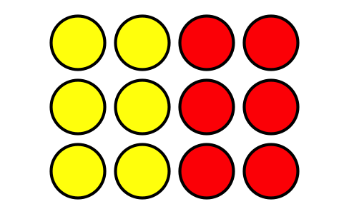
  - Explain how you found the total number of counters.
  - Circle 2 expressions that represent the array.
  - $3+3+3+3$
  - $3+3+3$
  - $4+3$
  - $4+4+4$
  - $4+4+4+4$

  - How many counters are there in all?
  - 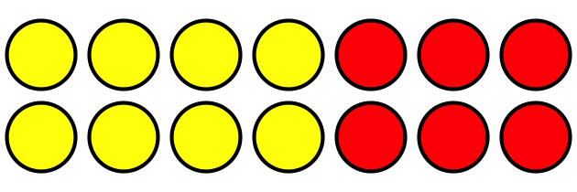
  - Explain how you found the total number of counters.
  - Circle 2 expressions that represent the array.
  - $2+2+2+2+2+2+2$
  - $6+6$
  - $7+7$
  - $2+2+2+2+2$
© CC BY 2021 Illustrative Mathematics®

