Lesson 12: Subtract From a Teen Number
- Let’s subtract and add within 20.

12.1: Noah’s Collection
Noah likes to collect game pieces.
He has 19 game pieces arranged like this in his bin.
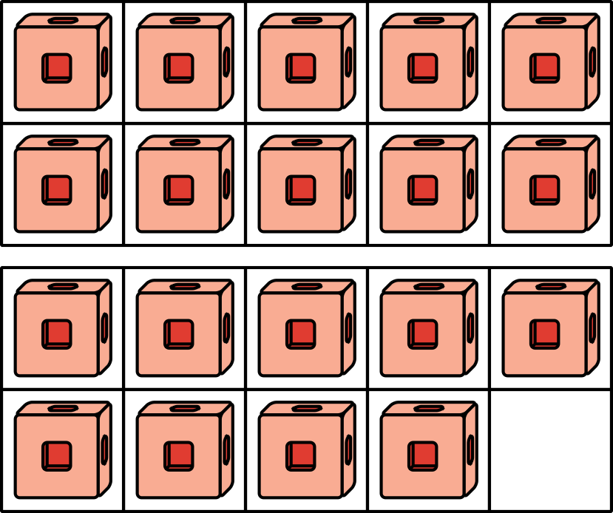
He takes out 8 game pieces to play with.
How many game pieces are left in the bin?
Show your thinking using drawings, numbers, or words.
Equation: ________________________________

12.2: Addition and Subtraction Equations with Teen Numbers
Find the number that makes each equation true.
Be ready to explain your thinking in a way that others will understand.
- 13+4=aaaiaaai
- 16+aaaiaaai=17
- 19−8=aaaiaaai
- 14−2=aaaiaaai
- 11+aaaiaaai=17
- aaaiaaai+1=18
- 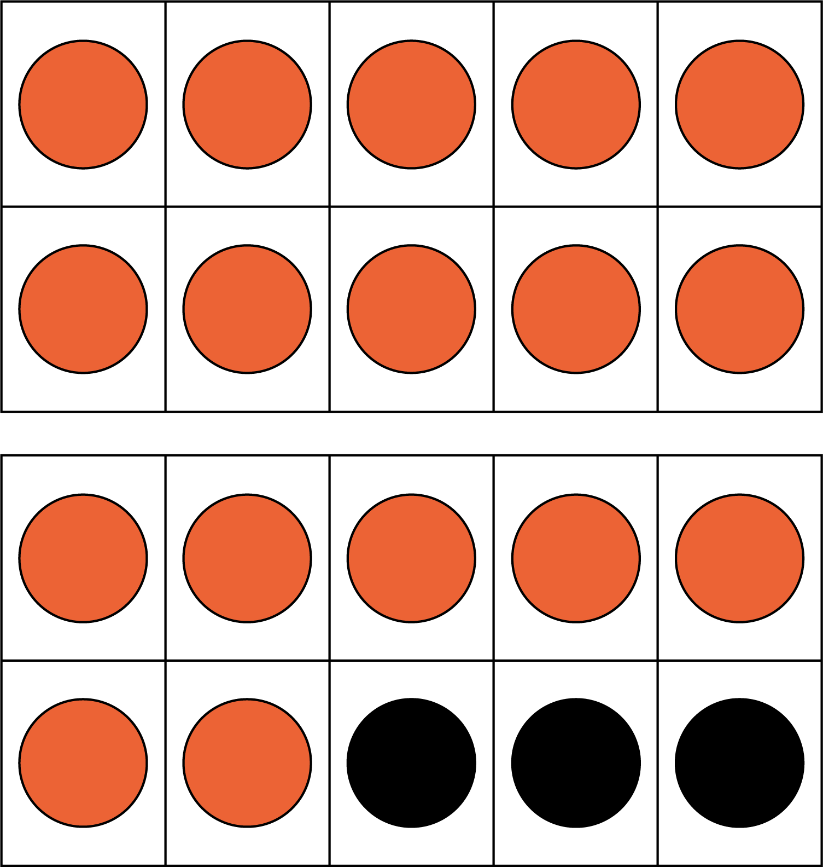
© CC BY 2021 Illustrative Mathematics®

