Lesson 3: Scaled Picture Graphs

Standards Alignments
Building On | 2.NBT.B.5
Addressing | 3.MD.B
Building Towards | 3.MD.B.3

Teacher-facing Learning Goals
- Interpret scaled picture graphs to generate questions (orally and in writing) about the data.

Student-facing Learning Goals
- Let’s explore scaled picture graphs.

Lesson Purpose
The purpose of this lesson is for students to read and answer questions about scaled picture graphs.
In previous lessons, students reviewed how to create and interpret single-unit scale picture graphs. In this lesson, students learn that a scaled picture graph is a picture graph where each picture represents an amount other than 1. They read, interpret, and answer questions about scaled picture graphs with a scale of 2 and 5, and generate questions that can be answered by these graphs.
Math Community
Tell students that, at the end of the lesson, they will be asked to identify specific actions from their “Doing Math” list (both teacher and student sections) they personally experienced.

Access for:

Students with Disabilities
- Representation (Activity 2)

English Learners
- MLR8 (Activity 2)

Instructional Routines
Number Talk (Warm-up)

Lesson Timeline
Warm-up | 10 min
Activity 1 | 15 min
Activity 2 | 20 min
Lesson Synthesis | 10 min
Cool-down | 5 min

Teacher Reflection Question
In this lesson, students make sense of scaling a picture graph by a number other than 1. How does this support the work that students will do with multiplication later in this unit?

Cool-down
(to be completed at the end of the lesson) 5min
Birds in the Park

Standards Alignments
Addressing | 3.MD.B

Student-facing Task Statement
Jada collected data to see how many of each type of bird she saw on her way home.
The data is shown in this picture graph:
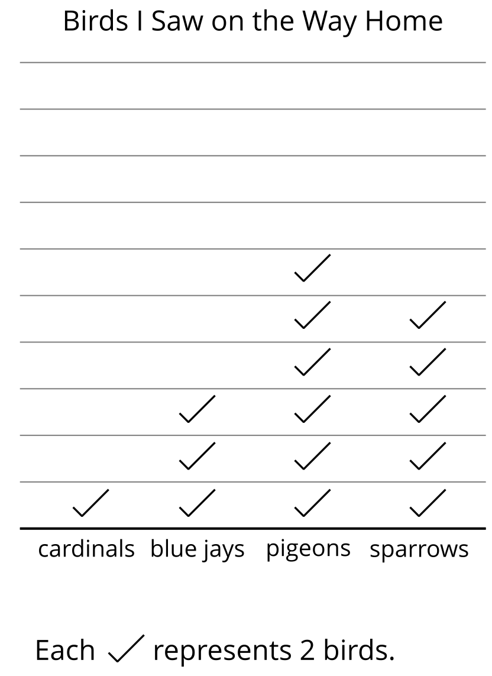
Based on the data on the graph:
- How many sparrows did Jada see on the way home?
- Write one question you could ask about the birds Jada saw on the way home.

Student Responses
- 10 sparrows
- Sample responses: How many birds did Jada see on the way home? How many blue jays and cardinals did Jada see on the way home?

