Lesson 9 Practice Problems
- A circle with a 12-inch diameter is folded in half and then folded in half again. What is the area of the resulting shape?
- Find the area of the shaded region. Express your answer in terms of $π$.
- 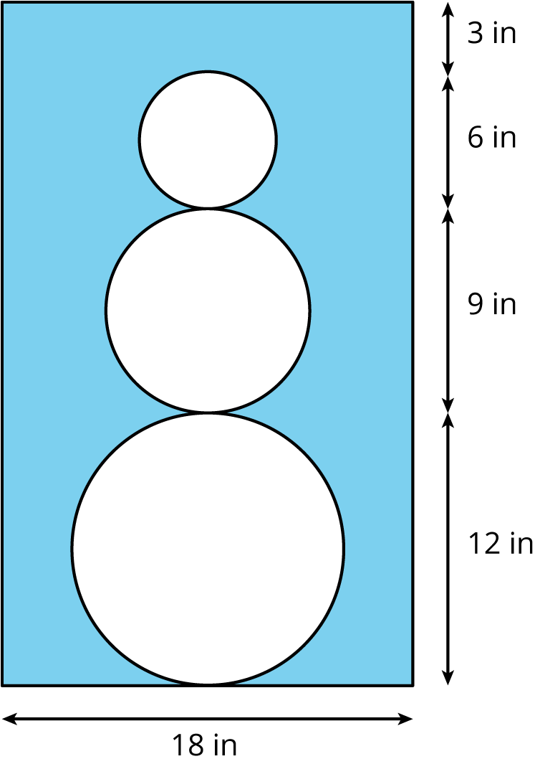

- The face of a clock has a circumference of 63 in. What is the area of the face of the clock?
- (From Unit 3, Lesson 8.)
- Which of these pairs of quantities are proportional to each other? For the quantities that are proportional, what is the constant of proportionality?
  - Radius and diameter of a circle
  - Radius and circumference of a circle
  - Radius and area of a circle
  - Diameter and circumference of a circle
  - Diameter and area of a circle
- (From Unit 3, Lesson 7.)
- Find the area of this shape in two different ways.
- 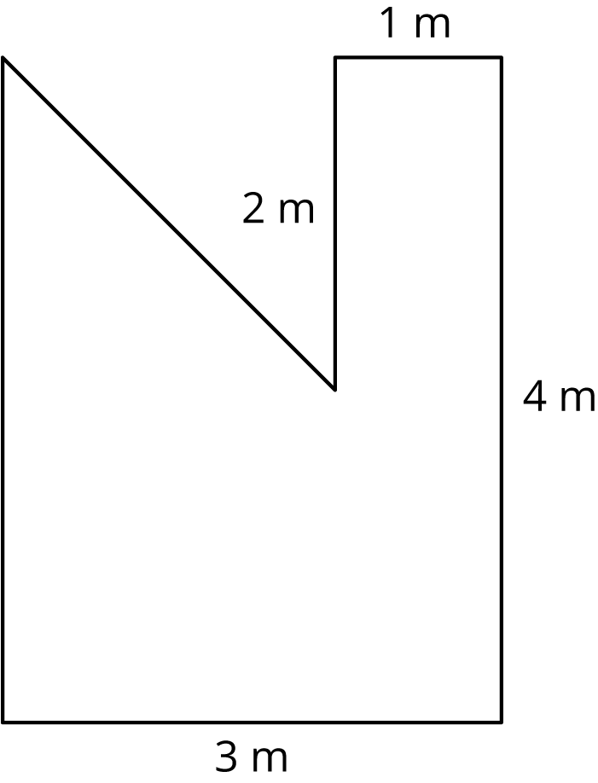
- (From Unit 3, Lesson 6.)
- Elena and Jada both read at a constant rate, but Elena reads more slowly. For every 4 pages that Elena can read, Jada can read 5.
  - Complete the table.
- pages read by Elena | - pages read by Jada
- 4 | - 5
  - 1
  - 9
  - $e$
 | - 15
 | - $j$
  - Here is an equation for the table: $j=1.25e$. What does the 1.25 mean?
  - Write an equation for this relationship that starts $e=\text{...}$
- (From Unit 2, Lesson 5.)
© CC BY Open Up Resources. Adaptations CC BY IM.

