Unit 5 Lesson 6: Even More Graphs of Functions

1 Dog Run (Warm up)

Student Task Statement
Here are five pictures of a dog taken at equal intervals of time.
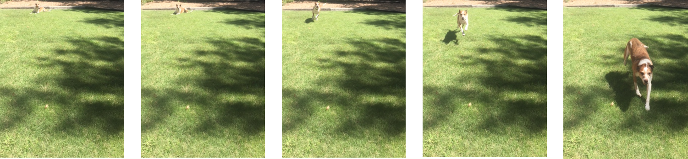
Diego and Lin drew different graphs to represent this situation:
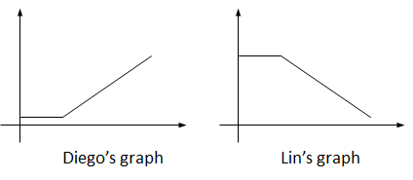
They both used time as the independent variable. What do you think each one used for the dependent variable? Explain your reasoning.

2 Which Graph is It?

Images for Launch
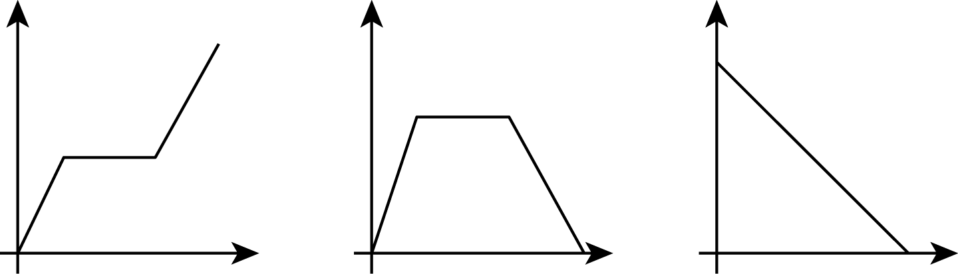

Student Task Statement
For each situation,
- name the independent and dependent variables
- pick the graph that best fits the situation, or sketch the graph if one isn't provided
- label the axes
- answer the question: which quantity is a function of which? Be prepared to explain your reasoning.
- Jada is training for a swimming race. The more she practices, the less time it takes for her to swim one lap.
- 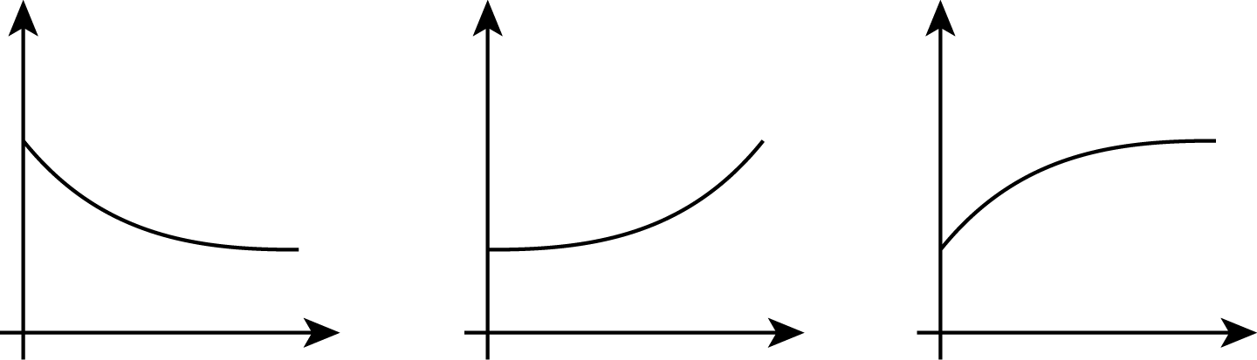
- Andre adds some money to a jar in his room each week for 3 weeks and then takes some out in week 4.
- 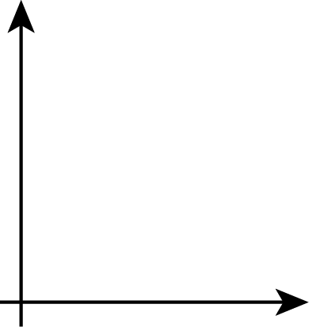

Activity Synthesis
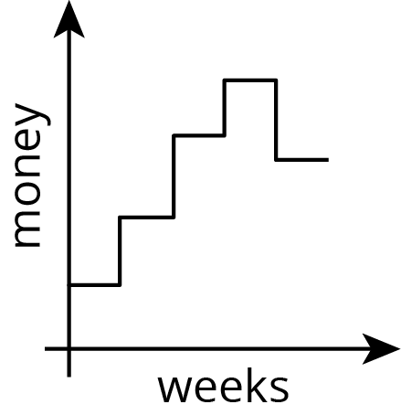

3 Sketching a Story about a Boy and a Bike

Student Task Statement
Your teacher will give you tools for creating a visual display. With your group, create a display that shows your response to each question.
Here is a story: “Noah was at home. He got on his bike and rode to his friend’s house and stayed there for awhile. Then he rode home again. Then he rode to the park. Then he rode home again.”
- Create a set of axes and sketch a graph of this story.
- What are the two quantities? Label the axes with their names and units of measure. (For example, if this were a story about pouring water into a pitcher, one of your labels might say “volume (liters).”)
- Which quantity is a function of which? Explain your reasoning.
- Based on your graph, is his friend’s house or the park closer to Noah's home? Explain how you know.
- Read the story and all your responses again. Does everything make sense? If not, make changes to your work.
© CC BY Open Up Resources. Adaptations CC BY IM.

