Unit 1 Lesson 14: Nets and Surface Area

1 Matching Nets (Warm up)

Student Task Statement
Each of the nets can be assembled into a polyhedron. Match each net with its corresponding polyhedron, and name the polyhedron. Be prepared to explain how you know the net and polyhedron go together.
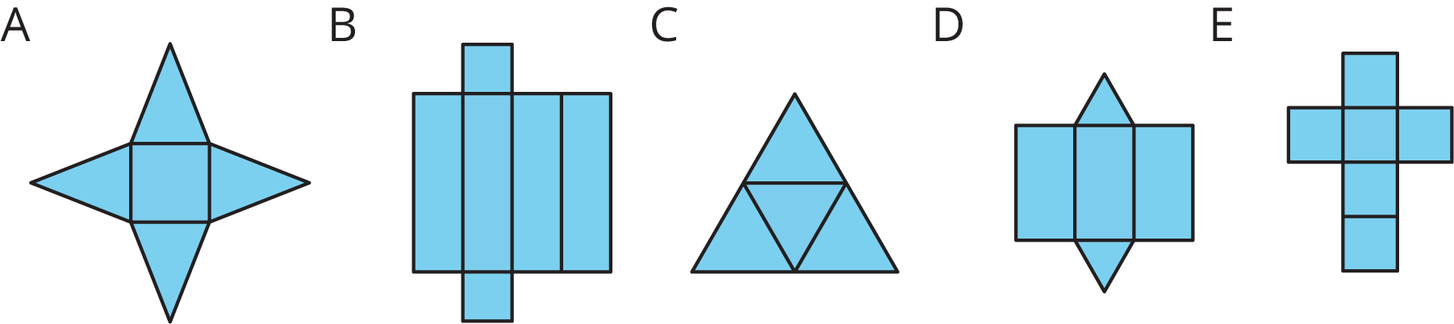
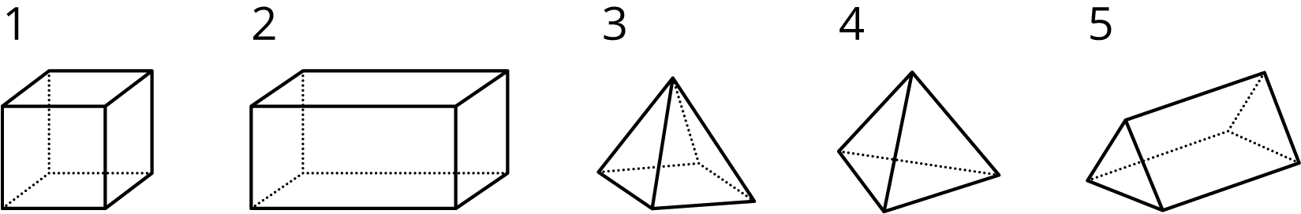

2 Using Nets to Find Surface Area

Student Task Statement
- Name the polyhedron that each net would form when assembled.
- 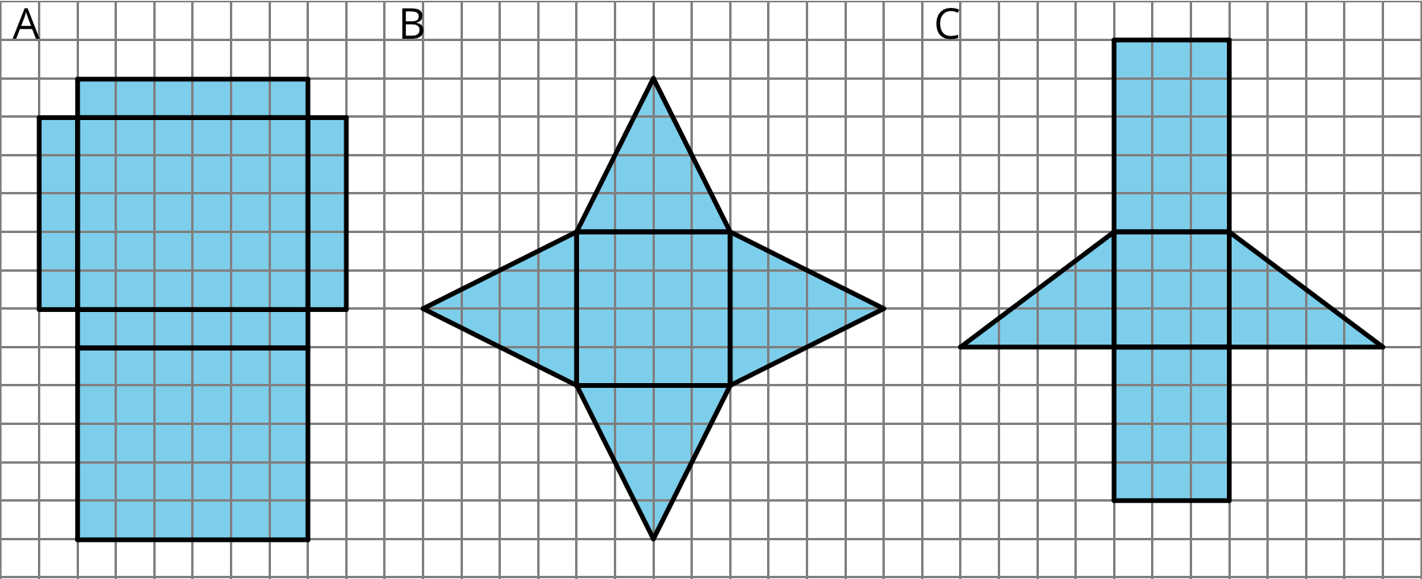
- Your teacher will give you the nets of three polyhedra. Cut out the nets and assemble the three-dimensional shapes.
- Find the surface area of each polyhedron. Explain your reasoning clearly.
© CC BY Open Up Resources. Adaptations CC BY IM.

