Lesson 14 Practice Problems
- Find the area of the polygon.
- 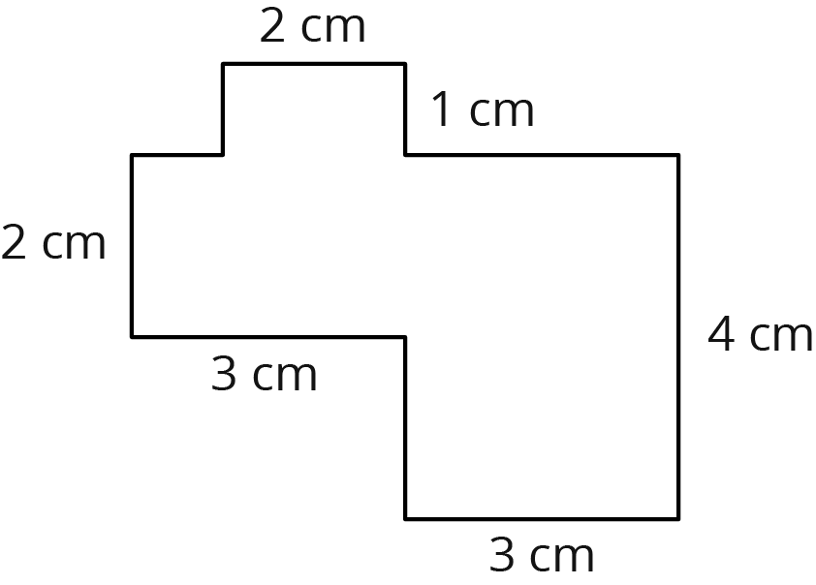
  - Draw polygons on the map that could be used to approximate the area of Virginia.
  - 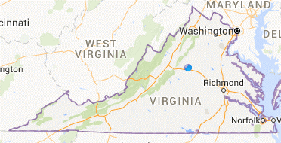
  - Which measurements would you need to know in order to calculate an approximation of the area of Virginia? Label the sides of the polygons whose measurements you would need. (Note: You aren’t being asked to calculate anything.)
- Jada’s bike wheels have a diameter of 20 inches. How far does she travel if the wheels rotate 37 times?
- This problem is from an earlier lesson
- The radius of Earth is approximately 6,400 km. The equator is the circle around Earth dividing it into the northern and southern hemispheres. (The center of the earth is also the center of the equator.) What is the length of the equator?
- (From Unit 5, Lesson 13.)
- Here are several recipes for sparkling lemonade. For each recipe, describe how many tablespoons of lemonade mix it takes per cup of sparkling water.
  - 4 tablespoons of lemonade mix and 12 cups of sparkling water
  - 4 tablespoons of lemonade mix and 6 cups of sparkling water
  - 3 tablespoons of lemonade mix and 5 cups of sparkling water
  - $\frac{1}{2}$ tablespoon of lemonade mix and $\frac{3}{4}$ cups of sparkling water
- (From Unit 5, Lesson 1.)
© CC BY Open Up Resources. Adaptations CC BY IM.

