Lesson 12 Practice Problems
- Here are equations defining three exponential functions $f$, $g$, and $h$.
- $f\left(x\right)=100⋅3^{x}$
- $g\left(x\right)=100⋅{\left(3.5\right)}^{x}$
- $h\left(x\right)=100⋅4^{x}$
  - Which of these functions grows the least quickly? Which one grows the most quickly? Explain how you know.
  - The three given graphs represent $f$, $g$, and $h$. Which graph corresponds to each function?
  - 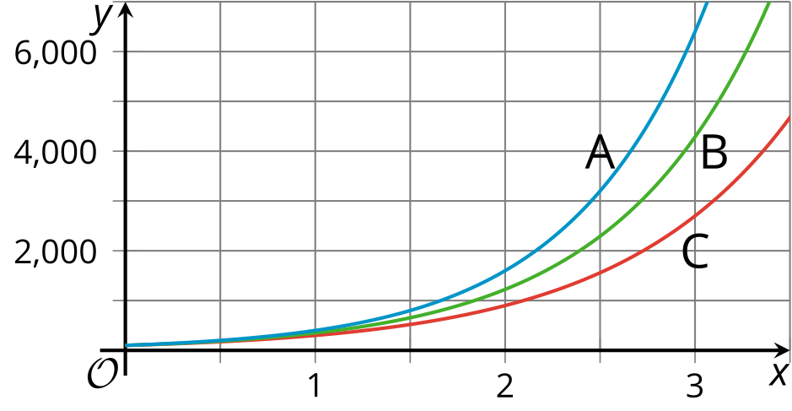
  - Why do all three graphs share the same intersection point with the vertical axis?
- Here are graphs of three exponential equations.
- Match each equation with its graph.
- 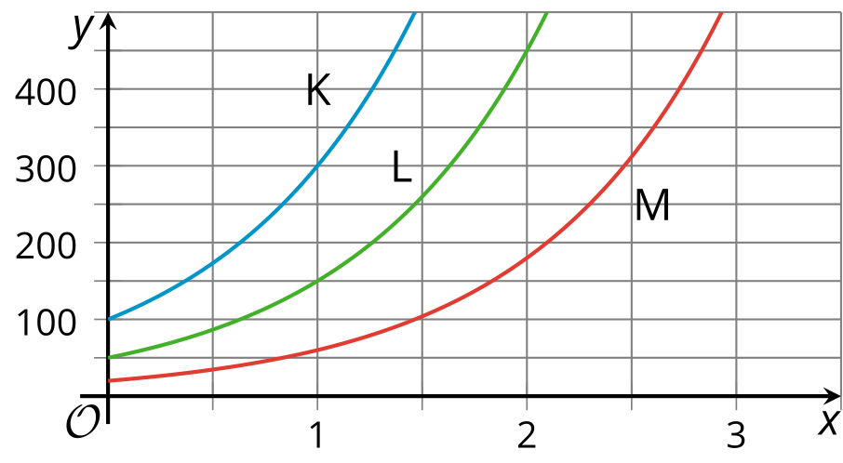
  - $y=20⋅3^{x}$
  - $y=50⋅3^{x}$
  - $y=100⋅3^{x}$
  - K
  - L
  - M
- The function $f$ is given by $f\left(x\right)=160⋅{\left(\frac{4}{5}\right)}^{x}$ and the function $g$ is given by $g\left(x\right)=160⋅{\left(\frac{1}{5}\right)}^{x}$. The graph of $f$ is labeled $A$ and the graph of $g$ is labeled $C$.
- If $B$ is the graph of $h$ and $h$ is defined by $h\left(x\right)=a⋅b^{x}$, what can you say about $a$ and $b$? Explain your reasoning.
- 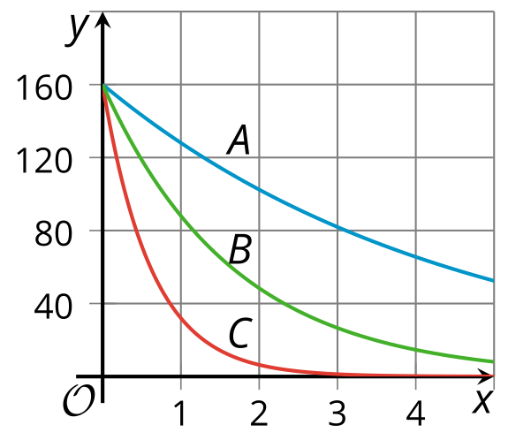

- Here is a graph of $y=100⋅2^{x}$.
- On the same coordinate plane:
  - Sketch a graph of $y=50⋅2^{x}$ and label it $A$.
  - Sketch a graph of $y=200⋅2^{x}$ and label it $B$.
- 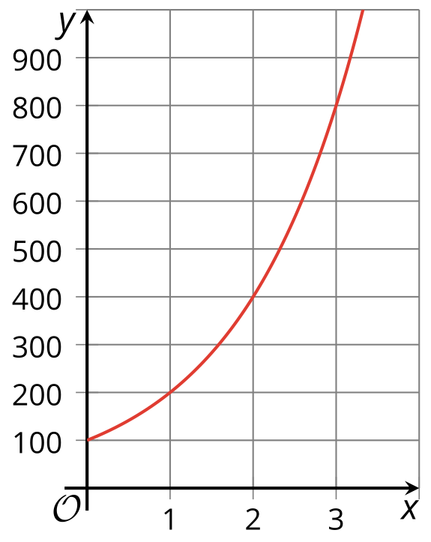

- Choose the inequality whose solution region is represented by this graph.
- 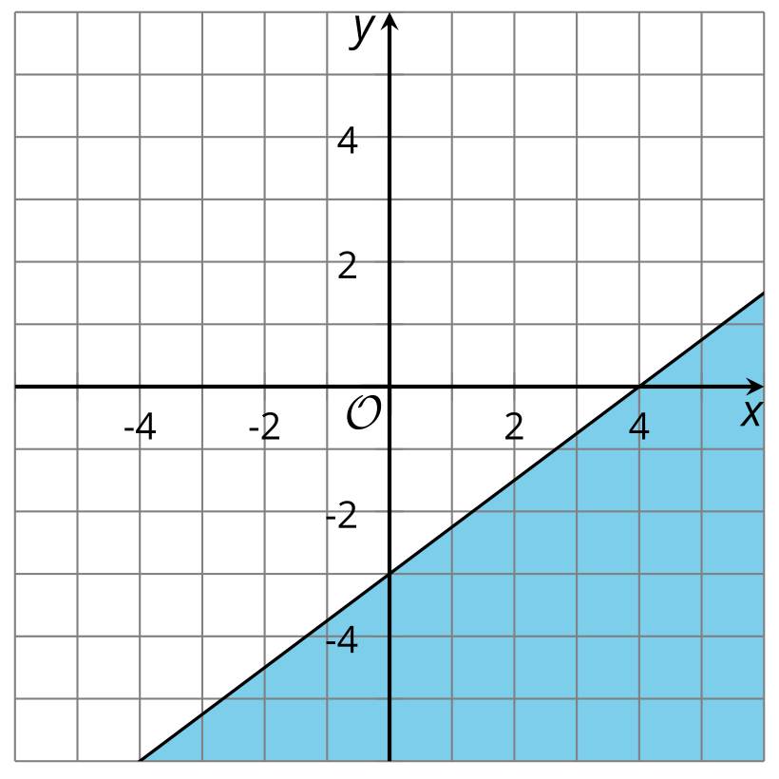

  - $3x−4y>12$
  - $3x−4y≥12$
  - $3x−4y<12$
  - $3x−4y≤12$
- (From Unit 2, Lesson 21.)
- Technology required. Start with a square with area 1 square unit (not shown). Subdivide it into 9 squares of equal area and remove the middle one to get the first figure shown.
  - What is the area of the first figure shown?
  - Take the remaining 8 squares, subdivide each into 9 equal squares, and remove the middle one from each. What is the area of the figure now?
  - Continue the process and find the area for stages 3 and 4.
  - Write an equation representing the area $A$ at stage $n$.
  - Use technology to graph your equation.
  - Use your graph to find the first stage when the area is first less than $\frac{1}{2}$ square unit.
- (From Unit 5, Lesson 5.)
- The equation $b=500⋅{\left(1.05\right)}^{t}$ gives the balance of a bank account $t$ years since the account was opened. The graph shows the annual account balance for 10 years.
  - What is the average annual rate of change for the bank account?
  - Is the average rate of change a good measure of how the bank account varies? Explain your reasoning.
- 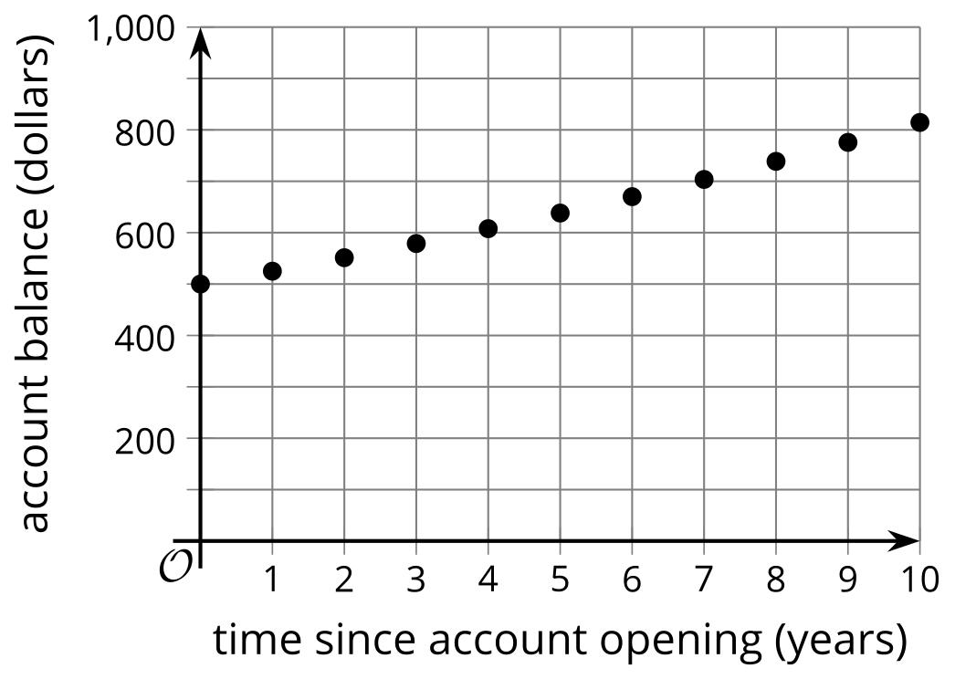
- (From Unit 5, Lesson 10.)
© CC BY 2019 by Illustrative Mathematics®

