Lesson 3 Practice Problems
- Function $f$ gives the temperature, in degrees Celsius, $t$ hours after midnight.
- Choose the equation that represents the statement: “At 1:30 p.m., the temperature was 20 degrees Celsius.”
  - $f(1​:​30)=20$
  - $f(1.5)=20$
  - $f(13​:​30)=20$
  - $f(13.5)=20$
- Tyler filled up his bathtub, took a bath, and then drained the tub. The function $B$ gives the depth of the water, in inches, $t$ minutes after Tyler began to fill the bathtub.
- Explain the meaning of each statement in this situation.
  - $B(0)=0$
  - $B(1)<B(7)$
  - $B(9)=11$
  - $B(10)=B(22)$
  - $B(20)>B(40)$
- Function $f$ gives the temperature, in degrees Celsius, $t$ hours after midnight.
- Use function notation to write an equation or expression for each statement.
  - The temperature at 12 p.m.
  - The temperature was the same at 9 a.m. and at 4 p.m.
  - It was warmer at 9 a.m. than at 6 a.m.
  - Some time after midnight, the temperature was 24 degrees Celsius.
- Select all points that are on the graph of $f$ if we know that $f(2)=\text{-}4$ and $f(5)=3.4$.
  - $(\text{-}4,2)$
  - $(2,\text{-}4)$
  - $(3.4,5)$
  - $(5,3.4)$
  - $(2,5)$
- Write three statements that are true about this situation. Use function notation.
- Function $f$ gives the distance of a dog from a post, in feet, as a function of time, $t$, in seconds, since its owner left.
- Use the $=$ sign in at least one statement and the $<$ sign in another statement.
- 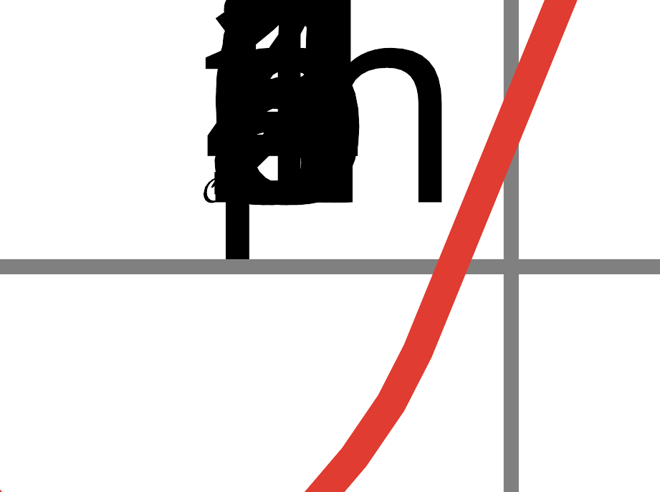
- Elena writes the equation $6x+2y=12$ . Write a new equation that has:
  - exactly one solution in common with Elena’s equation
  - no solutions in common with Elena’s equation
  - infinitely many solutions in common with Elena’s equation
- (From Unit 2, Lesson 17.)
- A restaurant owner wants to see if there is a relationship between the amount of sugar in some food items on her menu and how popular the items are.
- She creates a scatter plot to show the relationship between amount of sugar in menu items and the number of orders for those items. The correlation coefficient for the line of best fit is 0.58.
  - Are the two variables correlated? Explain your reasoning.
  - Does either of the variables cause the other to change? Explain your reasoning.
- (From Unit 3, Lesson 9.)
© CC BY 2019 by Illustrative Mathematics®

