Lesson 3: Measuring Dilations
- Let’s dilate polygons.

3.1: Dilating Out
Dilate triangle $FGH$ using center $C$ and a scale factor of 3.
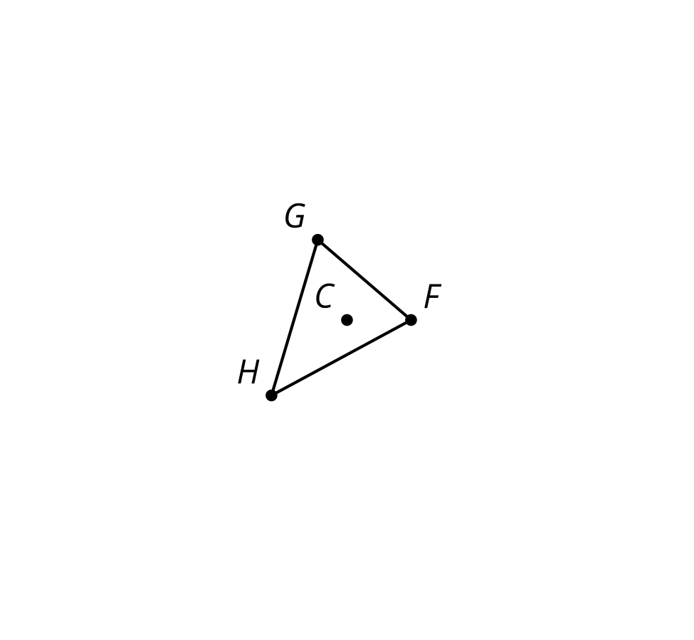

3.2: All the Scale Factors
Here is a center of dilation and a triangle.
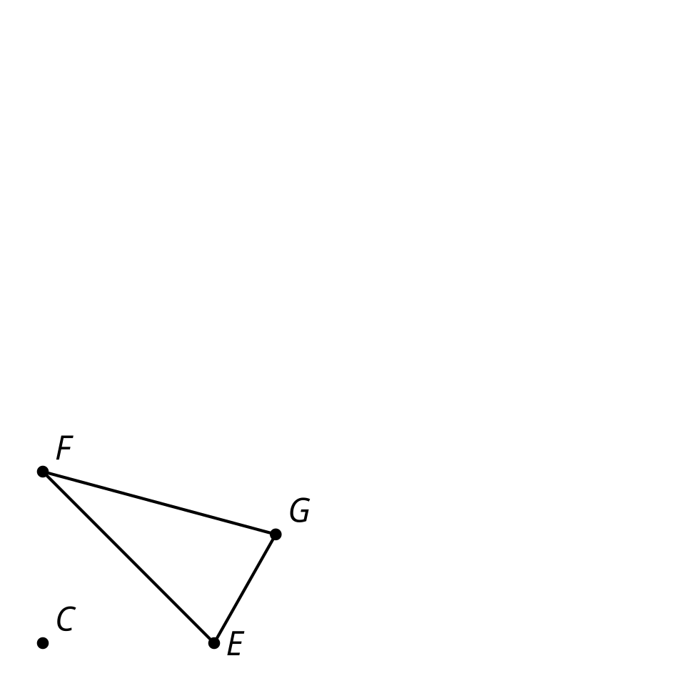
- Measure the sides of triangle $EFG$ (to the nearest mm).
- Your teacher will assign you a scale factor. Predict the relative lengths of the original figure and the image after you dilate by your scale factor.
- Dilate triangle $EFG$ using center $C$ and your scale factor.
- How does your prediction compare to the image you drew?
- Use tracing paper to copy point $C$, triangle $EFG$, and your dilation. Label your tracing paper with your scale factor.
- Align your tracing paper with your partner’s. What do you notice?

Are you ready for more?
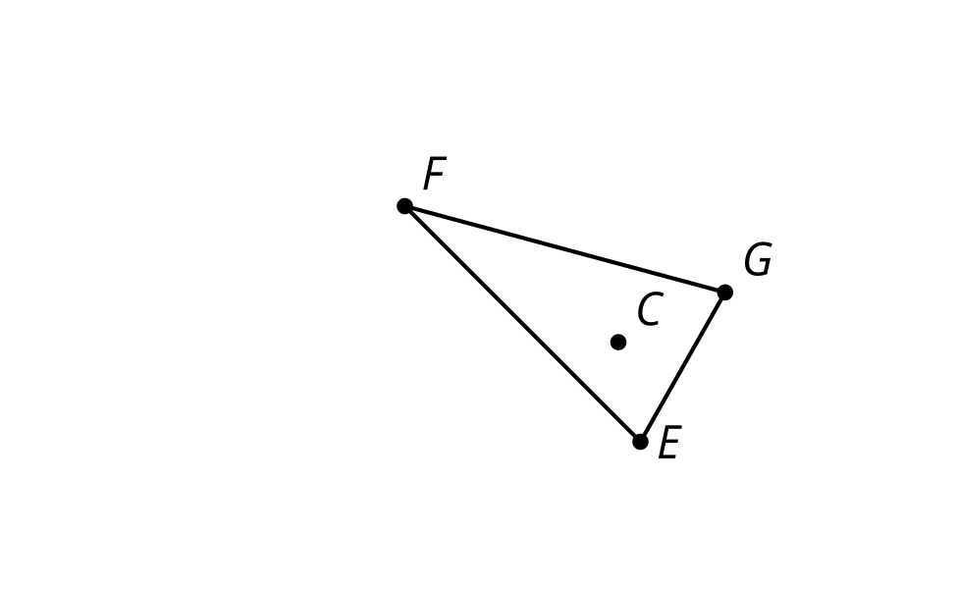
- Dilate triangle $FEG$ using center $C$ and scale factors:
  - $\frac{1}{2}$
  - 2
- What scale factors would cause some part of triangle $E^{′}F^{′}G^{′}$’ to intersect some part of triangle $EFG$?

3.3: What Stays the Same?
- Dilate quadrilateral $ABCD$ using center $P$ and your scale factor.
- 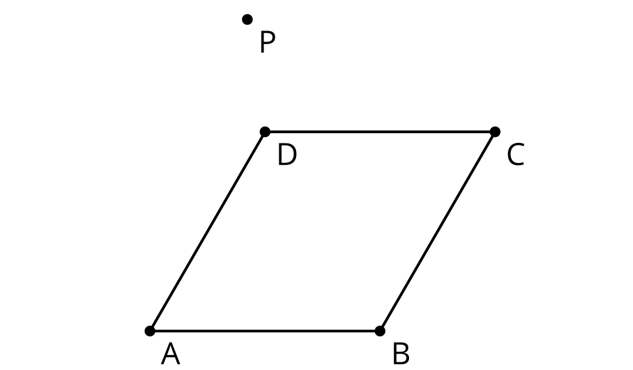
- Complete the table.
- Ratio | - $\frac{PA^{′}}{PA}$ | - $\frac{PB^{′}}{PB}$ | - $\frac{PC^{′}}{PC}$ | - $\frac{PD^{′}}{PD}$
- Value
- What do you notice? Can you prove your conjecture?
- Complete the table.
- Ratio | - $\frac{B^{′}A^{′}}{BA}$ | - $\frac{C^{′}B^{′}}{CB}$ | - $\frac{D^{′}C^{′}}{DC}$ | - $\frac{A^{′}D^{′}}{AD}$
- Value
- What do you notice? Does the same reasoning you just used also prove this conjecture?

Lesson 3 Summary
We know a dilation with center $P$ and positive scale factor $k$ takes a point $A$ along the ray $PA$ to another point whose distance is $k$ times farther away from $P$ than $A$ is.
The triangle $A^{′}B^{′}C^{′}$ is a dilation of the triangle $ABC$ with center $P$ and with scale factor 2. So $A^{′}$ is 2 times farther away from $P$ than $A$ is, $B^{′}$ is 2 times farther away from $P$ than $B$ is, and $C^{′}$ is 2 times farther away from $P$ than $C$ is.
Because of the way dilations are defined, all of these quotients give the scale factor: $\frac{PA^{′}}{PA}=\frac{PB^{′}}{PB}=\frac{PC^{′}}{PC}=2$.
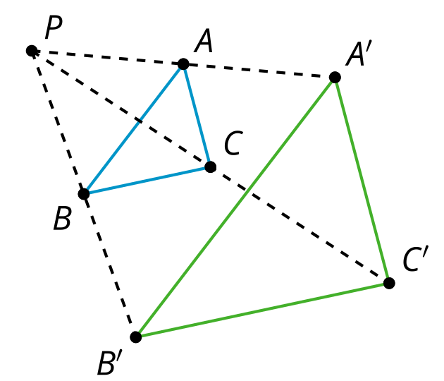
If triangle $ABC$ is dilated from point $P$ with scale factor $\frac{1}{3}$, then each vertex in $A^{″}B^{″}C^{″}$ is on the ray from P through the corresponding vertex of $ABC$, and the distance from $P$ to each vertex in $A^{″}B^{″}C^{″}$ is one-third as far as the distance from $P$ to the corresponding vertex in $ABC$.
$\frac{PA^{″}}{PA}=\frac{PB^{″}}{PB}=\frac{PC^{″}}{PC}=\frac{1}{3}$
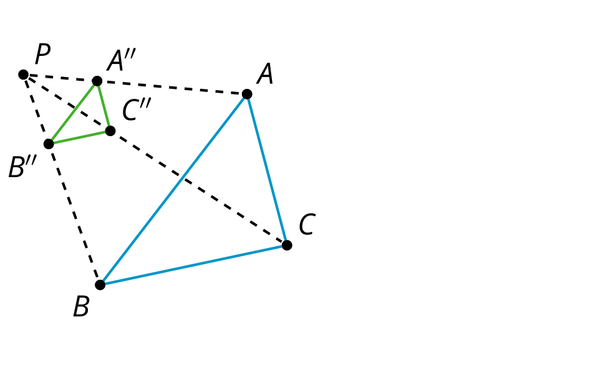
The dilation of a line segment is longer or shorter according to the same ratio given by the scale factor. In other words, If segment $AB$ is dilated from point $P$ with scale factor $k$, then the length of segment $AB$ is multiplied by $k$ to get the corresponding length of $A^{′}B^{′}$.
$\frac{A^{″}B^{″}}{AB}=\frac{B^{″}C^{″}}{BC}=\frac{A^{″}C^{″}}{AC}=k$.
Corresponding side lengths of the original figure and dilated image are all in the same proportion, and related by the same scale factor $k$.
© CC BY 2019 by Illustrative Mathematics®

