Lesson 6: Make a Ten and Make Sense of Equations
- Let’s add one-digit and two-digit numbers and make sense of equations.

Warm-up: Number Talk: Add Within 20
Find the value of each expression mentally.
- $8+2$
- $8+5$
- $9+8$
- $7+6$

6.1: How Many to the Next Ten?
Find the number that makes each equation true.
Be ready to explain your thinking in a way that others will understand.

- 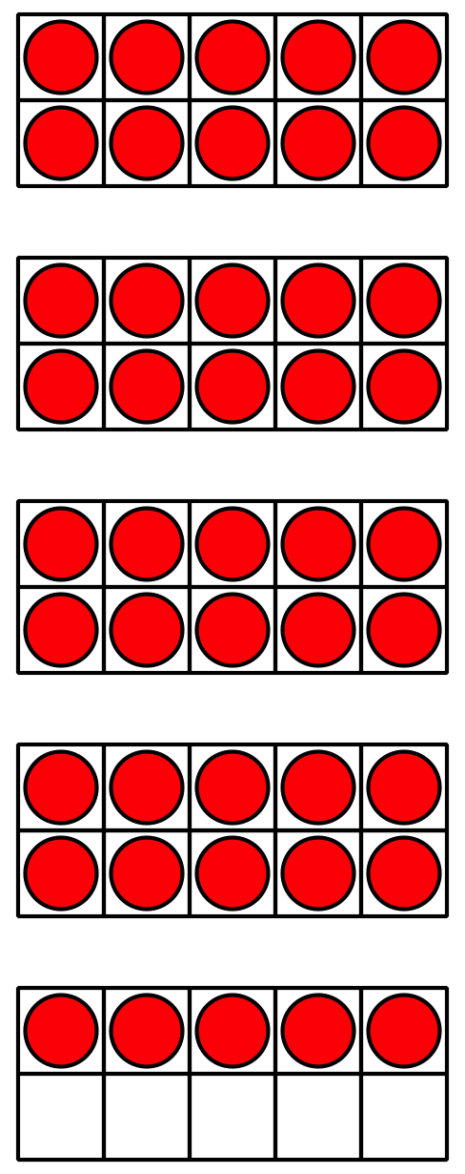
- 45+aaaiaaai=50

- 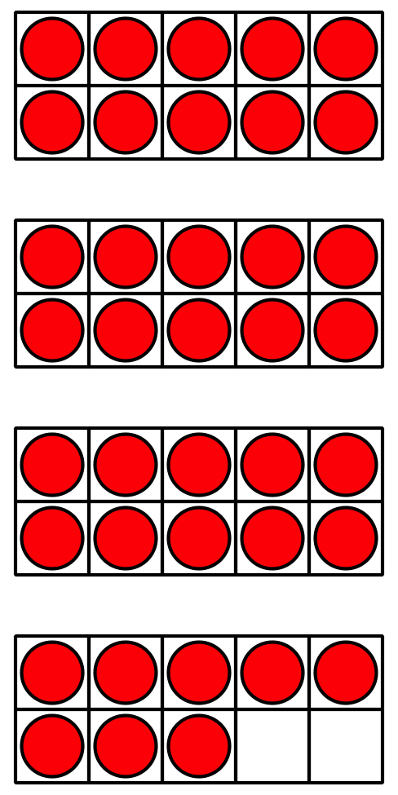
- 38+aaaiaaai=40
- 63+aaaiaaai=70
- 24+aaaiaaai=30
- 42+aaaiaaai=50
- 57+aaaiaaai=60
- 71+aaaiaaai=80
- 89+aaaiaaai=90
- What did you notice about the unknown number in each equation?

6.2: Elena and Andre Add
Elena and Andre found the value of $34+9$.
- Elena started with $34+6=40$.
What does Elena need to do next?
Show your thinking using drawings, numbers, or words.
- Andre started with $9+1=10$.
What does Andre need to do next?
Show your thinking with drawings, numbers, or words.
- Find the value of $6+68$. Show your thinking using drawings, numbers, or words.
© CC BY 2021 Illustrative Mathematics®

