Unit 3 Lesson 15: Create Line Plots

WU Number Talk: Subtraction within 50 (Warm up)

Student Task Statement
Find the value of each expression mentally.
- $47−20$
- $47−24$
- $36−10$
- $36−15$

1 Measure and Plot Pencil Lengths

Student Task Statement
- Measure the pencils in centimeters. Work with a partner and check each other’s measurements. Record each measurement in the table.
- pencil length (cm)
- Create a line plot to represent the lengths of all the pencils in your group.

2 Plot Pencil Lengths

Student Task Statement
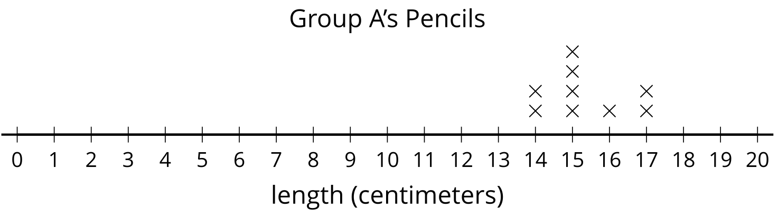
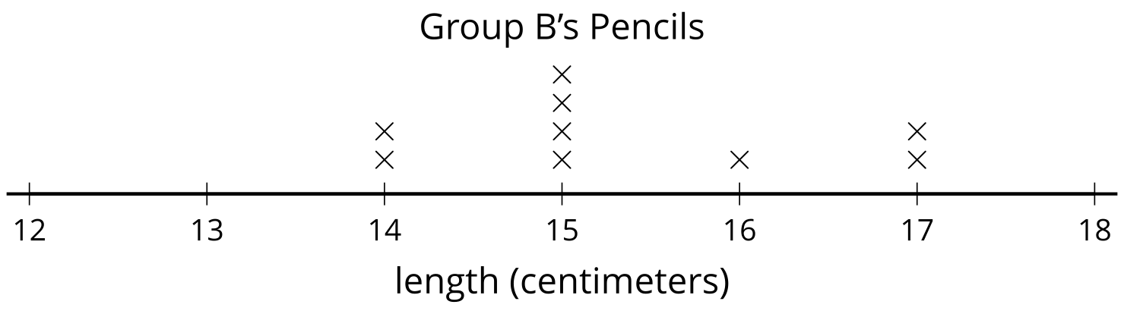
Use this data to create a line plot.
Group C | pencil length (centimeters)
Andre | 12
Clare | 10
Diego | 10
Elena | 10
Han | 13
Jada | 12
Kiran | 14
Noah | 16
Priya | 14
Tyler | 13

Images for Activity Synthesis
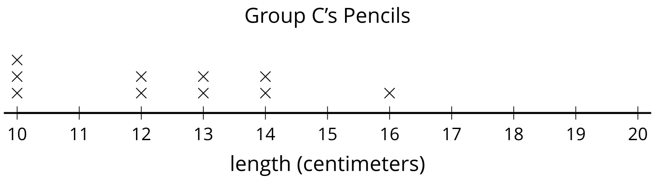
© CC BY 2021 Illustrative Mathematics®

